MODULE C –DIFFUSION OF PULMONARY GASES

CHAPTER 3

Definition of Terms

  - Alveolar Air Equation
  - Dalton’s Law
  - Diffusion
  - DL_{CO}
  - Fick’s Law
  - Fractional Concentration
  - Graham’s Law
  - Henry’s Law
  - Respiratory Quotient
  - Water Vapor Pressure

- Questions:

    - Why does breathing 100% oxygen increase oxygen’s diffusion rate?
    - Which of the following constitutes a diffusion problem: partially obstructed airways or a reduced alveolar capillary membrane area?

Diffusion
  - Definition: Diffusion is defined as the movement of gas molecules from an area of relatively high concentration of gas to an area of low concentration or from an area of high partial pressure to an area of low partial pressure. Diffusion will continue until the gas(s) have reached equilibrium.
  - Barometric Pressure: The atmospheric pressure that surrounds the earth is called the barometric pressure. At sea level one atmosphere equals 760 mm Hg or 1034 cm H₂0.
    - Barometric Pressure is measured with a barometer
    - Barometric pressure changes with altitude; as you increase in altitude, the barometric pressure decreases.
  - Fractional (%) Concentration of the Gases
    - The atmosphere is composed of primarily 4 gases
      - Nitrogen (N₂) – 78% (78% of the atmosphere is comprised of N₂)
      - Oxygen (O₂) – 21% (21% of the atmosphere is comprised of O²)
      - Argon (Ar) – 0.93%
      - Carbon Dioxide (CO₂) – 0.03%
    - The % composition of each gas is called the Fractional Concentration
      - FIN₂ or FN₂
      - FIO₂ or FO₂
      - FIAr or FAr
      - FICO₂ or FCO₂
NOTE: The inclusion of an “I” indicates inspired gas, which implies that it is saturated with water vapor.
    - The % concentrations of gases do not change with altitude. It remains the same at high and low altitudes.
    - Patients can be given supplemental oxygen (21 – 100%) to raise the fractional concentration.
  - Dalton’s Law of Partial Pressures
    - Each gas in a gas mixture exerts its own individual partial pressure
      - Barometric pressure x Fractional Concentration = Partial Pressure of the Dry Gas
    - The partial pressures of each atmospheric gas (dry) is as follows:
      - Nitrogen 760 x .78 = 593 mm Hg or Torr
      - Oxygen 760 x .21 = 159.6 mm Hg or Torr
      - Argon 760 x .0093 = 7.1 mm Hg or Torr
      - Carbon Dioxide 760 x .0003 = 0.23 mm Hg or Torr
    - The sum of all gases in a gas mixture must equal the total gas pressure (or barometric pressure).
      - Total Gas Pressure = PO₂ + PN₂ + PAr + PCO₂
    - 760 mm Hg = 593 torr + 159.6 torr, + 7.1 torr, + 0.23 torr
      - EXAMPLE: Total pressure in a gas mixture is 50 mm Hg. Gas A is 10 mm Hg, Gas B is 20 mm Hg, Gas C is 5 mm Hg, Gas D is 15 mm Hg. 50 mm Hg = PA + PB + PC + PD
  - Water Vapor Pressure
    - Water in the molecular form is called water vapor and exerts a partial pressure in a gas mixture.
    - Alveolar gas is 100% saturated at body temperature by the time it reaches the carina. The partial pressure exerted by water vapor is 47 torr and the absolute humidity is 44 mg/L.
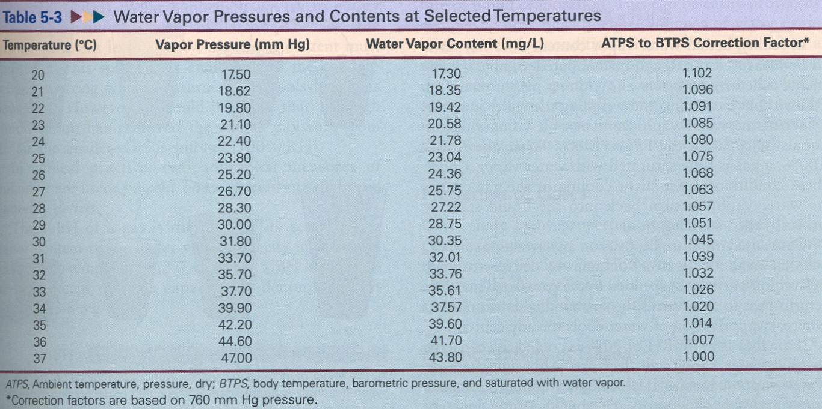
    - At temperatures other than 37°C, you will need a chart to look up the PH₂O.

  - Partial Pressures of Oxygen, Carbon Dioxide, and Water Vapor.
    - Partial Pressure of the Inspired Gas = PBARO - 47 mm Hg x F
      - PIO₂ = 150 torr
      - PICO₂ = 0.21 torr
      - PIN₂ = 556 torr
    - Partial Pressure in the Alveoli
      - PAO₂ = 100 (104) torr
      - PACO₂ = 40 torr
      - PH₂O = 47 torr
    - Partial Pressure in the Arterial Blood
      - PaO₂ = 80 – 100 torr
      - PaCO₂ = 35 – 45 torr
      - PH₂O = 47 torr
    - Partial Pressure in the Venous Blood
      - $P\bar{v}O_{2}$ = 35 - 45 torr
      - $P\bar{v}{\text{CO}}_{2}$ = 46 torr
      - PH₂O = 47 torr
  - Alveolar Air Equation
    - The PAO₂ can be computed from the Alveolar Air Equation
    - PAO₂ = [(PBARO – 47 torr x FIO₂) – (PaCO₂ * (1.25)] or

    - PAO₂ = [(PBARO - 47 torr x FIO₂) - (PaCO₂)]
RQ
      - RQ: Respiratory Quotient or Respiratory Exchange Ratio
      - CO₂ production = RQ
O₂ consumption
      - 200 mL/min = 0.8
250 mL/min

Diffusion of Gases Across the Alveolar – Capillary Membrane
  - Pathway of Diffusion: In the lungs, a gas molecule must diffuse through the alveolar – capillary membrane from a higher partial pressure to an area of lower partial pressure.
    - The pathway includes:
      - liquid lining of the intra-alveolar membrane
      - the alveolar epithelium
      - the basement membrane of the alveolar epithelial cell
      - interstitial space
      - the basement membrane of the capillary endothelium
      - the capillary endothelium
      - plasma
        - erythrocyte membrane
        - intracellular fluid in the erythrocyte
        - Hemoglobin
    - The thickness of this barrier is between 0.36 and 2.5 microns.
    - This can be easily traversed by both oxygen and carbon dioxide under normal conditions.
  - Alveolar – Capillary Gas Tensions
    - When venous blood enters the Alveolar – Capillary system, the PAO₂ is approximately 100 torr and the venous $P\bar{v}O_{2}$ is approximately 40 torr. This is a pressure gradient of 60 torr. As a result, O₂ diffuses from the alveoli into the capillary and results in a PaO₂ of 100 torr.
    - When the venous blood enters the Alveolar – Capillary system, the $P\bar{v}{\text{CO}}_{2}$ is 46 torr and the PACO₂ is 40 mm Hg. This is a pressure gradient of 6 mm Hg and results in CO₂ molecules moving from the venous blood into the alveoli.
    - The equilibrium is reached between the two gases in about 0.25 seconds. Under normal conditions, the total transit time for blood to move through the AC membrane is 0.75 seconds.
    - This means that diffusion is completed in about ¹/₃ the amount of time allotted for diffusion under resting conditions. During exercise, however, blood flow is passing through much quicker and therefore the time for diffusion decreases (the time available for gas diffusion is less than 0.75 seconds). In certain lung diseases, equilibration may not be reached in this shorted time allowed for diffusion and dyspnea results (Dyspnea on Exertion – DOE)
  - Fick’s Law
    - Diffusion of gases takes place according to Fick’s Law
    - Diffusion of gas (mL/min ) = Surface Area (Diffusion constants) (P1 - P2)
Thickness of the tissue

    - V gas = A x D x (P1-P2)
T

    - The law states that the rate of gas transfer across a sheet of tissue is directly proportional to the surface area, the diffusion constants and the partial pressure of the gas on both sides of the tissue and is inversely proportional to the thickness of the tissue.
    - The diffusion constants in Fick’s Law are determined by Henry’s Law and Graham’s Law.
  - Henry’s Law
    - Henry’s Law states that the amount of gas dissolved in a liquid at a given temperature equals its solubility coefficient times its partial pressure. This means that:
      - The amount of gas dissolved is directly proportional to the partial pressure of the gas (increase partial pressure, you will increase amount dissolved).
      - The amount of gas dissolved is ALSO dependent on its solubility coefficient.
    - The amount of gas that can be dissolved by 1 mL of a given liquid at standard pressure (760 mm Hg) and body temperature (37° C) is known as the solubility coefficient of the liquid.
      - Solubility Coefficient of Oxygen: At 37° C and 760 mm Hg, the solubility coefficient for oxygen is 0.024 mL (0.023).
      - This means that 0.024 mL of oxygen will dissolve in 1 mL of blood/760 torr/37° C.
      - Solubility Coefficient of Carbon Dioxide: At 37° C and 760 mm Hg the solubility coefficient for CO2 is 0.592 mL (0.510).
      - This means that 0.592 mL of Carbon Dioxide will dissolve in 1 mL of blood/760 torr/37° C.
    - In a liquid medium, carbon dioxide is much more soluble (24 times) than oxygen.
      - Solubility CO₂ 0.592 = 24
      - Solubility O₂ 0.0244 1
    - As temperature increases, solubility decreases
  - Grahams Law
    - Graham’s Law states that the gas diffusion rate is inversely proportional to the square root of its gram molecular weight (GMW). The GMW of O₂ is 32 grams and for CO₂ 44 grams.
$\frac{O_{2}\text{ Diffusion }\text{Rate}}{{\text{CO}}_{2}\text{ Diffusion Rate}}=\frac{\sqrt{\text{GMW}{\text{ CO}}_{2}}}{\sqrt{\text{GMW}{\text{ O}}_{2}}}=\frac{\sqrt{\text{44}}}{\sqrt{\text{32}}}=\frac{6\text{.}\text{63}}{5\text{.}\text{66}}=\frac{1\text{.}\text{17}}{1\text{.}0}$
    - Therefore, because O₂ is a lighter gas molecule, it diffuses through a gaseous medium 1.17 times faster than CO₂.
  - Diffusion Coefficient for Fick’s Law is calculated as follows:
    - By combining Henry’s and Grahams Laws, CO₂ diffuses across the alveolar – capillary membrane about 21 times faster than oxygen.
      - This is calculated by the following:
$\frac{{\text{CO}}_{2}\text{ Diffusion Rate}}{O_{2}\text{ Diffusion Rate}}=\frac{\sqrt{\text{32}}×0\text{.}\text{592}}{\sqrt{\text{44}}×\text{.}\text{0244}}=\frac{3\text{.}\text{35}}{0\text{.}\text{16}}=\text{20}\text{.}7$

    - For this reason, defects in the A-C membrane limit oxygen diffusion long before they limit CO₂ diffusion. Therefore diffusion is primarily focused on O₂ diffusion.

    - The Diffusion Coefficient used in Fick’s Law is calculated for each gas as follows:
$D=\frac{\text{Solubility}}{\sqrt{\text{GMW}}}$
    - Diffusion for a particular gas is directly proportional to the solubility coefficient and inversely proportional to the square root of the GMW of the gas.
  - Clinical Application of Fick’s Law
    - A decreased surface area decreases the ability of oxygen to enter the pulmonary capillary (alveolar collapse, alveolar fluid, pneumonectomy, and lobectomy).
    - A decreased PAO₂ (high altitudes) will decrease diffusion because of a decreased pressure gradient.
    - An increased thickness of the alveolar capillary membrane (alveolar fibrosis or edema) decreases diffusion of O₂.
  - Correction of Diffusion Defects
    - If the oxygen diffusion rate is decreased because of thickening of the membrane, decreased partial pressure, or decreased surface area, the administration of oxygen is beneficial.
    - By increasing the FIO₂, the PAO₂ will increase. This will facilitate oxygen movement across the A-C membrane

Carbon Monoxide (CO) Diffusion
  - CO bonding to Hemoglobin
    - If CO enters the bloodstream, it rapidly enters the RBC and bonds tightly to hemoglobin.
    - CO has an affinity for hemoglobin that is about 210 times greater than that of oxygen.
    - When gases are in chemical combination with hemoglobin, they no longer exert a partial pressure.
    - Since CO does not exert a partial pressure, only the diffusion characteristics of the A-C membrane and not the amount of blood flowing through the capillary, limit the CO.
  - DL_{CO}
    - CO is an excellent gas for evaluating the lungs ability to diffuse gases. This is called the Diffusion Capacity of Carbon Monoxide Test (DL_{CO}) and is done in a pulmonary function lab.
    - The DL_{CO} test measures the amount of CO that moves across the A-C membrane into the blood in a given time. The normal DL_{CO} is 25 mL/min/mm Hg.
    - The tests is performed by having the patient breathe in 0.3% CO and then hold their breath for 10 seconds. They then exhale back to residual volume and the amount of CO diffusion is calculated.

Clinical Conditions that Decrease Rate of Diffusion

  - Thickening of the alveolar wall (pulmonary fibrosis)
  - Destruction of the A-C membrane (emphysema)
  - Interstitial Edema
  - Pulmonary Edema
ASSIGNMENT MODULE C

- List the fractional concentrations of the four major gases that comprise the atmosphere

Gas Fractional Concentration
  - _____________________________ _____________________
  - _____________________________ _____________________
  - _____________________________ _____________________
  - _____________________________ _____________________

- Given a barometric pressure of 760 torr, calculate the PIO₂

- Given a barometric pressure of 760 torr, calculate the PIN₂

- Given a barometric pressure of 760 torr, calculate the PIAr

- Given a barometric pressure of 760 torr, calculate the PICO₂

- Given a barometric pressure of 750 torr, calculate the PIO₂

- Given a barometric pressure of 740 torr, calculate the PICO₂

- Given a barometric pressure of 755 torr and an FIO₂ of .40, calculate the PIO₂

- Given a barometric pressure of 735 torr and an FIO₂ of .60, calculate the PIO₂

- Given a barometric pressure of 740 torr and an FIO₂ of .30, calculate the PIO₂

- Given the following information, calculate the partial pressure of Gas C

Total Pressure in the gas mixture: 740 mm Hg
Partial Pressure of Gas A 400 torr
Partial Pressure of Gas B 30 torr
Partial Pressure of Gas D 50 torr
Partial Pressure of Gas E 35 torr
Partial Pressure of Gas C ?

- Given a PBARO of 760 mm Hg, FIO₂ of .40 and a PaCO₂ of 50 torr, calculate the PAO₂.

- Given a PBARO of 750 mm Hg, FIO₂ of .50 and a PaCO₂ of 70 torr, calculate the PAO₂.

