MODULE B: BASIC CHEMISTRY
LESSON 1: Atomic and Subatomic Matter

- Definition of Terms

  - MASS: A measure of the quantity of matter a body contains; mass is independent of the force of gravity and therefore does not change when the location of the body changes. Mass is not the same as weight.
  - WEIGHT: A measure of the force of attraction between the earth and the mass of an object; the gravitational force pulling the body toward the center of the earth.
Weight = Mass (M) x Acceleration due to gravity (G).
  - MATTER: Anything that occupies space and has mass.
  - PURE SUBSTANCE: A form of matter that always has a definite and constant composition. All pure substances must have the same properties under the same conditions.
  - PHYSICAL PROPERTY: A quality or condition of a substance that can be observed or measured without changing the substance's composition. Physical properties include color, solubility, mass, odor, hardness, density, magnetism, melting point, boiling point, and whether a substance is a solid, liquid or gas.
  - CHEMICAL PROPERTY: Describes how a substance behaves during a chemical reaction. Chemical properties are observed only when a substance is undergoing a change in composition.
  - ELEMENTS: The simplest form of matter that can exist under normal laboratory conditions; they cannot be decomposed into simpler substances by ordinary chemical changes. Elements are composed of tiny particles called atoms.
  - COMPOUND: Pure substances composed of 2 or more elements combined in a fixed weight ratio and which can be decomposed by ordinary chemical means. Compounds can be separated into simpler substances only by chemical reactions. There are two types of compounds: molecular compounds and ionic compounds.
  - MOLECULE: Two or more atoms which have chemically combined to form a single species.
  - MACRONUTRIENTS: An element required in large amounts for the normal growth and development of an organism.
  - MICRONUTRIENTS: An element, such as a vitamin or mineral, that is essential in minute amounts for the proper growth and metabolism of an organism.
  - MIXTURE: Two or more elements or compounds that are not chemically combined and that are put together in any proportion. They differ from compounds because mixtures have variable compositions whereas the elements in compounds are always present in a fixed proportion. There are two types of compounds: heterogeneous and homogeneous.
  - HETEROGENEOUS: A mixture which contains visibly different parts or phases each of which has different properties.
  - HOMOGENEOUS: A mixture which contains only one phase which has uniform properties throughout.
  - ATOMS: The smallest particle of an element that retains the chemical properties of that element. It consists of protons and neutrons in a nucleus surrounded with electrons.
  - PROTON: A component of an atomic nucleus with a mass defined as 1 and a charge of +1.
  - NEUTRON: A component of an atomic nucleus with a mass defined as 1 and a charge of zero.
  - ELECTRON: A negatively charged component of an atom. Electrons exist outside of and surrounding the atom nucleus. Each electron carries one unit of negative charge and has a very small mass as compared with that of a neutron or proton.
  - NUCLEUS: The positively charged mass within an atom composed of neutrons and protons, and possessing most of the mass but occupying only a small fraction of the volume of the atom.
  - ATOMIC NUMBER: The number of protons in the nucleus of the atom.
  - MASS NUMBER: The total number of protons and neutrons in the nucleus of an atom. The mass number of each element (or isotope) is not found on the periodic chart.
  - ATOMIC MASS: An average mass of the mixture of isotopes that reflects the masses and relative abundance of the elements as they occur in nature. (Also called atomic weight.) This number can be found on the periodic chart.
  - ISOTOPE: Atoms of the same element which have the same number of protons but different numbers of neutrons. They have the same atomic number but different atomic weights and mass number.
- Atomic & Subatomic Matter
  - Matter
    - Matter is anything that occupies space and has mass. The air we breathe, the food we eat, clothes we wear, are all different kinds of matter.
      - If it’s “something” it’s matter, if it’s “nothing”, it’s not matter
    - Matter can be perceived by the senses.
    - Matter exists in 3 phases or states:
      - Solid
      - Liquid
      - Gaseous
    - Matter can be divided into two forms:
      - Pure Substances
        - Matter in its simplest form.
        - Includes the atom, an element, a molecule, and a compound.
        - Always the same regardless of where it is found.
        - Examples: Oxygen (O), water (H₂O), table salt (NaCl).
        - It cannot be broken down any further without a chemical or nuclear reaction. (It will then become a different substance; e.g. Uranium in a nuclear bomb)
        - Pure substances are homogenous (Uniform in structure or composition throughout)
      - Mixtures
        - Matter most often exists in nature as mixtures.
        - A mixture is defined as 2 or more elements or compounds that are not chemically combined and that are put together in any proportion
        - They differ from compounds because mixtures have variable compositions whereas the elements in compounds are always present in a fixed proportion.
        - Mixtures do not interact chemically and they retain their individual identities and properties.
        - Examples: beef stew; air, soil, petroleum, blood, candy.
        - Mixtures can be heterogeneous or homogeneous.
        - A heterogeneous mixture is not uniform in composition (mixing sand in water).
        - A homogeneous mixture has a completely uniform composition and are also called solutions. If we could sample a sugar solution, we would find that is has the same composition throughout the solution.
        - One important characteristic of both heterogeneous and homogeneous mixtures is that their compositions may vary.
  - Elements
    - Elements are the simplest form of matter that can exist under normal laboratory conditions.
    - They cannot be decomposed into simpler substances by ordinary chemical changes.
    - Elements are a large collection of atoms of the same type.
    - Elements are the building blocks of matter.
    - They combine with one another to form compounds
    - There are 117 known elements (A listing of all the elements known to man is called the Periodic Table).
      - 80% of the elements can be found in nature (94 natural elements). 23 elements are not found in nature and are man-made elements.
      - The human body is made up of only 11 of the 117 elements.
      - The elements in the human body can be subdivided into two types:
        - Macronutrients: Those elements that are required in large amounts for the normal growth and development of an organism.
          - 1% of total atoms in the human body
          - Hydrogen, oxygen, carbon, nitrogen
          - Note: ²/₃ of the mass of the human body is water (H₂O) which is why hydrogen and oxygen are the most abundant elements.
        - Micronutrients: Those elements, that are essential in minute amounts for the proper growth and metabolism of an organism.
          - 0.01 - 1% of total atoms
          - Calcium, chlorine, potassium, phosphorus, magnesium, sulfur, sodium,
    - Introduction to the Periodic Table
      - The periodic table is a listing of all the known elements.
      - The table is arranged so similar elements are arranged in columns and ordered left to right and up and down by the weight of the individual element.
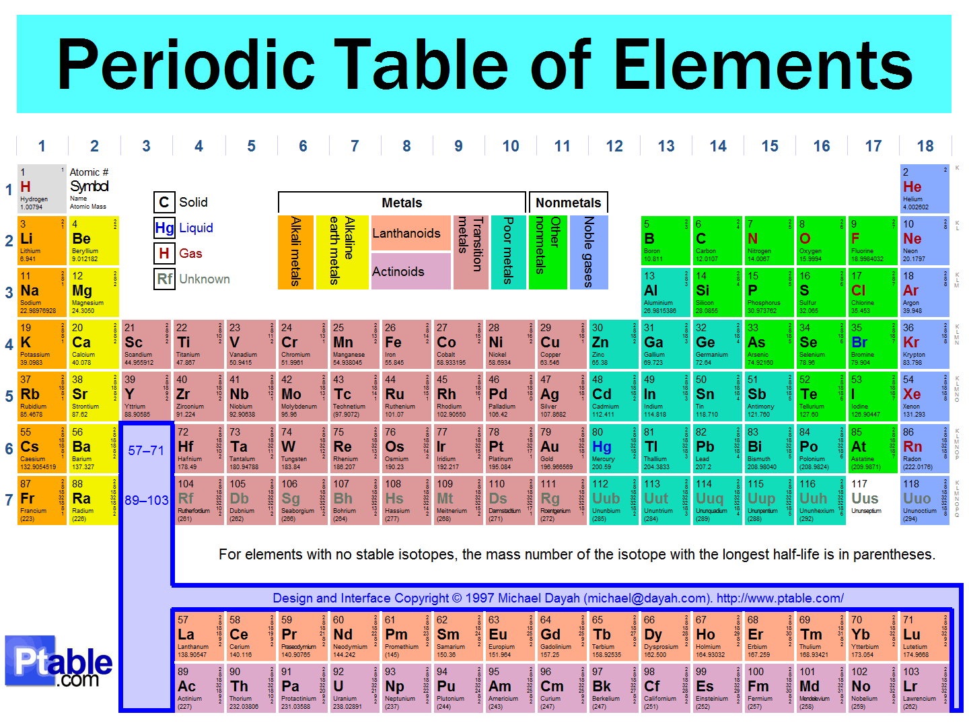
      - 91% of all the atoms in the universe are Hydrogen atoms and 9% are Helium. The remaining 115 elements are only found in trace amounts.
      - In the Earth’s crust, oxygen is the most abundant (60%), followed by silicon (21%), aluminum (6%), hydrogen (3%), calcium (2.6%), magnesium (2.4%), iron (2.2%), and sodium (2.1%).
  - Molecules
    - A molecule is composed of two or more atoms that are chemically combined and act as a unit.
    - Examples of molecules:
      - CH₄ – Methane: This molecule is composed of 1 atom of carbon and 4 atoms of hydrogen.
      - CO - Carbon Monoxide: The molecule is composed of 1 atom of carbon and 1 atom of oxygen.

  - Compounds
    - Compounds are pure substances composed on 2 or more elements combined in a fixed weight ratio and which can be decomposed by ordinary chemical means.
    - Compounds can be separated into simpler substances only by chemical reactions.
    - The constituent elements in a compound are always present in the same proportions.
    - Whereas elements are composed of 1 kind of atom, compounds are composed of 2 or more different kinds of atoms.
    - Though there are only 117 elements, there are over 5 million known compounds formed from the combination of elements.
    - Examples of Compounds:
      - HCl: Hydrochloric acid
      - NaHCO₃: Sodium Bicarbonate
      - H₂CO₃: Carbonic Acid
      - NaCl: Sodium Chloride
      - C₆H₁₂O₆: Glucose

  - Atoms
    - All elements are composed on tiny particles called atoms.
    - The atom is the smallest particle of an element that retains the chemical properties of that element.
    - It consists of protons and neutrons in a nucleus surrounded with electrons.
    - Atoms are not destroyed in physical or chemical reactions.
      - Atoms can be fragmented but extraordinary effort is required and it does not occur in usual chemical reactions (e.g. breaking the atom into sub-atomic particles in a linear accelerator).
      - Atoms are extremely small with the radius measured in Ångstroms (Å).
    - Protons and neutrons are found inside the nucleus.
      - Protons have a positive charge and neutrons are neutral.
      - The majority of the mass of an atom is found within the nucleus. The proton is 1840 times heavier than the electron.
    - The electrons are outside the nucleus and are negatively charged.
      - Although they contribute almost no mass to the atom, they occupy most of the volume of the atoms.
      - Electrons travel in orbits, circulating around the nucleus, known as electron shells or energy levels.
    - Since the number of protons equals the number of electrons, the atom is electrically neutral.
    - The Atomic Number of an element is the number of protons in the nucleus of the atom.
      - If we know the atomic number, we will know the number of protons.
      - Since protons = electrons, we will also know the number of electrons.
      - Example: Hydrogen has an Atomic Number of 1, therefore, there must be one proton and one electron (no neutron).
      - Oxygen has an Atomic Number of 8. It has eight protons and eight electrons.
    - Since the mass of an atom is concentrated in its nucleus, the total number of protons and neutrons in the nucleus is the Mass Number of an atom (Mass number is equal to the number of protons and the number of neutrons).
      - Also, the number of neutrons would be equal to the Mass Number less the Atomic Number.
      - The Mass Number of an atom also equals the approximate atomic weight of the atom.
    - The Atomic Weight or Atomic Mass is the mass of the protons and neutrons in the nucleus of an atom.
      - Mass and weight are often used to mean the same thing, though there is an important difference between them.
        - Mass is defined as the quantity of matter contained in an object.
        - Weight is defined as the gravitational force pulling the body toward the center of the earth.
      - The mass of an object will remain the same regardless of its position relative to the earth
      - The weight of the same object will change according to the nature of the gravitational field in which it is positioned.
      - The weight of an object decreases as the distance from the center of the earth increases (this is why you would weight slightly less on top of Mt. Everest than you would in Death Valley though your mass would be the same).
      - Why do we use the terms weight and mass interchangeably? Because if two objects with the same mass are weighted in the same place, the weights of each will be identical.
    - Some elements have atoms composed of the same number of protons and electrons but different numbers of neutrons.
      - These atoms are called Isotopes.
        - An isotope is defined as atoms of the same element which have the same number of protons but different numbers of neutrons.
        - They have the same atomic number but different atomic weights and mass numbers.
        - Only 20 elements exist without isotopes.
        - An example of an isotope is Cl⁻. Cl⁻ has 2 isotopes found in nature: Cl⁻ 35 and Cl⁻ 37.
 | Cl⁻ 35 | Cl⁻ 37
Mass Number | 35 | 37
Atomic Number | 17 | 17
Protons | 17 | 17
Electrons | 17 | 17
Neutrons | 18 | 20

        - The isotope Cl⁻ 35 exists in nature 3 times more frequently then Cl⁻ 37 (i.e. a 3:1 ratio).
        - To calculate the atomic weight: Add 35 + 35 + 35 + 37 and divide by 4 to get 35.5, which is the weight you would see displayed on a periodic table.
    - Hydrogen is the lightest element and has a mass of 1.7 x 10⁻²⁴ gram. Uranium is 238 times heavier and has a mass of 4.0 x 10⁻²² gram.
    - Rather than stating the mass in scientific notation (which represents extremely small amounts), the atoms of all the elements are expressed as relative weights compared to the mass of the Carbon-12 isotope. This method is much more convenient to work with.
    - Carbon 12 was assigned an atomic mass of 12 amu (Atomic Mass Units).
      - Hydrogen weighs ¹/₁₂ as much as Carbon 12 so it was assigned at atomic mass of 1.
      - Magnesium weighs twice as much as carbon 12 so the atomic mass for magnesium is 24 amu.

  - Atomic Properties
    - There are two properties of atoms that are important to understand:
      - Physical Properties: The physical property is a quality or condition of a substance that can be observed or measured without changing the substance's composition.
        - Examples include the following:
          - Physical State of a substance (liquid, gas, solid)
          - Color
          - Solubility
          - Density
          - Odor
          - Mass
          - Hardness
          - Magnetic qualities
          - Boiling point
          - Freezing point
      - Chemical Properties: The chemical property relates to how a substance behaves in a chemical reaction.
        - Chemical properties are observed only when a substance is undergoing a change in composition.
        - Examples include how the substance relates to the following changes in condition:
          - Combustion: Is it flammable or non-flammable?
          - Reaction to light, heat or air.
          - Halogenation (the degree to which the substance can combine with a halogen)
        - Examples of chemical properties include:
          - Moist air causing copper to turn green.
          - Hydrogen peroxide changing into water and oxygen when exposed to light.

Physical Properties of Oxygen | Chemical Properties of Oxygen
- Odorless. | - Reacts with hydrogen at high temperatures to produce water.
- Colorless in gaseous state. | - Reacts with fats in foods causing a rancid odor and taste.
- Light blue in liquid state. | - Combines with hemoglobin to form oxyhemoglobin.
- Boiling point of 183° Celsius. | - Does not react with gold at room temperature.

    - The number and arrangement of the electrons determine the chemical properties of an element.
    - The number of neutrons will determine the physical properties which vary slightly between isotopes.
    - Result: The same element may “appear” slightly different depending on which isotope you look at. All isotopes should “act” the same because the electron numbers don’t change.

