MODULE C: APPLIED PHYSICS
LESSON 1: Mechanics of Ventilation

- Terminology

  - Ventilation
  - Respiration
  - Internal Respiration
  - External Respiration
  - Equation of Motion
  - Compliance
  - Resistance
  - Elastance
  - Dynamic Compliance
  - Static Compliance
  - Surface Tension
  - LaPlace’s Law
  - Surfactant
  - Poiseuille’s Law
  - Laminar
  - Turbulent
  - Equal Pressure Point

- Ventilation vs. Respiration

  - Ventilation: The bulk movement of gas in and out of the lung.
  - Respiration: The exchange of gas (specifically oxygen and carbon dioxide) at the cellular level.
    - Internal Respiration: The exchange of gas between a peripheral capillary and a cell of the body.
    - External Respiration: the exchange of gas across the alveolar-capillary membrane.
- Equation of Motion
  - Equation:
STRETCH
FRICTION
  - Mechanical Ventilator vs. Spontaneous Breathing
    - Spontaneous Breathing
      - Contraction of muscles generates a negative pressure in lungs & gas is pulled into lungs.
      - Work done by patient.
    - Mechanical Ventilator
      - Positive pressure builds in the ventilator circuit & gas is pushed into the lungs.
      - Work done by machine.
  - WORK OF BREATHING
    - The forces that oppose inflation of the lung.
      - Elastic (stretch)
        - Physical tendency of an object to resist stretching.
        - Determined by measurement of the Compliance.
          - Compliance is determined by dividing the lung volume created by the pressure change required.

        - Represents 65% of the work of breathing.
        - Comprised of forces of the lungs and the chest wall.
          - Elastic and collagen fibers found in lung parenchyma give the lungs elasticity.
        - A pressure-volume loop is a graphic representation of the amount of pressure required to generate a specific volume.
          - Changes in compliance can be readily seen by the slope of the pressure-volume loop.
        - Compliance vs. Elastance
          - Compliance is the distensibility of the lung (how easy it is to inflate).
          - Elastance is the desire of a structure to return to its initial shape.
          - Compliance and Elastance are reciprocals of each other.
          - $$\text{Compliance}=\frac{1}{\text{Elastance}}$$
          - Normal lungs have a normal elastance and a normal compliance.
            - Normal compliance is composed of two parts:
              - Compliance of the lung parenchyma
                - Normal value is 0.2 L/cm H₂O
              - Compliance of the chest wall
                - Normal value is 0.2 L/cm H₂O
              - Overall lung compliance is 0.1 L/cm H₂O
            - These forces move in opposite directions
            - At rest they form the Functional Residual Capacity (FRC).
          - With emphysema, the lung loses elastic tissue and elastance falls (and compliance increases).
            - The lung is easier to inflate, but doesn’t return to its natural shape (paper bag)
          - With a fall in lung compliance (as seen with pneumonia or ARDS), the lung has a greater elasticity and a fall in compliance
            - The lung becomes more difficult to inflate, but also become easily collapsible.
        - Patients with reduced lung compliance will breathe rapid and shallow.
        - Compliance can be expressed in two ways:
          - Dynamic Lung Compliance: Compliance with air movement.
            - $$C_{\text{DYN}}=\frac{\text{Tidal}\text{Volume}(L)}{{\text{Pr}}_{\text{PEAK}}−\text{PEEP}({\text{cmH}}_{2}O)}$$
          - Static Lung Compliance: Compliance with no air movement (a pause or plateau)
            - $$C_{\text{ST}}=\frac{\text{Tidal}\text{Volume}(L)}{{\text{Pr}}_{\text{PLATEAU}}−\text{PEEP}({\text{cmH}}_{2}O)}$$
          - PEEP stands for Positive End Expiratory Pressure or Baseline Pressure.
        - Surface tension
          - Surface tension is defined as the force (dynes) necessary to produce a tear 1 cm long in the surface layer of a liquid.
          - The alveoli are like bubbles lined with fluid and filled with air (there is a fluid/air interface).
          - Surface tension is the attractive force exerted by like molecules at the liquid’s surface.
          - Surface tension forces cause the bubble to collapse.
          - The Force of Surface Tension in a drop of liquid. Cohesive force (arrows) attracts molecules inside the drop to one another. Cohesion can pull the outermost molecules inward only, creating a centrally directed force that tends to contract the liquid into a sphere.
          - To prevent alveoli from collapsing, the lung secretes a substance known as surfactant which helps to stabilize the alveoli and prevent collapse. (The surface tension of a fluid is reduced by chemical substances called surfactants) Surfactants decrease surface tension by interfering with the molecules of the fluid at the interface (surface) causing a reduction in the force that draws the fluid centrally inward. (Soaps and detergents are surfactants).
          - The purpose of surfactant is to:
            - decrease lung inflation pressure during inspiration
            - prevent alveolar collapse during expiration
            - decrease the patients work of breathing
          - LaPlace’s Law
            - Two bubbles of different sizes with the same surface tension.
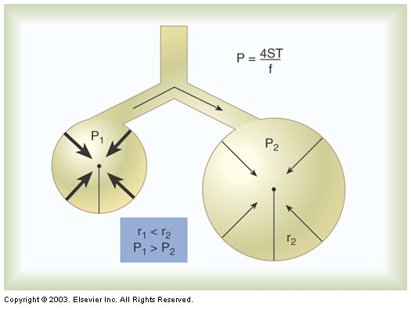
            - The bubble on the left, with the smaller radius, has the greater inward or deflating pressure and is more prone to collapse than the larger bubble on the right.
            - Because the two bubbles are connected, the left bubble would tend to deflate and empty into right bubble.
            - Conversely, because of bubble on the left's greater surface tension, it would be harder to inflate than the bubble on the right.
          - Calculation of Surface Tension
            - LaPlace’s formula
            - $$\text{*Pressure in a bubble}∝\frac{4×\text{Surface}\text{ tension}}{\text{radius}}$$
            - Surface Tension: If surface tension increases, the pressure required to inflate the bubble (open the alveoli) increases.
            - Radius: If the radius decreases, the pressure required to inflate the bubble (open the alveoli) increases.
        - Surfactant
          - Alveoli are lined with a surface-tension lowering agent (surfactant) produced by alveolar type II cells.
          - Surfactant has a low attractive force exerted by its molecules.
          - The purpose of surfactant is to:
            - decrease lung inflation pressure during inspiration
            - prevent alveolar collapse during expiration
            - decrease the patients work of breathing
          - Each alveolus has a critical volume: which is the volume below which the effects of surface tension are so great that the structure collapses resulting in atelectasis.
          - Destruction of surfactant will significantly decrease compliance and increase the work of breathing.
          - Disorders altering or destroying surfactant:
            - Prematurity
            - Adult respiratory Distress Syndrome
            - Oxygen toxicity
      - Non-elastic (friction)
        - Occurs only when gas and the system is moving.
        - Two types of resistance:
          - Airway resistance (80%)
            - Mainly in the upper airway; only 20% in lower airway.
            - High gas flow
            - Turbulent gas flow
            - Narrow airway
            - Long airway
            - Viscous gases
          - Tissue resistance (20%)
            - Obesity
            - Fibrosis
            - Abdominal distention
        - The amount of pressure required to push gas through a tube is dictated by Poiseuille’s Law
          - $$\begin{aligned}\text{*Pressure required to push gas through a tube}∝\frac{η×8×ℓ×\overset{˙}{V}}{π×{\text{radius}}^{4}} \\ \text{where}η\text{ is viscosity of the fluid }(\text{gas})\text{, }ℓ\text{ is the length of the tube, } \\ \overset{˙}{V}\text{ is the flow of the fluid }(\text{gas})\text{, and 8 and }π\text{ are constants}\text{.}\end{aligned}$$
          - Reducing the radius of a tube by ½ requires an increase in pressure 16 fold to maintain the same speed of gas flow through the tube.
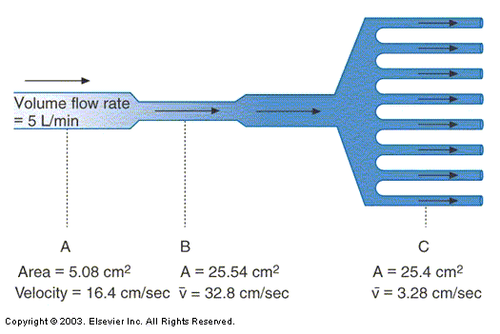
        - Counter intuitively, the largest amount of resistance to airflow is actually in the larger airways.
          - The smaller airways are more total cross-sectional area and have a slower, more laminar flow.
        - Determined by measurement of Resistance.
          - $$R=\frac{Α\text{Pressure }({\text{cm H}}_{2}O)}{\overset{˙}{V}(L\text{min})}×\text{60}$$
          - Normal Resistance = 0.5 – 2.5 cmH₂O/L/sec
        - Represents 35% of the work of breathing.
        - Diseases that cause an increase in airway resistance
          - Asthma
          - Emphysema
          - Excessive sputum production
          - Tumors
        - Things that decrease airway resistance
          - Bronchodilators
          - Anti-inflammatory agents

    - Inflation occurs as a result of forcibly stretching lung fibers during inspiration. (work)
      - Deflation or exhalation is normally passive.
      - The resting position of the lung is deflation.
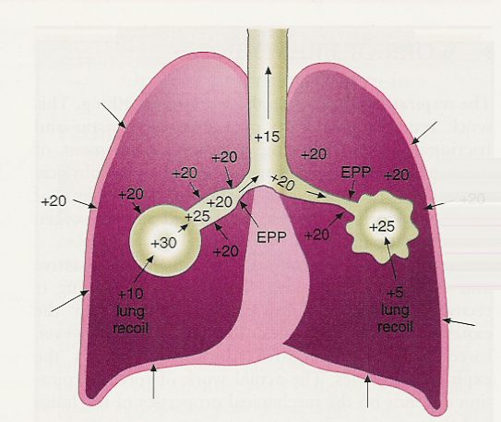
  - Equal Pressure Point
    - Point where the pressure within the airway is equal to the pressure outside the airway.
    - The airway will collapse downstream from the EPP.
      - Airway caliber is determined by:
        - Anatomical support from cartilage and traction by tissues
        - Pressure differences across their walls
          - If the pressure inside the airway is greater than that outside the airway (within the surrounding lung parenchyma) the airway will stay open.
          - If the pressure inside the airway is less than that outside the airway, the airway will collapse.
    - During forced exhalation, outside pleural pressure can become higher than inside airway pressure and airways collapses.
    - Low compliance found in emphysema results in less recoil pressure and less pressure inside the airway.
    - Airways collapse sooner and more gas is trapped as EPP moves upstream toward smaller airways. (increased resistance)
    - The use of purse-lip breathing (a technique taught to patients with emphysema) allows for back pressure to be created within the airways and moves the equal pressure point more distally. Encourage the patient to use slow deep inspirations and slow the expiratory phase by exhaling through pursed lips.

