MODULE C: APPLIED PHYSICS
LESSON 3: Properties of Gases and Gas Mixtures

- Terminology
  - Kinetic Theory
  - Avogadro’s Law
  - Molar volume
  - Standard Temperature and Pressure, Dry (STPD)
  - Pressure
  - Tension
  - Barometer
  - Partial pressure
  - Dalton’s Law
  - Pressure Gradient
  - Fractional concentration
  - Hypobarism (hypobaric)
  - Hyperbarism (hyperbaric)
  - Water Vapor Pressure
  - Diffusion
  - Mole

- Kinetic Molecular Theory
Principle assumptions of  Kinetic Molecular Theory | Gas properties as they relate to  Kinetic Molecular Theory
1. Gases are composed of tiny particles called molecules.
2. The distance between the molecules of a gas is very great compared to the size of the molecules themselves. Most of the volume occupied by a gas is empty space.  (He Balloon is 1% He and 99% nothing) | - Low density  - Greater volume than an equal mass of solid or liquid - (1 g of liquid water = 1 mL, 1 g of solid water = 1 mL, 1 g of water vapor = 1250 mL)  - Easily compressed by increasing pressure of a gas in a closes container  - Allows one gas to diffuse through another (odors travel)
3. Gas molecules are in rapid motion and move in straight lines, frequently colliding with each other and the walls of the container. | - O₂ molecules move at 1000 miles per hour  - Exert equal pressure in all directions  - Keep moving until they hit something and therefore….  fill their container  have no definite volume  have no definite shape
4. Gas molecules do not attract each other. | - are easily expanded
5. When molecules of a gas collide with each other or the walls of the container, they bounce back with no loss of energy. Such collisions are said to be perfectly elastic | - Gases never settle out because they do not loose their energy when they collide.
6. The average kinetic energy of the molecules is the same for all gases at the same temperature. The average kinetic energy increases as the temperature increases and decreases as the temperature decreases. | - Gases expand and contract in response to temperature

- Gas Pressures And The Atmosphere
  - Definitions
    - Pressure – Pressure is defined as the force per unit of surface area (pounds per square inch).
      - All gases exert pressure due to colliding molecule.
      - The higher the altitude, the less gravity and the less pressure from colliding molecules.
    - Tension - Gases in a liquid exert pressure called “tension”
    - Fractional Concentration (Percent) - The parts per 100 parts expressed as a % or as a fraction (decimal).
      - Be careful when doing calculations because one or the other may be specified.
    - Partial Pressure – The portion of the total pressure exerted by a gas in a gas mixture.
      - All the partial pressure added up will equal the total pressure of the mixture.
      - Symbolically represented by the letter P (pressure).
      - Specific gases that are expressed are shown in a smaller font size after the letter P.
        - PBARO – The barometric pressure measured with a piece of equipment and changing with altitude and atmospheric conditions.
        - PATM – The pressure of one atmosphere or pressure at sea level (760 mmHg).
        - PH₂O – Water vapor pressure
  - Atmospheric Gas Composition at sea level
    - Normobaric

Composition of air at sea level
COMPOUND | PARTIAL PRESSURE  mmHg | PERCENT  % | FIO₂
Nitrogen (N₂) | 590.0 | 78.09 | .78
Oxygen (O₂) | 158.0 | 20.95 | .21
Carbon Dioxide (CO₂) | 0.2 | 0.03 | 0.0003 (0)
Argon, Neon, Krypton, Hydrogen, Xenon, Ozone, Radon | 6.8 | 0.93 | .01
Water Vapor | 0 | 0 | 0

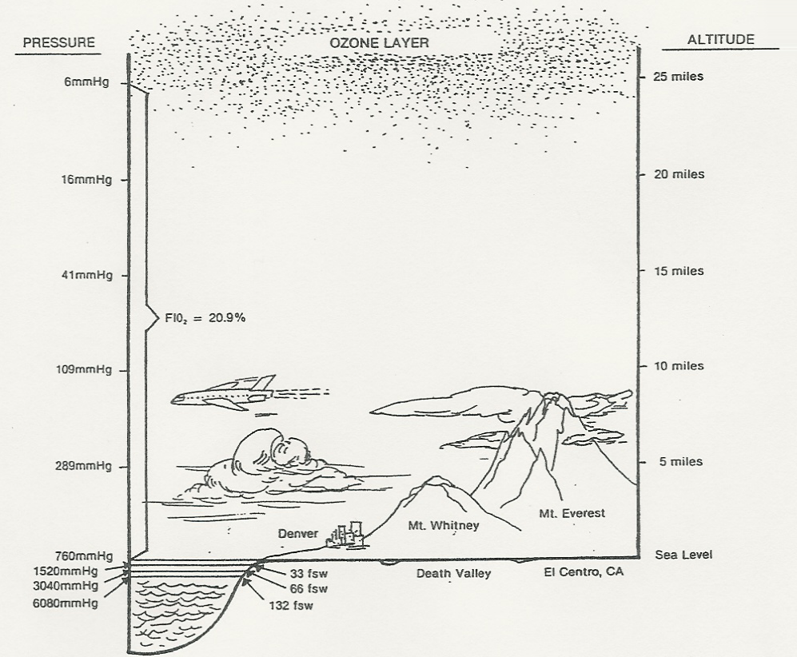
  - Atmospheric Gas Composition above sea level
    - Hypobaric conditions are those which are at less than one atmosphere (760 mmHg).
    - Increased altitude leads to decreased gravitational force, decreased molecular attraction, decreased kinetic energy, decreased density, and therefore decreased pressure.
    - Decreases oxygen pressure available & proper body function
      - This leads to a need supplemental O₂.
      - Increased altitude = same gas concentrations (%) or (F)

Composition of air at HIGH ALTITUDE
ALTITUDE  (ft) | BAROMETRIC PRESSURE  (mmHg) | PO2 IN AIR  (mmHg) | PERCENT  O2 %
0 | 760 | 159 | 21
10,000 | 523 | 110 | 21
20,000 | 349 | 73 | 21
30,000 | 226 | 47 | 21
40,000 | 141 | 29 | 21
50,000 | 87 | 18 | 21

See Egan page 98 - Mini Clini “Why are Oxygen masks Needed on Airplanes?”

  - Atmospheric Gas Composition below sea level
    - Hyperbaric conditions are those which are at greater than one atmosphere (760 mm Hg).

Composition of air at BELOW SEA LEVEL
BELOW SEA LEVEL  (ft) | BAROMETRIC PRESSURE  (mmHg) | PO2 IN AIR  (mmHg) | PERCENT  O2 %
0 | 760 (1 ATM) | 159 | 21
33 | 1530 (2 ATM) | 321 | 21
66 | 3040 (3 ATM) | 638 | 21
132 | 6080 (4 ATM) | 1277 | 21

    - Medical use of hyperbaric therapy
      - 2 - 3 ATM when used for increased O2 concentration benefits
        - Oxygen under pressure makes a higher partial pressure available. 21% of 3040 mmHg = 638 mmHg.
        - High O₂ concentrations used in wound care to fight infection by improving WBC function, forming new capillaries, repairing tissue and decreasing inflammation through vasoconstriction.
        - Can be used for treatment of:
          - Gas gangrene infection (anerobe).
          - Cyanide poisoning
          - CO poisoning (>25% COHb) by forcing CO off the Hemoglobin
          - Extreme blood loss (anemia).
      - Up to 6 ATM when needed for high pressure benefits
        - Hyperbaric Therapy can be used to decrease the size of the gas (N₂) bubbles in the blood.
        - Used when air accidentally enters the cardiovascular system.
        - Air can enter accidentally during CV surgery, lung biopsy, and hemodialysis or line placement.
        - Treatment for deep water diving accidents.
    - Problems
      - Barotrauma - pressure in ears, air entry into pleural space (pneumothorax), air entry into blood stream (air embolism)
      - Oxygen toxicity and seizures
      - Fire hazards increase
      - Sudden decompression can cause problems
      - Cataract maturation may occur faster
      - Patient’s and workers may get claustrophobia
  - Dalton’s Law
    - The Law: The total pressure of a gas mixture is equal to the sum of the partial pressures.
      - PTOTAL = P1 + P2 + P3
    - Partial Pressure: The pressure exerted by a single gas.
      - PGas = PTOTAL x Fractional Concentration of that gas (FGAS)
      - Example: Oxygen therapy makes more oxygen available to cells by increasing the partial pressure of oxygen in the atmosphere.
        - On room air: 760 X 21% = 160 mmHg
        - On oxygen therapy: 760 X 40% = 304 mmHg
    - Gas mixture: Many gases with different partial pressures.
      - In a mixture of gases, each gas exerts a partial pressure proportional to its concentration and is not affected by the presence of other gases.
      - PBARO or PATM or PTOTAL or PAMBIENT = PN₂ + PO₂ + PCO₂ + PAr + PH₂O + PTrace Gases
    - PRACTICE PROBLEMS:
      - What is the total pressure in a dry gas mixture given the following information:
PO₂ 150 torr PN₂ is 500 torr Anesthetic Gas is 8 torr
PTOTAL = 150 torr + 500 torr + 8 torr = 658 torr
      - The total pressure exerted by a mixture of the three gases, oxygen, nitrogen and water vapor is 742 mm Hg. The partial pressures of the nitrogen and oxygen in the sample are 581 mm Hg and 143 mm Hg respectively. What is the partial pressure of water vapor in the mixture?
742 mm Hg = 581 mm Hg + 143 mm Hg = X
18 mm Hg = X
      - If the total pressure in a gas mixture is 730 mm Hg, What is the partial pressure of the anesthetic gas if the PO₂ is 150 mm Hg, PH₂O is 47 mm Hg, PN₂ is 480 mm Hg?
730 mm Hg = 150 mm Hg + 47 mm Hg + 480 mm Hg + X
53 mm Hg = X
  - Water Vapor (PH₂O)
    - Partial pressure of water in the gaseous form.
    - Fully saturated air (as would be in the alveoli) has PH₂O of 47 mmHg.
    - Subtract 47 mm Hg when working with saturated gas before multiplying by F or %
    - Example: (760 mmHg - 47 mmHg) x .21 = 150mmHg
  - PRACTICE PROBLEMS:

Calculate the partial pressure of oxygen in a dry gas at a barometric pressure of 760 Torr and an F_{I}O2 of 60%?

PO₂ = 760 Torr x .60
= 456 Torr

Calculate the partial pressure of CO₂ in a dry gas where the barometric pressure is 740 Torr?

PCO₂ = 740 Torr x .0003
= .22 Torr

Calculate the partial pressure of N₂ in a dry gas at a barometric pressure of 650 mm Hg?

PN₂ = 650 mm Hg x .78
= 507 mm Hg

The patient is breathing room air. The barometric pressure is 750 mm Hg. What is the partial pressure of oxygen before it enters the patient’s lungs?

PO₂ = 750 mm Hg x .21
= 157.5 mm Hg

  - Alveolar Air

Composition of air IN ALVEOLI
COMPOUND | PARTIAL PRESSURE  mmHg | PERCENT  % | FIO2
Nitrogen (N₂) | 569 | 74.8 | .75
Oxygen (O₂) | 104 | 13.7 | .14
Carbon Dioxide (CO₂) | 40 | 5.3 | .05
Argon, Neon, Krypton, Hydrogen, Xenon, Ozone, Radon | <1 | <1 | <.01 (0)
Water Vapor | 47 | 6.2 | .06

  - Determination of adequacy of oxygen
    - Alveolar-Arterial Oxygen Difference (P A-a DO₂ or P(A-a)O₂)
      - Assesses the amount of oxygen that gets across the alveolar-capillary membrane.
      - Expressed as a difference in partial pressures (in mm Hg).
      - PAO₂ = [(PBARO - PH₂O) x FIO₂] - PaCO₂/0.8
      - Normal values vary depending on inspired oxygen concentration:
        - Room Air: 5 to 20 mm Hg
        - 100% Oxygen: 25 to 65 mm Hg
    - Arterial-Alveolar Ratio (PaO₂/PAO₂)
      - Assesses the amount of oxygen that gets across the alveolar-capillary membrane.
      - Expressed as a percentage of the partial pressures.
      - $$\frac{{\text{PaO}}_{2}}{{\text{PAO}}_{2}}$$
      - Normal value is 75% or 0.75.
    - Arterial – FIO₂ Ratio (PF Ratio)
      - Assess the amount of oxygen in the arterial system as it relates to the concentration of being administered.
      - Can be used to assess the severity of an oxygenation problem.
      - Normal value is 400 to 500.
      - Less than 200 is a criteria for ARDS.
  - Diagram Of Atmospheric, Alveolar, And Arterial Gas Relationship
PO₂ = PBARO x FIO₂ = 158 mm Hg

PH₂O = 0 mmHg PCO₂ = 0 mmHg
Atmosphere
PAO₂ = [(PBARO - PH₂O) x FIO₂] - PaCO₂/0.8
PAO₂ =[ (760 - 47) x .21 ] - 40/0.8
PAO₂ = 100 mmHg

PH₂O = 47 mmHg PCO₂ = 45 mmHg
PaO₂ = 80 - 100 mmHg
PO₂ = 35 - 45 mmHg
- P(A-a)DO₂ = 5 - 15 mmHg

- a/A Ratio = 80 - 90%

- PaO₂/FIO₂ = > 400
Capillary
Alveolus

  - Standard Conditions

SPECIFIC CONDITIONS FOR GASES
INITIALS | TEMPERATURE  (C) | PRESSURE  (mmHg) | AMOUNT OF MOISTURE
STPD  Standard Temperature and Pressure Dry | 0 | 1 atmosphere  (760 mmHg) | Dry
BTPS  Body Temperature and Pressure Saturated | 37 | Ambient Pressure or Barometric Pressure (reading varies depending upon location and weather conditions) | Saturated  (always 47 mmHg)
ATPS  Ambient Temperature and Pressure Saturated | Room Temp.  (needs to be provided) | Ambient Pressure or Barometric Pressure (reading varies depending upon location and weather conditions) | Saturated  (need to look at saturation table to get reading)
ATPD  Ambient Temperature and Pressure Dry | Room Temp.  (needs to be provided) | Ambient Pressure or Barometric Pressure (reading varies depending upon location and weather conditions) | Dry
    - Note: Atmospheric Pressure is a reading of present Barometric or Ambient Pressure and will change with location and weather conditions.
    - “One Atmosphere” is always 760 mmHg.
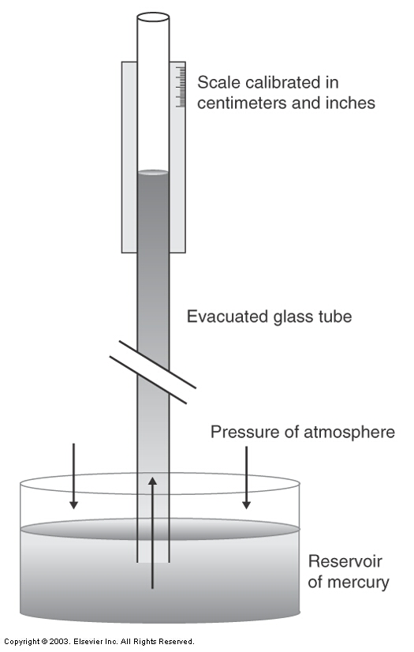
  - Pressure measuring instruments (Egan pages 106-107)
    - Measuring Atmospheric pressure
      - Mercury Barometer
        - Invented by Evangelista Torricelli in 1643
        - Measures atmospheric pressure against a mercury reservoir forces mercury up a tube the distance equivalent to the force exerted.
      - Aneroid Barometer
        - Sealed evacuated metal box with a flexible spring-supported top that responds to external pressure changes.
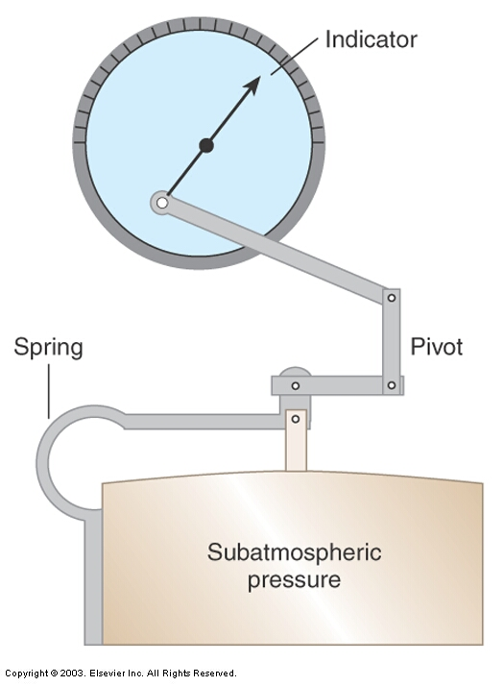
        - The motion activates a gear pointer, which provides a scale reading analogous to pressure.
    - Measuring Airway and Blood Pressures
      - Mechanical Manometer
        - Measures either an asolute (psia) reading or a gauge reading (psig)
        - One atmosphere can be expressed as 14.7 psia or 0 psig.
        - Pressure source is connected to the inside of this unit and the flexible chamber expands and contracts as pressure changes inside.
        - Commonly used to measure blood pressure and airway pressures.
          - Sphygmomanometer - mercury column used to measure blood pressure.
          - Water column (used for hemodynamics) - A water barometer can only be used for low pressures because water is less dense than mercury and the column would have to be too high.
      - Strain gauge (electronic and very accurate for hemodynamics) - pressure changes expand and contract a flexible metal diaphragm connected to electrical wires. Physical strain on the metal changes the amount of electricity flowing through the wires. Direct measurement of this change in electrical flow indirectly measures pressure changes.
    - Units of measure:
UNIT OF MEASURE | ONE ATMOSPHERE
Metric  mmHg | 760
Torr | 760
cm H₂O | 1034
ft H₂O | 33.9
British  lbs / in² or psi | 14.7
cmHg | 76
Standard International  kpa | 101.3
inHg | 29.9
millibar | 1014

    - Conversion between units of measure
      - Basic formula is
$\frac{\text{Given}(\text{Units})}{1}×\frac{\text{Unknown}(\text{Units})}{\text{Given}(\text{Units})}=\text{Unknown}(\text{Units})$
      - Example:
        - Convert 105 ft H₂O to pounds per square inch (psi).
$\begin{aligned}\frac{\text{Given}(\text{Units})}{1}×\frac{\text{Unknown}(\text{Units})}{\text{Given}(\text{Units})}=\text{Unknown}(\text{Units}) \\ \frac{{\text{105 ft H}}_{2}O}{1}×\frac{\text{14}\text{.}7\text{ psi}}{\text{33}\text{.}9{\text{ ft H}}_{2}O}=\text{45}\text{.}5\text{ psi}\end{aligned}$
        - Convert 96 cm H₂O to mm Hg.
$\begin{aligned}\frac{\text{Given}(\text{Units})}{1}×\frac{\text{Unknown}(\text{Units})}{\text{Given}(\text{Units})}=\text{Unknown}(\text{Units}) \\ \frac{{\text{96 cm H}}_{2}O}{1}×\frac{7\text{60 mm Hg}}{1{\text{034 cm H}}_{2}O}=\text{70}\text{.}6\text{ mm Hg}\end{aligned}$
  - Avogadro’s Law
    - Equal volumes of different gases under the same conditions of temperature and pressure contain the same number of molecules. (6.02 x 10 ²³)
    - In one mole of gas at STP, the volume (22.4 liters) and number of particles (6.02 x 10 ²³) are always the same.
    - The volume occupied by 1 mole of a gas is 22.4 liters and is known as the molar volume.
    - Even though the law states that equal volumes of different gases contain the same number of molecules, the composition of these molecules are different; some weigh more or less; they have different densities and masses.
Compound | Oxygen O₂ | Carbon Dioxide CO₂
Volume in Liters | 22.4 L | 22.4 L
Number of molecules | 6.02 x 10²³ | 6.02 x 10²³
GMW | 32 grams | 44 grams

  - Avogadro’s Number
    - Mole: A measure of mass for very small objects. Early chemists found the gram formula weight or gram molar mass so useful that they gave it a special name: the mole (Mol).
    - One mole of any pure substance contains the same number of particles as one mole of any other substance whether the particles are atoms, ions, or compounds.
    - The number of particles in 1 mole is referred to as Avogadro’s Number.
    - A mole contains 6.02 x 10²³ number of particles (atoms, molecules or formula units).
    - EXAMPLE:
SPACE TRAVEL | EGGS | COMPOUNDS & MOLECULES
Light years vs. miles | Dozens vs. each | Moles vs. amu or picograms
1 amu = 1.6606 x 10-24g (nearly mass of a proton or a neutron)
1 mol = molecular or formula weight (mass) in amu expresses in grams

    - One mole of any pure substance is equal to the gram molecular or gram formula weight (mass) of that substance.
      - Example: 1 mole of H₂O = 18 amu = 18 grams
    - Sometimes concentrations are so small that they are referred to in terms of millimoles.
      - 1 millimole = 1/1,000 of a mole (.001 Mole)
      - 1 mole = 1,000 millimoles
    - Molar volumes are measured under “standard conditions” which means a temperature of O° C and an ambient pressure of 1 atmosphere.
    - Molar Volume Of A Gas - One mole of gas (6.02 x 10 ²³ particles) always occupies 22.4 Liters at standard temperature and pressure (STP = O° C and PBARO of 760 mmHg).
    - Molar Volume will be used to calculate moles per volume and density (mass/volume) of gases.
substance | mass equals  (amu) | # of particles in one mole | type of particles
element | atomic weight / mass | 6.02 x 10 ²³ | atoms
molecular compound | molecular weight / mass | 6.02 x 10 ²³ | molecules
ionic compound | formula weight / mass | 6.02 x 10 ²³ | formula units

    - Calculation of Moles
$\begin{aligned}\text{of}\text{moles}=\frac{\text{ of grams of substance}}{\text{Gram}\text{ Molecular Weight }\left(g\text{mole}\right)} \\ \text{ of moles }=\frac{\text{106}\text{.}\text{5 g of chlorine }({\text{Cl}}_{2})}{\text{71 }g\text{mole}}=1\text{.}5\text{ moles}\end{aligned}$
  - Density Of Gas:
    - Density is expressed in g/L for gases.
      - Note: For liquids and solids it is g/mL.
    - For a Single Gas
      - $$\text{Density}=\frac{\text{GMW}}{\text{22}\text{.}4L}$$
      - Example: If the volume occupied by 1 mol. of O₂ at STP is 22.4 L, calculate the density of oxygen at STP.
$\text{Density}=\frac{\text{GMW}}{\text{22}\text{.}4L}=\frac{\text{32}g}{\text{22}\text{.}4L}=1\text{.}\text{43}gL$=
    - Density of a gas mixture
      - $\frac{\left[\left(\text{GMW}\text{ of gas \#1}×\text{\% of gas \#1}\right)+\left(\text{GMW}\text{of}\text{gas} | | 2×\text{\%}\text{ of gas \#2}\right)\right]}{\text{22}\text{.}4L}$Note - when multiplying % use either % on calculator or change % to decimal before multiplying)
      - Example: Determine the density of a helium/oxygen mixture that has 70% helium and 30% oxygen.
$\begin{aligned}\frac{\left[\left(\text{GMW}\text{ of gas \#1}×\text{\% of gas \#1}\right)+\left(\text{GMW}\text{of}\text{gas} | | 2×\text{\%}\text{ of gas \#2}\right)\right]}{\text{22}\text{.}4L} \\ \frac{\left[\left(4g\text{ of gas \#1}×0\text{.}7\right)+\left(\text{32}\text{ g of gas \#2}×\text{.}3\right)\right]}{\text{22}\text{.}4\text{ L}}=\frac{2\text{.}7g+9\text{.}6g}{\text{22}\text{.}4\text{ L}}=\frac{\text{12}\text{.}3\text{ g}}{\text{22}\text{.}\text{4 L}}=0\text{.}\text{55}gL\end{aligned}$
        - Note: Heliox (He/O₂ mixtures) must be at least 20% oxygen to support life and 70% helium to decrease WOB.
- Abbreviations
ABBREVIATION | DESCRIPTION | UNIT | EXAMPLE
P | Pressure or Partial Pressure | mmHg or Torr | PO2, PCO2, PN2, PH2O
P total | Total pressure in a gas mixture | mmHg or Torr | Total pressure in a gas cylinder
PB | Barometric or Ambient Pressure | mmHg or Torr | Measured with a barometer at the location
P atm | Atmospheric Pressure | mmHg or Torr | Measured with a barometer at the location
Pressure of one atmosphere | Pressure at sea level | mmHg or Torr | Measured with a barometer at sea level
PI | Pressure of an inspired gas | mmHg or Torr | PIO2, PICO2
PE | Pressure of an exhaled gas | mmHg or Torr | PEO2, PECO2
Gas % | % of total gas mixture | % | 21% O2
F | Fractional Concentration | % expressed as a decimal | FO2, FCO2
FI | Fractional Concentration of an inspired gas | % expressed as a decimal | FIO2, FECO2
FE | Fractional Concentration on an exhaled gas | % expressed as a decimal | FEO2, FECO2
PA | Partial pressure of gas in the alveoli | mmHg or Torr | PAO2, PACO2
Pa | Partial pressure of gas in the arterial blood | mmHg or Torr | PaO2, PaCO2
Pv | Partial pressure of gas in the venous blood | mmHg or Torr | PvO2, PvCO2
Pv | Partial pressure of gas in the mixed venous blood | mmHg or Torr | PvO2, PvCO2

