MODULE C: APPLIED PHYSICS
LESSON 4: Gas Laws

- Terminology
  - Adiabatic
  - Isothermic
- Gas Laws

  - Physical laws that describe the behavior of gases under changing conditions.
  - Supported by the Kinetic Molecular Theory.
  - Applies to most situations, EXCEPT
    - Extremely high temperatures.
    - Extremely low temperatures.
  - Compares four physical properties of gases:
    - Mass: The amount of matter.
    - Pressure: The force per unit area. Represented by the number of molecular collisions.
    - Temperature: The degree of molecular activity.
    - Volume: The space occupied by matter.

- BOYLE’S LAW - When the temperature and mass of a gas remains constant, the pressure exerted by that gas is inversely proportional to its volume.

  - Isothermic - constant temperature (is difficult to maintain.)
  - Adiabatic - temperature varies
  - Formula: $V_{1}×P_{1}=V_{2}×P_{2}$
    - Inverse relationship
      - If the pressure increases, the volume the gas occupies decreases.
      - If the volume decreases, the resulting pressure increases.
      - Example:
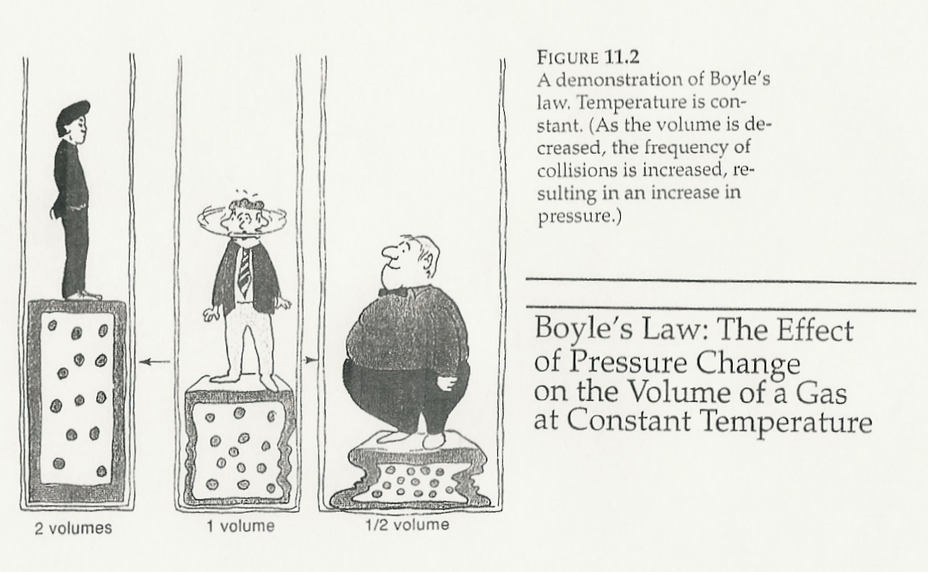
        - Closed syringe with plunger being pulled back.
        - Normal ventilation.
        - Body Plethysmography (Body Box) in PFT lab.

Sibberson page 17 - 19 Sample Problems Fourth Set & Practice #21 - 26 page 29

- $\frac{V_{1}}{T_{1}}=\frac{↑V_{2}}{↑T_{2}}$CHARLES LAW - When the pressure and mass of a gas remains constant, the volume of that gas is directly proportional to its absolute temperature.
  - Formula
    - Direct Relationship
      - If the temperature increases, the volume the gas will occupy also increases.
      - If the temperature decreases (molecular activity slows), the volume the gas will occupy also decreases.
      - Example:
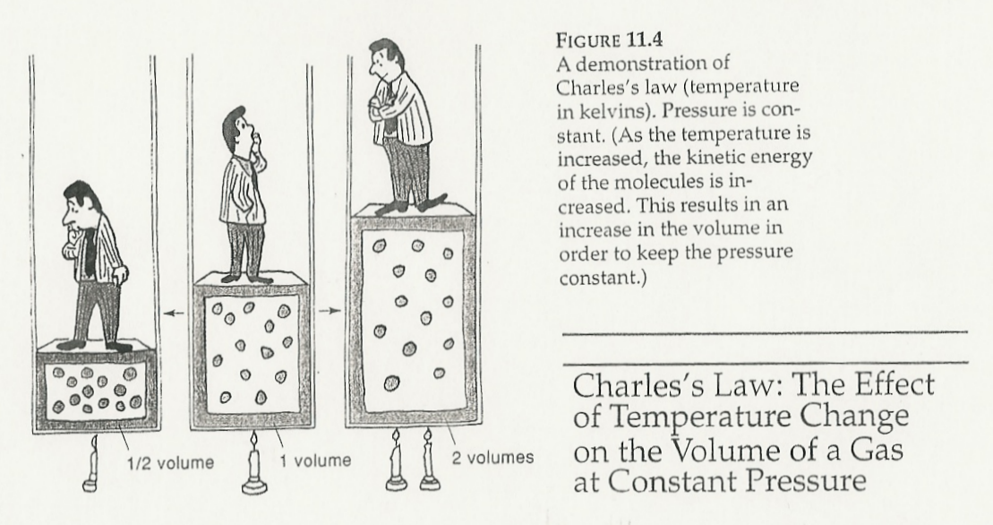
        - Balloon filled with room temperature air and placed in a refrigerator.
        - Pulmonary Function measurements measured at room temperature but estimating body temperature.
          - Requires a conversion from ATPS to BTPS.
    - Always change temperature to the Kelvin scale.
      - °Celsius (C) + 273° = °Kelvin (K)

Sibberson pages 19 - 20 Sample Problems Fifth Set & Practice Problems #27 - 32 page 29 & 30

- GAY LUSSAC’S - When the volume and mass of a gas remains constant, the pressure of that gas is directly proportional to its absolute temperature.
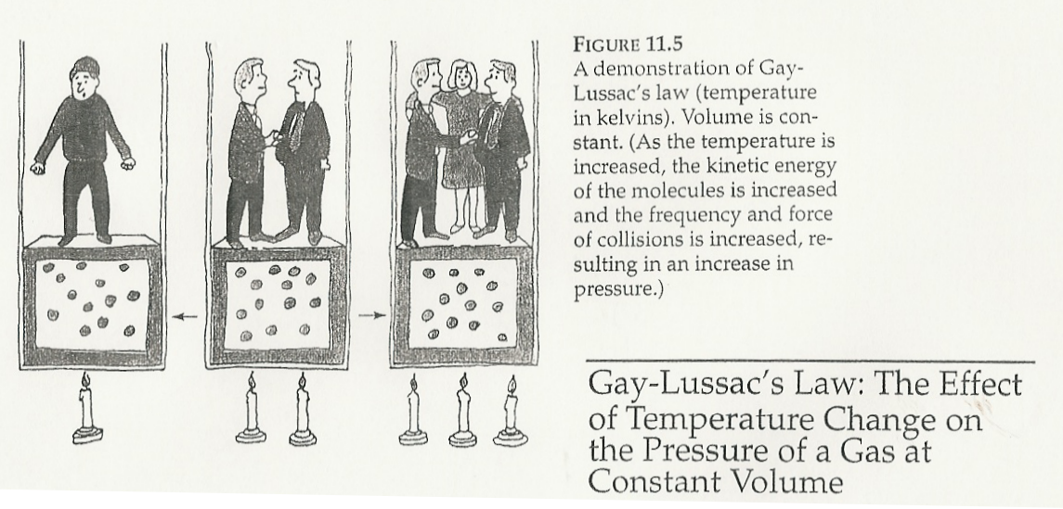
$\frac{P_{1}}{T_{1}}=\frac{↑P_{2}}{↑T_{2}}$
  - Formula
    - Direct relationship
      - If the temperature increases, the molecular activity increases and the number of molecular collisions increases and so will the pressure.
      - If the temperature decreases (molecular activity slows), the number of collisions goes down as does the pressure.
      - Always change temperature to the Kelvin scale.
        - °Celsius (C) + 273° = °Kelvin (K)
  - Examples
    - Gas cylinder storage
    - Bicycle/Car tires

- COMBINED LAW - Combination of above laws and used when T, P and V do not remain constant.

Sibberson pages 22 - 26 Sample Problems Seventh & Eighth Set &
Practice Problems 39 - 60 page 30 - 32
Workbook RSP 106 - E-1 Gas Laws Homework
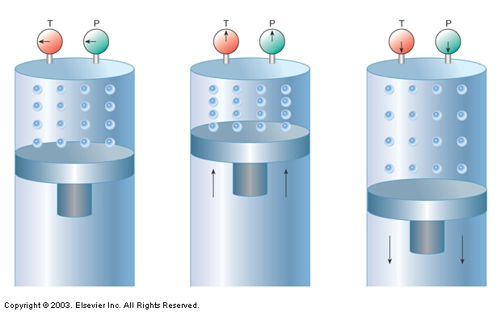
$\frac{P_{1}V_{1}}{T_{1}}=\frac{P_{2}V_{2}}{T_{2}}$
  - Formula

  - Mass is the only constant.
  - Always change temperature to the Kelvin scale.
    - °Celsius (C) + 273° = °Kelvin (K)
  - Always subtract water vapor from the given pressure.
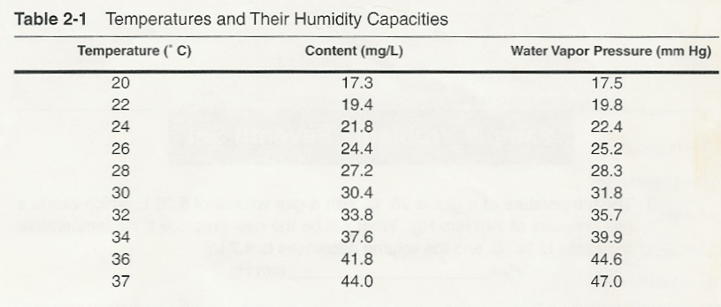
    - Use temperature and Humidity Chart.

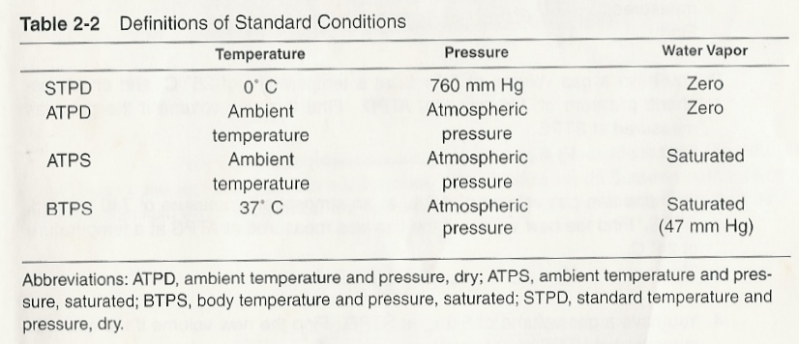
  - EXAMPLE: A gas is at 42° C and 760 mmHg pressure. It occupies 2.5 liters volume. The volume is changed to 2 liters and its temperature to 37° C. What will be the new pressure of the gas?

    - Step 1 Set up your table
    - Step 2 Change to Kelvin
    - Step 3 Subtract PH2O (if needed)
    - Step 4 Solve

P₁ (- P_{H2O}) 760 mmHg | P₂ (- P_{H2O}) UNKNOWN
V₁ 2.5 liters | V₂ 2 liters
T₁ (+ 273) 42°C + 273 = 315°K | T₂ (+273) 37°C + 273 = 310°K
$\begin{aligned}\frac{P_{1}V_{1}}{T_{1}}=\frac{P_{2}V_{2}}{T_{2}} \\ P_{2}=\frac{T_{2}×P_{1}×V_{1}}{V_{2}×T_{1}} \\ P_{2}=\frac{{\text{310}}^{∘}K×\text{760}\text{ mm Hg}×2\text{.}\text{5 \{}L}{2\text{.}0L×{\text{315}}^{∘}K}\end{aligned}P_{2}=\frac{\text{589},\text{000}}{\text{630}}\text{mm}\text{ Hg}=\text{934}\text{.}\text{93}≃\text{935 mm Hg}$

- $P_{1}V_{1}={\text{nRT}}_{1}$IDEAL (UNIVERSAL) LAW - The law gives you V, T & P plus one of the constants, and asks you to solve for the remaining constants.
  - Formula
Where n = Gram molecular weight (mass) and R = 22.4 L and contains 6.02 x 10²³ molecules (molar volume).
  - All parameters can vary
    - Pressure
    - Temperature
    - Volume
    - Mass
  - Used in situations where mass is varying.
  - Not used in Respiratory Therapy.

