MODULE C: APPLIED PHYSICS
LESSON 5: Gas Movement

- Terminology

  - Fluid
  - Flow
  - Flowmeter
  - Speed
  - Velocity
  - Law of Continuity
  - Viscosity
  - Friction
  - Density
  - Laminar
  - Turbulent
  - Reynold’s Number
  - Transitional
  - Tidal Volume
  - Minute Ventilation
  - I:E ratio
  - Inspiratory time
  - Expiratory time
  - Peak Inspiratory Flowrate
  - Bernoulli's Principle
  - Venturi Principle
  - Fluid Entrainment
  - Low Flow Oxygen Delivery Systems
  - High Flow Oxygen Delivery Systems
  - Air Entrainment Masks
  - FDO₂
  - Air-entrainment port
  - Jet Orifice
- Key Terms
  - Fluid - A substance that is capable of flowing and that changes its shape at a steady rate when acted upon by a force tending to change its shape and to assume the shape of its container. Includes both liquids and gases
  - Flow – The bulk movement of a substance through space.
    - Volume per unit of time.
    - Measured in L/min, L/sec, ml/min, ml/sec.
    - Flow occurs because of a pressure gradient.
      - This gradient is also known as the driving pressure.
    - Flow is measured with a device called a flowmeter.
    - When studying oxygen therapy, there will be three types of flowrates that you will measure:
      - Oxygen Flowrate as measured with an oxygen flowmeter;
      - Air Flowrate as measured with an air flowmeter or calculated;
      - Total Flowrate which is the sum of the prior two and is a calculated value.
  - Speed – The distance traveled per unit of time.
    - This is a scalar measurement involving only magnitude.
    - Measured in miles per hour, feet per second, centimeters per second, kilometers per hour.
  - Velocity - The rate at which an object changes position.
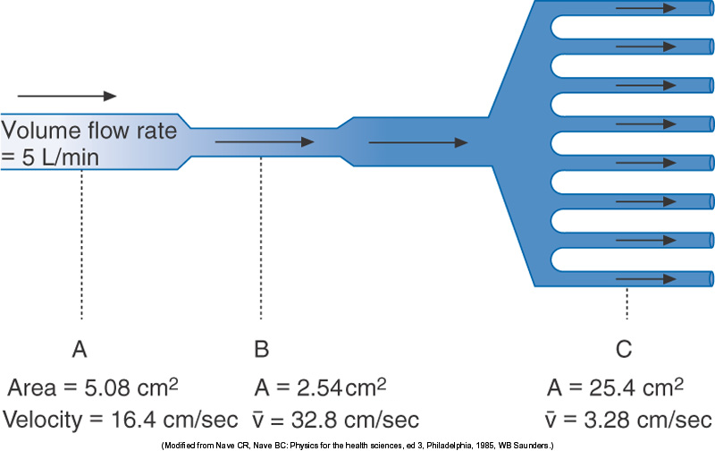
    - A vector quantity involving both magnitude and direction.
  - Law of Continuity - The velocity of a fluid moving through a tube varies inversely with the cross-sectional area.
    - As the cross-sectional area decreases, the velocity increases to maintain a constant flow.
    - You can determine the flow rate present if you know the cross-sectional area and the velocity.
      - $$\begin{aligned}\text{Cross}−\text{Sectional}\text{ Area}×\text{Velocity}=\text{Flow} \\ 5\text{.}\text{08}{cm}^{2}×\text{16}\text{.}4\text{cm}\text{sec}=\text{83}\text{.}\text{312}{\text{cm}}^{3}\text{sec} \\ \text{83}\text{.}\text{312}{\text{cm}}^{3}\text{sec}×\text{60}\text{sec}\text{min}=4,\text{999}\text{cc}\text{min}=5L\text{min}\end{aligned}$$
    - Example: A hose that is pinched results in an increased velocity to maintain a constant flow.
      - This follows the conservation of mass in that the amount of a fluid entering a tube must be the same as the amount leaving the tube.
      - This principle is used in jet and nozzles and clinically in nebulizers and gas entrainment devices.
  - Viscosity - The property of a fluid that resists the force tending to cause the fluid to flow.
  - Friction - Surface resistance to relative motion caused by the rubbing of one object or surface against another.
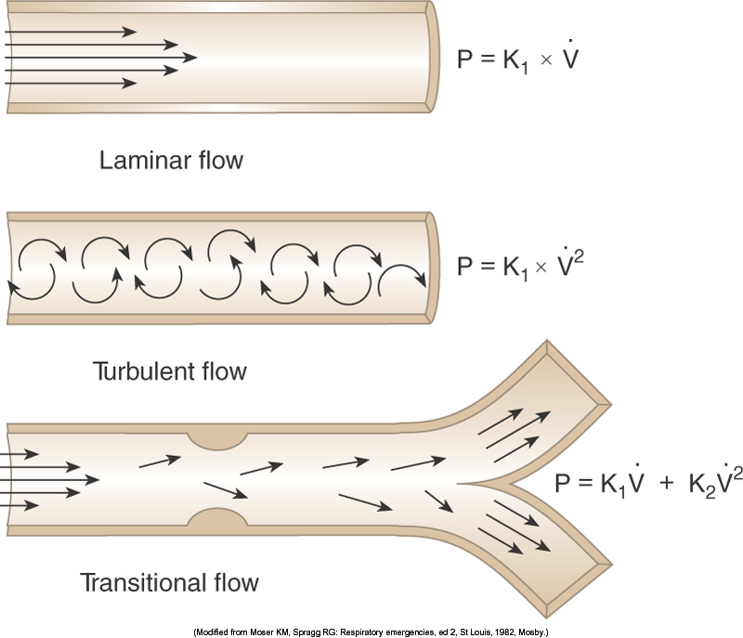
  - Density – Mass per unit of volume (mg/L).
  - Types of Flow – Three primary patterns of flow exist within the tracheobronchial tree:
    - Laminar - Smooth movement in a parabolic pattern through a smooth tube of fixed size.
      - The flow is present in layers (or lamina) that have the highest velocity in the center.
      - The parabolic shape is due to reduction in flow along the walls due to frictional resistance.
      - This is present when Poiseuille’s Law is applied.
        - The pressure required to produce a flow under these conditions is directly related to the viscosity, the length, and the flow rate present, and inversely related to the radius of the tube to a power of 4.
      - Present only in the most distal of airways.
    - $P=\frac{\overset{˙}{V}8ℓn}{{πr}^{4}}$Turbulent – Flow where the pattern is a loss of streamlines and the presence of multiple eddy currents in a chaotic fashion.
      - The presence of multiple flow patterns requires a higher driving pressure.
      - The change from a laminar flow to a turbulent one occurs at a Reynold’s Number of greater than 2000.
      - Reynold’s Number is a dimensionless measurement (no units) that is determined from the following factors:
        - $\text{Reynold's Number}=\frac{ν×d×\text{2r}}{h}$Linear velocity (v)
        - Density of the fluid (d)
        - Radius of the tube (r)
        - Viscosity of the fluid (h)
      - If you increase the radius, increase the velocity of the gas, reduce the viscosity, or increase the density of the gas, Reynold’s number will increase and flow will become turbulent.
      - Present in the upper airways.
    - Transitional – A flow which is a mixture of laminar and turbulent flow.
      - This is the type of flow which is predominant in the tracheobronchial tree.
  - Patient Flow Needs – The inspiratory flow rate varies between patients. Normally it is 30L/min but can be as high as 60-100 L/min. There are two methods of estimating the patient’s inspiratory flow rate and therefore the minimum flow needed by any device being used to provide gas flow to the patient.
    - ${\overset{˙}{V}}_{E}×\left(I+E\right)$, where I & E are the components of the I:E ratio.
      - Since the normal I:E ratio is 1:2, the minute ventilation is simply multiplied by 3.
    - $$\text{PIFR}=\frac{V_{t}}{t_{I}}×\text{60}$$
    - Example:
      - Minute Ventilation ${\overset{˙}{V}}_{E}$: 8 ^{L}/_{min}
      - Tidal Volume: 0.4 L
      - Respiratory Rate: 20 ^{breaths}/_{min}
      - Inspiratory Time: 1 sec
      - $$\text{Total}\text{ Flow }={\overset{˙}{V}}_{E}×\left(I+E\right)=8L\text{min}×3=\text{24}L\text{min}$$
      - $$\text{Total}\text{ Flow }=\frac{V_{t}}{t_{I}}=\frac{0\text{.}4\text{ L}}{\text{1 sec}}×\text{60}=\text{24}L\text{min}$$
  - Oxygen Therapy – If alveolar oxygen is reduced (and therefore arterial oxygen levels are reduced (hypoxemia), a simple method to increase the alveolar level of oxygen is to increase the fractional concentration of oxygen (FIO₂) being provided. There are four categories of oxygen delivery equipment available:
    - Low-Flow Oxygen Delivery Systems
      - These devices typically provide flows between ¹/₄ and 8 ^{L}/_{min}, which do not supply all the patient’s peak inspiratory needs. This means that additional flow must be made up by entraining room air which will cause the FIO₂ delivered to be variable.
      - FIO₂ will vary with the liter flow set on the flowmeter and the patient’s ventilatory pattern of breathing (V_{t}, f, regularity).
      - The actual flowmeter setting has nothing to do with if the device is a low- or high-flow system.
      - Examples of low-flow oxygen delivery systems include:
        - Nasal cannula
        - Nasal catheter
        - Transtracheal catheter (SCOOP)
      - Some authors include what Egan refers to as “Reservoir Systems” (simple mask, partial rebreather, and non-rebreather masks) as low-flow oxygen delivery systems.
      - These systems are also called variable-performance devices.
    - High-Flow Oxygen Delivery Systems
      - These devices provide a fixed oxygen concentration at a flow that equals or exceeds the patient’s peak inspiratory flowrate, thus ensuring a stable FIO₂.
      - Examples of high-flow oxygen delivery systems include:
        - Air-entrainment masks
        - Air-entrainment nebulizers
          - Devices that attach to a nebulizer include:
            - Aerosol masks
            - Trach masks
            - Briggs (T-) adapters
            - Face tents
        - Blenders
        - Dual flowmeters
          - Sometimes is may be necessary to blend oxygen and air together to obtain a desirable FDO₂. The formula is:
${\text{FDO}}_{2}=\frac{\text{Oxygen}\text{ Flow Rate}+(\text{.}2×\text{Air Flow Rate})}{\text{Total}\text{ Flow}}$
          - Example: If an air flowmeter is set at 6 L/min and the oxygen flowmeter is set at 2 L/min, calculate the FDO₂.
$\begin{aligned}{\text{FDO}}_{2}=\frac{\text{Oxygen}\text{ Flow Rate}+(\text{.}2×\text{Air Flow Rate})}{\text{Total}\text{ Flow}} \\ {\text{FDO}}_{2}=\frac{2+\left(\text{.}2×6\right)}{8}=\frac{2+1\text{.}2}{8}=\frac{3\text{.}2}{8}=\text{.}\text{40}\end{aligned}$
      - These systems are also called fixed-performance devices.
      - High-flow oxygen systems create the high flow rates through fluid entrainment.
        - The tube through which a flow of a source gas (typically oxygen) is altered by reducing the diameter.
        - The Law of Continuity states that as the cross-sectional area of a tube is reduced, the forward velocity increases.
        - Two methods of air entrainment are utilized in Respiratory Care:
          - Air-entrainment masks utilize jet mixing.
          - Air-entrainment nebulizers utilize the Bernoulli principle.
        - Jet Mixing
          - As the source gas proceeds through a narrowed opening (a jet), the forward velocity of the gas increases.
          - If a port is placed at the point of the jet opening (orifice), air can be entrained into and mixed with the flow of the source gas.
          - The amount of entrained air is regulated by either adjusting the jet orifice size or the size of the entrainment port.
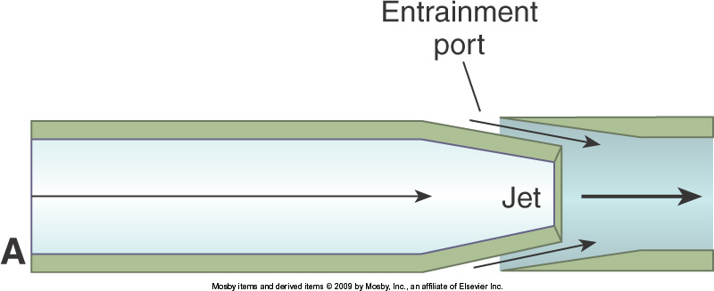
            - The larger the air-entrainment port, the more room air is entrained, and the lower the FDO₂ will be.
            - The smaller the air-entrainment port, the less room air is entrained, and the higher the FDO₂ will be.
            - The smaller the jet orifice, the more room air is entrained and the lower the FDO₂.
            - The larger the jet orifice, the less room air is entrained and the higher the FDO₂.
          - Precise concentrations can be attained by regulating the jet orifice size or the size of the entrainment port.
          - The ratio of the amount of air entrained to the source gas flow can be determined and used to calculate the total flow the system can create.
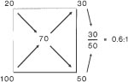
          - To determine the Air:02 ratio for each FDO2, use the MAGIC BOX (Egan pg. 883).
          - The total flow rate can be determined by multiplying the oxygen flow rate by the entrainment ratio and adding that value to the oxygen flow rate.
            - This value is called Total Flow.
          - If the Total Flow exceeds the patient’s inspiratory flow the device is considered a high-flow device and the FDO₂=FIO_{2.}
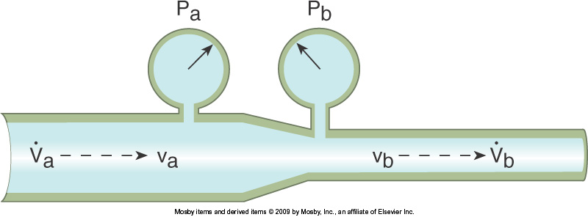
        - Bernoulli Effect – As fluid flows through a tube and meets a restriction, the forward velocity will increase and the lateral wall pressure will decrease.
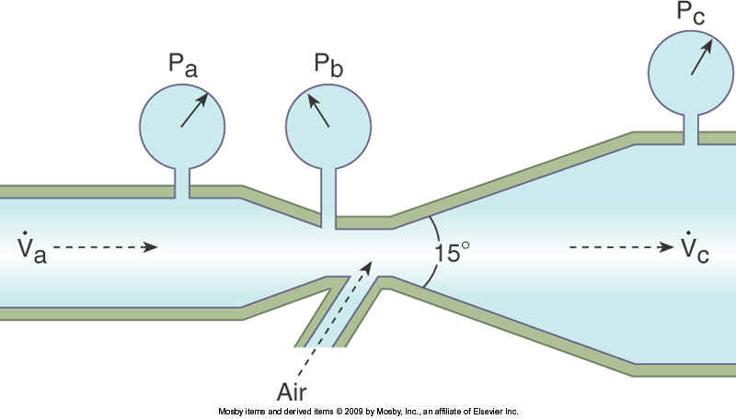
        - Venturi Principle: If gas flowing through a tube meets a small enough constriction, the pressure will drop to sub atmospheric and actually entrain a second gas (fluid).
    - Reservoir Systems
      - These devices have mechanisms where additional oxygen is stored between breaths and made available to the patient during the inspiratory phase.
      - Examples of reservoir systems include:
        - Reservoir nasal cannulas
        - Simple masks
        - Partial-Rebreather masks
        - Non-Rebreather masks
    - Enclosures
      - These devices provide a controlled-oxygen environment in which the patient is placed.
      - Examples of enclosures include:
        - Oxygen Tents
        - Hoods
        - Incubators

