MODULE C: APPLIED PHYSICS
LESSON 7: Thermodynamics and Humidity

- Terminology
  - Absolute zero
  - Heat
  - Calorie (cal)
  - Kilocalorie (Cal)
  - Specific Heat
  - Conduction
  - Convection
  - Radiation
  - Evaporation
  - Humidity
  - Vapor pressure
  - Water Content
  - Isothermic Saturation Boundary (ISB)
  - Absolute Humidity
  - Relative Humidity
  - Humidity Deficit
  - Saturated
  - Dew Point
  - Critical Temperature
  - Critical Pressure
  - Critical Point
- Temperature
  - Temperature is defined in multiple ways:
    - One method of quantifying matter.
    - How cold or hot an object is.
    - The amount of Kinetic activity.
  - Measurement Systems
    - °F = Fahrenheit (British)
    - °C = Celsius (Centigrade) (European)
    - °K= Kelvin (Standard International)
    - °R = Rankine (used in engineering; not in medicine)
  - Other Temperature Scales
    - Delisle (°D)
    - Newton (°N)
    - Réaumur (°Re or °R)
    - Rǿmer (°Rǿ)
  - Normal body temperature is 37°C (98.6°F).
    - Exercise can increase it to 100 - 103° F.
    - Individual daily patterns (diurnal variation) may cause 1 - 3 degree change in a day.
  - Temperatures to Know
 | °F | °C | °K
Absolute Zero | -460 | -273 | 0
Freezing of Water | 32 | 0 | 273
Body Temperature | 98.6 | 37 | 310
Boiling of Water | 212 | 100 | 373
  - Conversion
    - Conversion is often necessary from one system to the other.
    - The rules for rearranging formulas, canceling and (+) & (-) numbers will be used.
    - Conversions will be used at the patient bedside, in blood gas labs and pulmonary function labs
  - Formulas For Temperature Conversion
    - Universal
      - 5°F = 9°C + 160
    - Celsius to Fahrenheit
      - °F = 1.8(°C) + 32
      - °F = 9/5(°C) + 32
    - Fahrenheit to Celsius
      - °C = .555(°F-32)
      - °C = 5/9(°F-32)
    - Celsius to Kelvin
      - °K = °C + 273
    - Kelvin to Celsius
      - °C = °K - 273
    - If you must convert between Fahrenheit and Kelvin, convert to Celsius as an intermediate step.
- Heat
  - Heat is a form of kinetic energy that is transferred from a hotter object to a colder object when the two come in contact.
  - Most common form of energy is heat energy.
    - Heat energy is measured with the unit of a calorie.
      - A calorie (cal) is the amount of heat needed to raise 1 gram of water 1°C
      - Because that unit is so small, we often speak of heat energy as a kilocalorie.
        - The abbreviation for kilocalorie is Cal (capital “C”) or kcal.
        - On food label 1 kilocalorie = 1,000 calories (cal)
      - In the S.I. system 1 cal is equal to 4.184 joules.
      - Example:
        - 12g of sugar when burned yields 45 Cal (or 45 kilocalories or 45,000 cal) of heat energy.
      - Adult males need 3,000 Cal/day; adult females need 2,200 Cal./day.
        - The amount of calories in food depends on the substrate involved in metabolism.
          - For every 1 g of carbohydrate, 4 kcal of energy is produced.
          - For every 1 g of fat, 9 kcal of energy is produced.
          - For every 1 g of protein, 4 kcal of energy is produced.
        - Example:
          - A serving of 12 pretzel rods yields the following:
            - 1 g of fat
            - 22 g of carbohydrate (CHO)
- 3 g of protein.
How many calories are present per serving? $\begin{aligned}1g\text{of}\text{fat}×\frac{9\text{kcal}}{\text{gm}\text{of}\text{fat}}=9\text{kcal} \\ \text{22}\text{ g of CHO}×\frac{\text{4 kcal}}{\text{gm of CHO}}=\text{88}\text{ kcal} \\ \text{3 g of protein}×\frac{\text{4 kcal}}{\text{gm of protein}}=\text{12}\text{ kcal} \\ \text{Total kcal}=\text{109 kcal or 109,000 cal}\end{aligned}$
  - “Specific” heat
    - Definition: The amount of heat that will raise the temperature of 1 gram of a substance 1°C.
      - Originally described by Joseph Black, who also discovered carbon dioxide and the latent heats.
      - This allows for comparison between various substances:
        - Water = 1 cal/g x °C
        - Gold = 0.031 cal/g x °C
        - Iron = 0.106 cal/g x °C
      - Since the body is 60% water, it takes a larger transfer of heat to change body temperature.
      - This is why body temperature remains relatively stable.
- Heat Transfer
  - Heat moves from an object of higher temperature to an object of lower temperature in four ways:
    - Conduction
      - Transfer of heat by direct contact
      - The amount of heat transferred depends on the number of molecules present as well as the force of the collisions between the two surfaces.
      - The measurement of how much heat is transferred between two solid objects is known as thermal conductivity.
        - In general metals have high thermal conductivity, while gases have very low thermal conductivity.
          - Silver: 1.01 (cal/sec)/(cm²_{x}°C/cm)
          - Copper: .99
          - Glass: 0.0025
          - Asbestos: 0.0004
          - Fiberglass: 0.00015
          - Air: 0.000057
      - Solid objects like metal conduct heat away quickly
        - They have a high thermal conductivity and often feel cool to the touch as they remove heat from your hand.
    - Convection
      - Transfer of heat by mixing of fluid molecules
        - This primarily affects how heat is transferred in liquids and gases.
      - When fluids of different temperature come in contact with each other, the fluids (gases or liquids) mix in currents (called convection currents) or through the forced movement of the gas as occurs in most forced air heating systems and in convection ovens.
    - Radiation
      - Radiation involves the transfer of heat to a cooler, more distant object.
      - There is no direct physical contact between objects involved in this type of transfer.
        - Example:
          - Sun warming the Earth in a vacuum.
          - Conventional oven
      - The degree to which an object is successful at emitting radiation heat (called emissivity) is dependent on the surface area involved (larger yields more radiation heat transfer) and the surrounding temperature (lower yields more transfer).
    - Evaporation
      - Evaporation is a form of vaporization where liquid turns to gas and heat is taken away from the air surrounding the liquid.
      - This leads to a cooling of the surrounding air.
        - This is why we sweat in warm weather to produce a surface liquid which will evaporate and take away heat.
  - In the neonatal unit, the temperature of a newborn (especially a premature neonate) must be regulated very carefully and large swings in body temperature can be detrimental.
    - Newborn babies are kept warm by:
      - Drying them off (reduces evaporation)
      - Placing them in a preheated isolette or warmer (reduces radiation & conduction)
      - Keeping them out of drafty areas (reduces convection).
- Humidity
  - Definitions & Measurements
    - Humidity is water in a gas or molecular form, also called a vapor.
    - Humidity is measured with a device called a hygrometer or psychrometer.
      - The psychrometer is the simple form of the device where two thermometers measure temperature. One is kept wet (wet-bulb thermometer) and the other is dry. The device is swung around (sling psychrometer) on a handle and the two temperatures are measured. A comparison of the temperatures when exposed to an environment allows for computation of relative humidity.
    - Water Vapor Pressure is the measurement of the amount of water vapor present and is expressed in mm Hg.
    - Water Content is the measurement of the amount of water vapor present and is expressed as mg/L.
    - In the human body at 37° C and when the inspired gas is fully saturated, the water vapor pressure is 47 mm Hg and the water vapor content is 43.8 mg/L.
TEMPERATURE  (° C) | WATER VAPOR PRESSURE  (mmHg) | WATER CONTENT  (mg/L) | ATPS to BTPS Correction Factor
20 | 17.5 | 17.3 | 1.102
21 | 18.6 | 18.4 | 1.096
22 | 19.8 | 19.4 | 1.091
23 | 21.1 | 20.6 | 1.085
24 | 22.4 | 21.8 | 1.080
25 | 23.8 | 23.0 | 1.075
26 | 25.2 | 24.4 | 1.068
27 | 26.7 | 25.8 | 1.063
28 | 28.3 | 27.2 | 1.057
29 | 30.0 | 28.8 | 1.051
30 | 31.8 | 30.4 | 1.045
31 | 33.7 | 32.0 | 1.039
32 | 35.7 | 33.8 | 1.032
33 | 37.7 | 35.6 | 1.026
34 | 39.9 | 37.6 | 1.020
35 | 42.2 | 39.6 | 1.014
36 | 44.0 | 41.7 | 1.007
37 | 47.0 | 44.0 | 1.000

    - Absolute humidity is the actual measurement of the amount of water in a gas and is expressed in the units mg/L.
      - This is the content of water present in a gas mixture.
      - This value varies with the temperature and when fully saturated (100% saturation), is given by the third column in the chart above.
      - When a gas is not fully saturated, its content can be determined by multiplying the content from the chart by the percent saturation (relative humidity).
        - Example: Determine the content of a gas that is 50% saturated with water vapor at 37° C.
          - Water vapor content at 37° C = 43.8 mg/L and 47 mm Hg.
          - Content at 50% saturation at 37° C is 21.9 mg/L and would exert a partial pressure of 23.5 mm Hg.
    - Saturated - A gas containing the maximum amount of water it can possibly hold (100% humidity).
    - Relative Humidity (RH) – The relative humidity of a gas is the ratio of the actual amount of water vapor present (the content) to the maximum amount of water vapor that would be present at that temperature if it was fully saturated (the capacity).
      - $\text{\%}\text{RH}=\frac{\text{Content}}{\text{Capacity}}×\text{100}\text{\%}$The formula for RH is
      - $\begin{aligned}\text{\%}\text{RH}=\frac{\text{Content}}{\text{Capacity}}×\text{100}\text{\%} \\ \text{\%}\text{RH}=\frac{\text{19}\text{mg}L}{\text{24}\text{.}4\text{mg}L}×\text{100}\text{\%} \\ \text{\%}\text{RH}=\text{.}\text{779}=\text{77}\text{.}9\text{\%}\end{aligned}$Example:
        - What is the relative humidity of a gas at 26° C with an absolute humidity of 19 mg/L?
        - 77.9% RH
    - $\begin{aligned}\text{\%}\text{BH}=\frac{\text{Absolute}\text{Humidity}}{\text{Capacity}@\text{37}°C}×\text{100}\text{\%} \\ \text{\%}\text{BH}=\frac{\text{30}\text{mg}L}{\text{43}\text{.}8\text{mg}L}×\text{100}\text{\%} \\ \text{\%}\text{BH}=\text{.}\text{685}=\text{68}\text{.}5\text{\%}\end{aligned}$Body Humidity (BH) – The body humidity of a gas is the ratio of the actual amount of water vapor present (the content) compared to the maximum amount of water vapor that would be possible at body temperature and pressure where the capacity is 43.8 mg/L and at a pressure of 47 mm Hg.
      - Example:
        - What is the body humidity of a gas with an absolute humidity of 30 mg/L.
    - Humidity Deficit – The humidity deficit (HD) is the difference between the absolute humidity and the body humidity (43.8 mg/L @ 37° C) and is expressed in mg/L.
      - This is the amount of humidity the tracheobronchial tree has to make up to attain 43.8 mg/L and 47 mm Hg at 37° C at the Isothermal Saturation Boundary (ISB).
      - Humidity Deficit (HD) = Absolute Humidity (AH) - Body Humidity (BH)
      - Example:
        - What is the Humidity deficit of a gas with an Absolute Humidity of 19 mg/L.
$\begin{aligned}\text{HD}=\text{Absolute}\text{ Humidity-Body Humidity} \\ \text{HD}=\text{19}\text{mg}L−\text{43}\text{.}8\text{mg}L=−\text{24}\text{.}8\text{mg}L\end{aligned}$

  - The AARC Clinical Practice Guideline (CPG) on Humidification During Mechanical Ventilation recommends that inspired gas be warmed to 33 + 2° C and with a minimum of 30 mg/L of water vapor.
    - It is easy to see that this level will provide a humidity deficit of approximately 13.8 mg/L, which is usually not an issue for a well-hydrated patient to make up.

  - Factors affecting humidity levels
    - Multiple factors can affect the degree to which a gas is humidified. They include:
      - Temperature
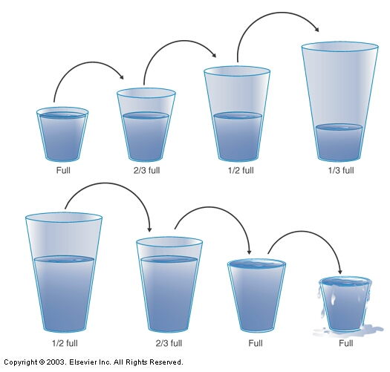
        - As temperature increases, the rate of evaporation increases and more water moves into gas as well as the gas can hold more water.
        - The top set of glasses shows the effect of increasing capacity without changing content, as would occur when heating a saturated gas.
        - The bottom set of glasses shows the effect of decreasing capacity, as when cooling a gas.
        - Note that the next to last class has become fully saturated.
        - The last glass has been oversaturated and temperature is such that water can no longer be held in the vapor form and condensation must occur. This is called the dew point.
        - Clinically this becomes important when we transport heated, moist gas from a humidifier to the patient’s airway. As it moves through a lower ambient temperature, it cools and condenses inside the circuit.
      - Pressure (altitude)
        - As pressure increases (decreases in altitude), the rate of evaporation decreases.
          - This is why water boils (evaporates) at a lower temperature as you rise in altitude and why cooking time is longer.
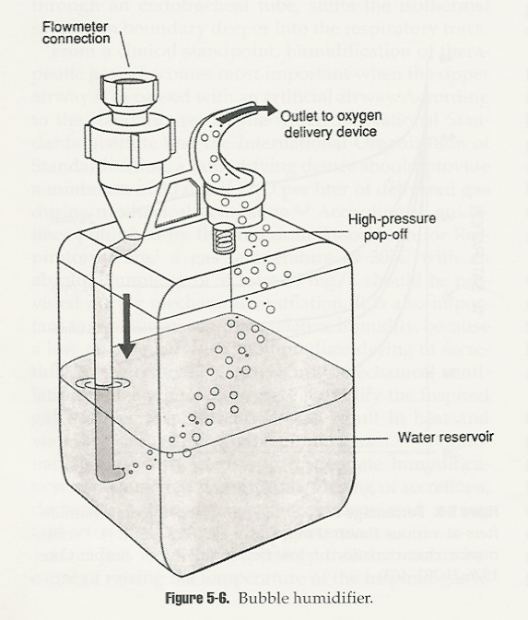
      - Surface Area
        - As you increase the surface area the gas comes in contact with a liquid (such as an increase in number and reduction in size of bubbles), the rate of evaporation will increase.
      - Exposure Time
        - An increase in exposure time means there is more time for evaporation to occur and means an increase in evaporation rate.
        - This is why the water level in any humidifier needs to be monitored.
  - Adverse effects of poor humidity
    - Multiple pathophysiological effects can result of reduced humidity delivery and significant humidity deficits. They include:
      - Decreased ciliary motility
      - Airway irritation
      - Increased mucus production
      - Thickening of secretions
      - Inspissated secretions (mucus plugging)
      - Destruction of airway epithelium
      - Atelectasis
- Critical Points

  - Every liquid has a temperature, above which, the kinetic activity is too great to keep the molecules at the surface from breaking free. This is the critical temperature.
  - The pressure at which equilibrium between the liquid and gaseous phases at the critical temperature is known as the critical pressure.
  - Together they are known as the critical point of a substance.
  - The importance of Critical Point is that this is the point at which a substance can no longer be held in the liquid phase, and conversion to a gas occurs.
  - In order to liquefy a gas (like oxygen) you have to two choices:
    - Cool it to below its boiling point (-183° C or -297° F) – or –
    - Cool it to its critical point (-118.8° C or -181° F and 49.7 atmospheres)
    - The more you cool it, the less pressure is needed.
  - The storage of oxygen in bulk systems or systems designed for portability is done with oxygen stored as a liquid.
  - These bulk oxygen systems store oxygen as a gas and allow the temperature to slowly rise (in a part of the device called a vaporizer) resulting in gaseous oxygen to escape.
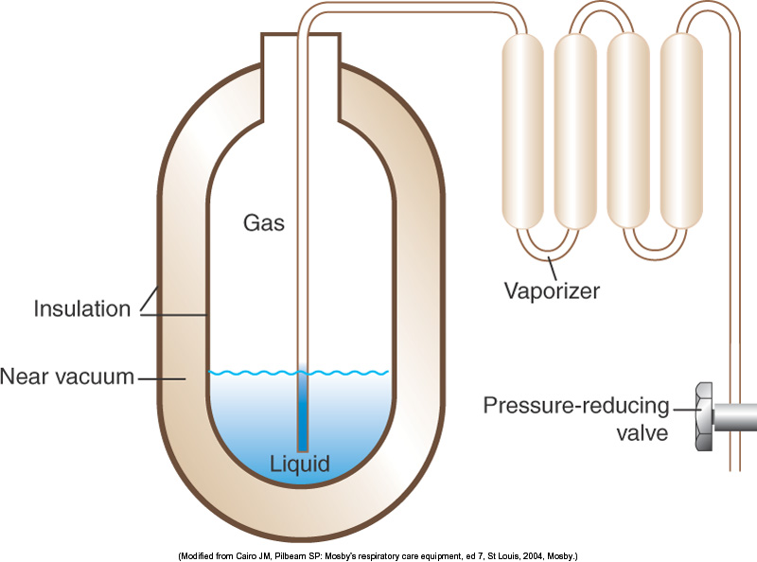
    - This means that a large amount of oxygen can be stored and used as needed by allowing the liquid to gradually warm.
  - For portable liquid systems, the amount of oxygen in the cylinder must be determined by weight.
  - Important conversion factors include the following:
    - 1 L of liquid oxygen weighs 2.5 pounds.
    - 1 L of liquid oxygen produces 860 L of gaseous oxygen when allowed to warm and expand.
  - To determine how long a container (cylinder) of liquid oxygen will last:
    - First determine the amount of gas in the cylinder by weighing it,
    - Convert that weight to the volume of liquid oxygen in liters,
    - Convert the volume of liquid oxygen in liters into the amount of gaseous oxygen in liters,
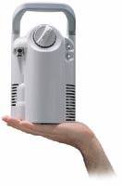
    - Determine the duration of the cylinder by dividing the amount of equivalent gaseous liters by the gas flow rate the oxygen delivery device is operating at.
    - Example:
      - $\begin{aligned}\text{Amount}\text{ of Gas in Cylinder}=\frac{{\text{Liquid O}}_{2}\text{ weight}×\text{860}}{2\text{.}5\text{lb}L} \\ \text{Amount}\text{ of Gas}=\frac{\text{5 lb}×\text{860}}{2\text{.}5\text{lb}L}=\frac{4,\text{300}}{2\text{.}5}=1,\text{720}\text{ L}\end{aligned}$You have a patient using a liquid oxygen cylinder who is planning to go Christmas shopping. She reports that her cylinder weighs 5 pounds and she has it connected to a nasal cannula running at 2 L/min. How long will the cylinder last?
$\begin{aligned}\text{Duration}\text{ of Cylinder}=\frac{\text{Amount}\text{ of Gas }}{\text{Flow}} \\ \text{Duration}\text{ of Cylinder}=\frac{\text{1,720 L}}{2L\text{min}}=\text{860}\text{ min}=\text{14 hours, 20 minutes!}\end{aligned}$

  - To determine the duration of a cylinder of gaseous oxygen it is a whole lot easier.
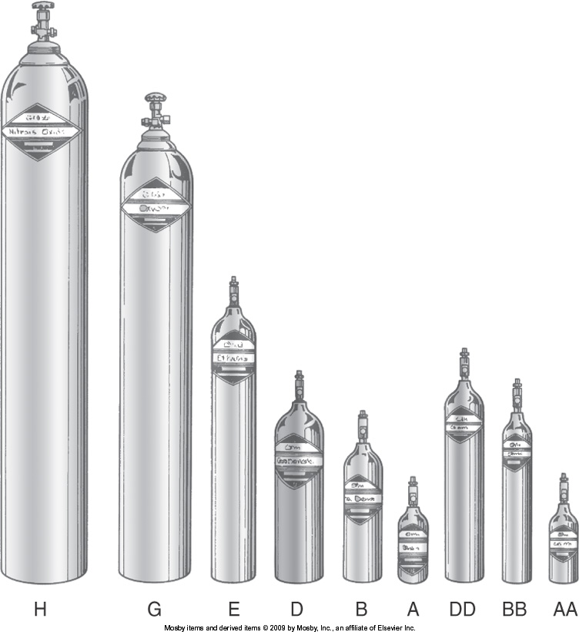
    - Gaseous oxygen comes in cylinders of various sizes.
    - In the hospital it typically comes in two sizes: E and H sizes.
    - You must know the cylinder factor for each size cylinder as follows:
      - E: 0.28
      - H: 3.14
    - The cylinder factor is determined by the amount of gas in each cylinder in liters (622 liters for an E cylinder and 6,900 liters for an H) by the maximum pressure of the cylinder which is 2,200 psig.
    - You then multiply the cylinder pressure by the appropriate factor and divide by the flow of oxygen powering the delivery device.
    - Example:
      - $\begin{aligned}\text{Duration}\text{ of Cylinder}=\frac{\text{Amount}\text{ of Gas }}{\text{Flow}} \\ \text{Duration}\text{ of Cylinder }=\frac{\text{Pressure }(\text{psig})×\text{Cylinder Factor}}{\text{Flow }(\text{L/min})} \\ \text{Duration}\text{ of Cylinder}=\frac{\text{1,500 psig}×\text{ 0}\text{.}\text{28}}{2L\text{min}}=\frac{\text{420}}{2}=\text{210}\text{ min}=3\text{.}5\text{ hours}\text{.}\end{aligned}$You have a patient using a liquid oxygen cylinder who is planning to go Christmas shopping. She reports that her E cylinder has 1,500 psig in it and she has it connected to a nasal cannula running at 2 L/min. How long will the cylinder last?

    - NOTE: Compare the two examples and you will see that a significantly longer period of time is available with a liquid system as opposed to a gas cylinder, which is why most patients prefer a liquid method of delivery as opposed to gaseous.

