RSPT 1210 FINAL REVIEW

- FETAL DEVELOPMENT
  - Fertilization occurs with the union of the sperm and egg (ovum) in the Fallopian Tube. The fertilized egg travels down the fallopian tube and attaches to the upper uterine wall. Duration of pregnancy is 40 weeks.
  - Development and Growth is divided into 3 distinct stages:
    - Ovum Stage - from conception to the implantation on the uterine wall. This takes 12 - 14 days.
    - Embryonic stage – From the end of ovum stage to the time the organism measures 3 cm from head to rump (54-56 days).
      - Major organ systems are developed. During this time the embryo is vulnerable to the effects of drugs, infections radiation and alcohol. Exposure can result in congenital malformation.
    - Third Stage - End of embryonic stage to the end of pregnancy.
      - The major organs are developed and now proceed to grow.
      - Fetus
  - Following Delivery
    - Neonate - delivery to 1 month
    - Infant - 1 month to 1 year
    - Child - older than 1 year
  - From the embryonic disc or blastoderm forms the three germ layers.
    - Ectoderm
      - Epidermis
      - Central and Peripheral Nervous System
    - Mesoderm
      - Connective Tissue, Muscles, Bones
      - Cardiovascular system
    - Endoderm
      - Respiratory tract
      - Digestive tract, bladder, thyroid
      - Liver and pancreas
  - There are five stages of lung development
    - Embryonic – 26 to 52 days
      - Lung bud begins to appear at about 26th day of gestation.
      - The diaphragm is complete at 7 weeks.
    - Pseudoglandular – Day 52 to Week 16
      - Bronchi & segmental bronchi form.
      - Submucosal glands, goblet cells, and smooth muscles appear.
      - Fetal breathing movements appear and these movements may serve as conditioning exercises for the respiratory muscles.
    - Canalicular - 17 to 28 weeks
      - Terminal and respiratory bronchioles form.
      - Capillary network appears.
      - Alveolar epithelium begins to differentiate into Type I and Type II cells
      - Surfactant first appears at approximately 24 - 26 weeks
    - Saccular Stage - 28 weeks to 36 weeks
      - Alveoli increase in number.
      - Surfactant production continues.
    - Alveolar - 36 weeks to birth
      - At term, there are approximately 30 - 50 million alveoli and this number will continue to increase after birth.
        - Additional alveoli can be added at any point after birth, but the number of airways never changes.
      - The surface area of the newborn lung is 3-4 meters square compared to 70 meters square in the adult.
  - Surfactant
    - Review 1050 notes.
    - Surfactant production is reduced with
      - Hypoxia
      - Shock
      - Hyperinflation
      - Hypoinflation
      - Acidosis
      - Mechanical Ventilation
      - Hypercapnia
      - Infants of Diabetic Mothers
      - Smaller of Twins
    - Surfactant production is increased with
      - Infants of Diabetic Mothers
      - Maternal Heroin addiction
      - Premature Rupture of Membranes
      - Maternal Hypertension
      - Maternal Infection
      - Placental insufficiency
      - Maternal administration of betamethasone or thyroid hormone
      - Abruptio Placentae
    - Lung maturity can be improved by administration of steroids to mother.
      - Administration of Glucocorticoids to women in premature labor increases the rate of lung maturity and decreases severity of RDS.
      - Fetus should be between 27 – 34 weeks gestation.
      - Must be given 48 hours prior to delivery.
      - Delivery has to occur within 7 days of administration; otherwise subsequent dose is needed.
  - Lung Fluid
    - During development, the lungs are filled with fluid. T
    - At term the lung is filled with 20-30 ml/kg of fluid that approximates the FRC. After birth the fluid is replaced by air.
    - This fluid is constantly being moved up into the trachea and mouth and is expelled into the amniotic fluid.
    - After birth, the lung fluid is removed by three mechanisms
      - Vaginal delivery - compression of a vaginal delivery results in squeezing out the fluid (25-33%).
      - Fluid is absorbed by pulmonary lymphatic system and into the bloodstream through the pulmonary capillary membrane.
      - Fluid evaporation.
    - Fetal lung fluid does not have the same composition as amniotic fluid. Lung fluid has a lower pH, lower protein and HCO₃⁻ and higher Na and Cl.
    - Failure to remove lung fluid after birth results in Transient Tachypnea of the Newborn (TTN). This occurs more often in C-Section Deliveries. TTN usually resolves in 24-48 hours.
  - Placenta and Umbilical Cord
    - Organ of respiration for the fetus.
    - It provides gas exchange, delivers nutrients to the fetus and removes waste products.
    - The normal placenta occupies 1/3 of the uterine surface and weighs 1 pound.
    - The umbilical cord is comprised of two umbilical arteries and one umbilical vein surrounded by Wharton's Jelly. The Jelly prevents the arteries and veins from being compressed.
  - Amniotic Fluid
    - The amnion is the sac that surrounds the growing fetus and contains the amniotic fluid.
    - At the end of 40 weeks there is approximately 1 liter of fluid (500 - 1500 mL).
    - The fluid is absorbed by fetal swallowing and is replenished by fetal urination and lung fluid.
    - Too much or too little amniotic fluid may indicate a problem with fetal development.
      - Too much amniotic fluid (>2,000 mL) is called polyhydramnios.
      - Its presence indicates a problem with the swallowing mechanism of the fetus. This may be caused from:
        - CNS malformation (Hydrocephalus, microcephaly, anencephaly, spina bifida)
        - Orogastric malformations (esophageal atresia, pyloric stenosis, cleft palate)
        - Down's Syndrome, Congenital Heart Disease, Diabetic Mothers, Prematurity
      - This may result in premature rupture of the membrane and a premature delivery
    - Too little amniotic fluid is called oligohydramnios. Causes are usually associated with a defect in the urinary tract.
    - The function of the amniotic fluid is:
      - Protection from traumatic injury
      - Thermoregulation
      - Facilitation of fetal movement
      - Dilation and effacement of the cervix
  - Assessing lung maturity
    - As lung fluid empties into the amniotic fluid, lung maturity can be monitored by amniocentesis. Test used include:
      - L/S ratio
      - Phosphotidlyglycerol (PG)
      - Phosphatidylinositol (PI)
        - The L/S ratio and the presence of PG is called the lung profile.
    - Lung maturity can be artificially accelerated by the administration of steroids (betamathasone and dexamethasone) to the mother. Giving steroids will not prevent the development of RDS but it will decrease severity.
  - Surfactant
    - The major composition of surfactant is phospholipids 85%, (DPPC or lecithin), protein (10%) and neutral lipids (5%) Phospholipids are: DPPC, PG, PI, Sphingomyelin.
  - Fetal Blood Flow - Pathway for most and least oxygenated
    - Three anatomic shunts in the fetus
      - Foramen ovale
      - Ductus venosus
      - Ductus arteriosus
    - The umbilical arteries carry deoxygenated blood to the placenta from the fetus.
    - The umbilical vein carries oxygenated blood from the placenta to the fetus.
    - Blood gases in the umbilical arteries and umbilical vein at term

 | Umbilical Artery | Umbilical Vein
pH | 7.36 | 7.39
PCO₂ | 43 | 37
PO₂ | 26 | 32

    - Sufficient oxygenation to the fetus does occur even though the PO₂ is low; the large maternal-fetal PO₂ gradient promotes the transfer of oxygen (maternal PO2 is 80 - 100 mm Hg). The fetus has increased hemoglobin levels and fetal hemoglobin (HbF) shifts the curve to the left so there is greater affinity. The oxygen saturation will be higher for any given PO₂.
- ASSESSMENT OF FETAL GROWTH/LABOR AND DELIVERY
  - HIGH RISK PREGNANCIES

    - AntePartum (Before Delivery)
      - Age of mother (< 16, >35)
      - Decreased social/economic status
      - Maternal diabetes
      - Bleeding in 2 or 3 trimester
      - Multiple gestations
      - Hypertension (pre-eclampsia)
      - Maternal infection
      - Maternal drug, alcohol, or cigarette abuse
      - Post-term gestation
      - Placenta previa
      - Family history of inherited disorders
      - Polyhydramnios
      - Oligohydramnios
    - Intrapartum (During Delivery)
      - Abnormal presentation
      - Cesarean section
      - Premature labor
      - Prolapsed cord
      - Abruptio placentae
      - Meconium staining
      - Rupture of membranes within 24 hours
      - Prolonged labor greater than 20 hours
      - General anesthesia/drugs
      - Foul smelling amniotic fluid
    - Preeclampsia: A rise in blood pressure greater than 30 mm Hg Systolic or 15 mm Hg diastolic during pregnancy. If not treated may develop to eclampsia.
    - Eclampsia: Occurrence of 1 of more convulsions not attributed to other cerebral conditions (epilepsy) in women. Usually between the 20th week and term. May be fatal if untreated.
  - HISTORY
    - Maternal History
      - Illnesses to identify include:
        - Diabetes
        - Problems with previous pregnancies
        - Alcohol use, smoking, or drug dependent
        - Medications
      - Prior pregnancies:
        - Gravida - Total number of pregnancies (including therapeutic and spontaneous abortions)
        - Parity - Total number of live born (delivered past 20 weeks)
      - Example:
        - Gravida 1, Para 0: Woman is pregnant for the first time.
        - Gravida 1, Para 1: Woman has delivered one child.
        - Gravida 1, Para 2: Woman has delivered twins.
      - Primigravida: Woman pregnant for the first time
      - Multigravida: Woman pregnant more than one time.
    - Family History
      - Familial history of prematurity or miscarriages.
      - Other children with respiratory problems
      - Presence of child who died from SIDS.
    - Pregnancy History
      - Illness during pregnancy.
      - Vaginal bleeding
      - Urinary tract infection
      - Vaginal infection
      - Trauma during pregnancy
    - Labor History
      - Maternal fever
      - High maternal WBC
      - Rupture of amniotic membrane for more than 24 hours
      - Foul smelling amniotic fluid
      - Fetal asphyxia
      - Fetal bradycardia
    - Delivery History
      - Method of delivery
      - Spontaneous versus forceps
      - Type of anesthesia
      - APGAR score
      - Postnatal History
  - MONITORING
    - During pregnancy, it is important to closely monitor the mother and fetus. Congenital disorders and/or asphyxia of the fetus can occur.
    - Asphyxia is a combination of hypoxia, hypercapnia and acidosis which may lead to irreversible damage to the brain and vital organs.
    - Asphyxia may result from:
      - Maternal hypoxia or asphyxia,
      - Decreased placental blood flow which impairs diffusion of gases,
      - Anemia of the fetus,
      - Drugs taken by the mother or given to the mother.
    - Asphyxia can occur in utero or during the delivery.
  - ASSESSMENT OF THE FETUS
    - Ultrasonography (Ultrasound)
      - Can be used to detect pregnancy at 5 weeks.
      - Ultrasound can be used for the following:
        - Identification of pregnancy
        - Identification of multiple fetuses
        - Observance of poly- and oligohydramnios
        - Determination of appropriate fetal growth
        - Detection of fetal anomalies
        - Determination of placental abnormalities
        - Location of placenta and fetus for amniocentesis
        - Determination of fetal position
        - Determination of fetal death
        - Examination of fetal heart rate and respiratory effort
        - Detection of incomplete miscarriages and ectopic pregnancies.
    - Amniocentesis
      - Can be performed before 15 weeks (early amniocentesis) but more commonly during the second and third trimester.
      - Complications include hemorrhage, trauma and infection and the fetus, placenta or umbilical cord could be punctured.
      - Tests which can be done include:
        - L/S ratio
        - Presence of PG
        - Creatinine (used to assess kidney maturity)
        - Alpha Fetoprotein (AFP). Alpha fetoprotein is the main serum protein in the developing fetus. Whenever there is a break in the fetal skin, the protein is released into the amniotic fluid. Elevated levels usually indicate a neural tube defect (brain or spinal cord).
        - Bilirubin. Bilirubin is created from the breakdown of RBC (hemolysis)
        - Rh incompatibility
        - Detection of meconium. Meconium is the thick, dark greenish stool found in the fetal intestine. Asphyxia causes relaxation of the anal sphincter and the release of the meconium into the amniotic fluid. This is most commonly seen in post-term infants greater than 42 weeks gestation.
        - Cytological examination of cells
    - Fetal Heart Rate Monitoring/Monitoring of Uterine Contractions
      - Fetal Heart Rate (FHR) can be monitored by a stethoscope or by electronic monitors and is usually monitored with the contractions during labor and delivery.
      - Signs of Fetal Distress are:
        - Presence of meconium in the amniotic fluid
        - Loss of beat-to-beat variability in the FHR
        - A FHR of greater than 160 beats/min or less than 100 beats/min
        - A drop in FHR between contractions (late decelerations)
      - Normal Heart Rate of the fetus is 120 - 160/min.
      - A loss of 20-30 beats/min may indicate a problem even if the heart rate is in the normal range.
      - Heart Rate Variability is normal in fetus. Expect to see 5-10 beat/min variability. Loss of this variability may indicate a problem.
      - Bradycardia is a heart rate less than 100/min or a drop of 20/min from the baseline. The most common cause of bradycardia is asphyxia and the mother should be given supplemental oxygen.
      - Tachycardia is a FRH greater than 160/min and the most common cause is maternal fever or infection of the fetus or mother.
      - During delivery, a fetal heart rate of greater than 160/min for less than 2 minutes is called “acceleration”. Accelerations during labor are a good sign that the fetus is reacting to the contraction.
      - If the heart rate drops below 120/min it is called a deceleration. Decelerations should be correlated with contractions and may be harmless or may indicate a problem.
        - There are three types of decelerations:
          - Early or Type I: Early or Type I decelerations closely follow uterine contractions. The FHR may drop to 60-80/min during the contraction rapidly returning to baseline following the contraction. This is caused by compression of the fetal head against the cervix and is a parasympathetic response and not indicative of hypoxia.
          - Late or Type II: Late or Type II decelerations do not follow uterine contractions. They occur following the onset of the contraction and the heart rate does not return to baseline until after the contraction is over. They indicate fetal asphyxia.
          - Variable or Type III: Variable or Type III decelerations are independent of uterine contractions. They are random in their onset, duration and severity. Type III decelerations are usually secondary to compression of the umbilical cord leading to asphyxia. Alleviation of cord compression is accomplished by turning the mother from side to side or by assuming a knee chest position.
    - Fetal Blood Gas Monitoring
      - Cordocentesis is the in utero sampling of fetal umbilical cord blood. Sampling is done to detect:
        - Fetal hemoglobin levels
        - Infections
        - Growth retardation
        - Decreased platelets
        - Genetic disorders
        - Fetal Scalp pH - Normal fetal blood pH is greater than 7.25. A pH of 7.2 - 7.24 shows slight asphyxia. A pH of less than 7.2 signifies severe asphyxia.
  - ESTIMATING THE DELIVERY DATE
    - The delivery date is called the Estimated Date of Confinement (EDC). Multiple methods that are used to estimate the EDC:
      - Nagele’s Rule – (Most common)
        - 3 months are subtracted from the first day of the last menstrual period.
        - Seven days are then added to the result.
        - Example:
          - The first day of the last menstrual cycle was December 5.
          - Subtract 3 months which is September 5
          - Add 7 days gives an EDC at September 12.
      - Quickening: The first sensation of fetal movement experienced by the mother. It generally occurs between 16 - 22 weeks with an average of 20 weeks.
      - Ultrasound: Ultrasound can be used to determine gestational age.
      - Fundal Height: Fundal Height is measured on the mother’s abdominal wall as it grows with the fetus. It is only reliable during the 1st and 2nd trimester. A tape measure is used to measure the distance from the symphysis pubis to the top of the fundus. Ex: 20 cm indicates 20 weeks gestation
  - STAGES OF LABOR
    - There are three stages of labor:
      - Stage I
        - Begins with the onset of the first true contraction.
        - Contractions come in waves gradually increasing in strength.
        - The first contractions are 10 minutes apart and last 30-90 seconds.
        - With the onset of Stage I, the cervix begins to thin and stretch which is called effacement and widen which is called dilatation.
        - Dilation is measured in centimeters and the cervix is fully dilated at 10 centimeters.
        - Stage I ends when the cervix is fully dilated.
        - Stage I averages 7-12 hours for multigravida and 16-18 hours for primigravida.
      - Stage II
        - Stage II is the actual delivery of the fetus.
        - 95% of all deliveries occur with the fetus in a head down or vertex position.
        - This stage lasts from 20 minutes to 2 hours.
      - Stage III
        - Stage III is the expulsion of the placenta. This takes 5 to 45 minutes.

  - PREMATURE LABOR
    - The process of stopping labor is called tocolysis. This is accomplished by the use of beta-sympathomimetic drugs which relax smooth muscle contractions
      - Terbutaline
      - Albuterol
      - Ritodrine (Yutopar)
      - Magnesium sulfate
      - Nifedipine
  - DYSTOCIA
    - Dystocia is a prolongation of labor secondary to uterine, pelvic or fetal factors.
    - Dystocia is present when the first and second stages of labor exceed 20 hours or if the second stage exceeds 2 hours in primigravida or 1 hour in multigravidas.
    - As the length of labor increases, the morbidity and mortality increase for three reasons:
      - Abruptio placenta
      - Compression of the umbilical cord
      - Risk of infection rises significantly if the amniotic membrane has been ruptured for more than 24 hours.
    - Causes of Dystocia include:
      - Uterine dysfunction
      - Abnormal fetal presentation
      - Excessive fetal size
      - Hydrocephalus
      - Abnormality in size or shape of the birth canal
    - Any presentation other than vertex is abnormal.
      - Breech presentation is the most common of all abnormal presentations and accounts for 3.5% of births. Breech means buttocks are down.
      - Other presentations include brow, face, shoulder or transverse lie.
      - Three types of breech presentation:
        - Complete breech - feet, legs and buttocks all present together
        - Incomplete breech or footling
        - Frank breech - buttocks is the presenting part.
  - PROBLEMS WITH THE UMBILICAL CORD
    - Prolapse of the umbilical cord is when the umbilical cord passes through the cervix into the birth canal ahead of the presenting part. The cord is easily compressed between the fetus and pelvis.

  - PLACENTAL ABNORMALITIES
    - When implantation of the placenta occurs in the lower portion of the uterus it is called placenta previa.
      - Low implantation - does not cover the cervical opening
      - Partial placenta previa - covers a portion of the cervical opening
      - Total placenta previa - completely covers the opening of the cervix.
    - Abruptio Placentae - any time a normally attached placenta separates prematurely from the uterine wall, it is called abruptio placentae. This causes labor to begin.
      - Maternal mortality is 2 - 10%
      - Fetal mortality is 50% due to blood loss.
      - Most common reason for this is preeclampsia and eclampsia

  - BIRTH

    - The first breath is attributed to stimulation of chemorecepters which detect changes in PaO₂ and PaCO₂. The asphyxia caused by the placental detachment from the uterus causes a decrease in PaO₂ and an increased PCO₂. These changes stimulate the chemorecepters in the aorta and carotid arteries.
    - Recoil of thorax. As the thorax passes through the birth canal during vaginal delivery, it is compressed. As the thorax exits the birth canal, the natural recoil of the thorax creates a negative pressure in the thoracic cavity causing air to enter the lungs
    - Environmental Change. As the fetus passes from an environment of darkness and warmth into a bright, loud and cold environment, it initiates a cry reflex.
    - The infant must generate -40 to -80 cm H₂O pressure to open and expand the alveoli. Pressures will continue to fall as FRC is established. Surfactant must be present to prevent the alveoli from collapsing. At birth the normal lung compliance is 2 mL/cm H₂O and will increase to the normal lung compliance on an infant which is 4-6 mL/cm H₂O.
    - There must be a change from Fetal to Adult Circulation.
      - Shortly after birth, the umbilical cord is clamped and blood flow no longer goes to the placenta but must perfuse the lower extremities. This increases SVR and raises the blood pressure. This pressure is relayed back to the left atrium and closes the foramen ovale. The high PaO₂ causes pulmonary capillary vasodilation which results in reduced pulmonary vascular resistance.
      - Right before birth the ductus arteriosus develops smooth muscle which remain relaxes by the presence of prostaglandins. After birth the high PaO₂ inhibit the prostaglandins and allows the smooth muscle to constrict, closing it. The ductus arteriosus is closed 12 hours after birth.
      - After the umbilical cord is clamped, there is no blood flow through the umbilical arteries, veins and ductus venosus and these vessels constrict and become ligaments.

Definition of Terms

    - Anencephaly – absence of cerebral hemisphere. This is incompatible with life.
    - Myelomeningocele – Spina bifida. Protrusion of the spinal cord and its membrane (meninges) through a defect in the vertebral spinal column.
    - Down’s syndrome – Trisomy 21. The presence of an extra chromosome 21. Infants tend to be placid, rarely cry, and have muscular hypotonicity. Mental and physical development is retarded.
    - Hydrocephalus – Increased amounts of cerebral spinal fluid in the cranial vault which dilates the brain and increases intracranial pressure. This can lead to atrophy of the brain.
    - Cleft Palate – malformation of the facial bones (soft and hard palate) which interferes with feeding and speech.
    - Atresia – congenital absence or closure of a normal body opening or tubular structure (e.g. esophageal atresia).
- POST-DELIVERY ASSESSMENT

  - Apgar Score
SIGN | SCORE 0 | SCORE 1 | SCORE 2
Heart Rate | Absent | Slow; less than 100/min | Over 100/min
Respiratory Effort | Absent | Slow; irregular or signs of hypoventilation | Good; Crying
Muscle Tone | Flaccid; Limp | Some Flexion; Hypotonia | Active Motion; Well Flexed
Reflex Irritability | No Response | Grimace | Cough, Sneeze, Vigorous Cry
Color | Blue, Pale | Body Pink, Extremities Blue; Acrocyanosis | Completely Pink
Scoring:
0-3: Need for full resuscitation
4-6: Support the infant with bag/mask ventilation/O2/Warm
7-10: Monitor, warm, the baby can be given to the mother

  - Dubowitz Score: Assessment of gestational age. Helps differentiate premature from those small for gestational age. There are 10 physical findings and 10 neurological findings. Not currently used.
  - Ballard (Modified Dubowitz): This is a modification of the original Dubowitz scoring system. Uses 6 neuromuscular findings and 6 physical findings. A score of 40 correlates with a gestational age of 40 weeks. A score of less than 35 indicates prematurity and a score greater than 45 indicates a post term infant.
  - Silverman/Anderson Index: This scoring method evaluates the respiratory status by observing the degree of respiratory distress. Five factors are evaluated:
    - Upper chest retractions
    - Lower chest retractions
    - Xiphoid retractions
    - Nares dilation
    - Expiratory grunting
The scoring system is reversed from the Apgar Score.
      - 0-3: Indicates no distress
      - 4-7: Mild/moderate distress
      - 8-10: Severe distress

- CLASSIFICATION OF NEWBORNS BY BIRTH WEIGHT AND GESTATIONAL AGE

  - Terminology
    - Preterm: Infants born before 38 weeks (these infants should be observed carefully for signs of RDS, even if their birth weight is normal).
    - Full Term: Infants born between 38 - 42 weeks
    - Post Term: Infants born after 42 weeks
  - Assessing Birth Weight
    - Small for gestational age
    - Large for gestational age
    - Appropriate for gestational age
    - Use height, weight and head circumference

  - Converting Birth Weights
    - 1 kilogram = 1,000 grams
    - 1 kilogram = 2.2 lbs
    - Example: A 5.5 lb infant weighs how many kilograms? How many grams?
$\frac{1\text{kg}}{2\text{.}2\text{lbs}}x5\text{.}5\text{lb}=2\text{.}5\text{kg}\text{ or 2500 grams}$
    - Example: A 1.5 kg infant weighs how many grams? How many pounds?
    - 1.5 kg = 1500 grams
$\frac{2\text{.}2\text{lbs}}{1\text{kg}}x1\text{.}5kg=3\text{.}3lb$
  - High Risk Delivery

    - If a high-risk delivery is anticipated, the baby may suffer from asphyxia.
    - Asphyxia can occur in utero, during or after delivery.
    - Asphyxia is a combination of hypoxia, hypercapnia, acidosis & hypotension that may lead to irreversible damage to the brain and vital organs.
    - Asphyxia may be caused from:
      - Maternal hypoxia or asphyxia.
      - Decreased placental blood flow which decreases diffusion of oxygen and CO₂.
      - Anemia of the fetus.
      - Drugs taken by or given to the mother.
    - Decreased oxygen levels will cause the fetus or newborn to begin deep, rapid respirations followed by a period of apnea. This is called primary apnea. Heart Rate and Blood Pressure decrease. If the newborn is in primary apnea, giving the baby oxygen and providing tactile stimulation will result in increased respirations.
    - Following primary apnea, the infant will begin irregular, gasping respirations followed by a second period of apnea. This is called secondary apnea. Heart Rate and Blood Pressure continues to fall. If the newborn is in secondary apnea, the baby will not respond to tactile stimulation and oxygen therapy. Bag-mask ventilations must be started with 100% oxygen.
    - When a baby is born apneic, if is often difficult to tell if they are in primary or secondary apnea. You must assume you are dealing with secondary apnea and begin resuscitation immediately.
- DELIVERY OF THE NEWBORN INFANT

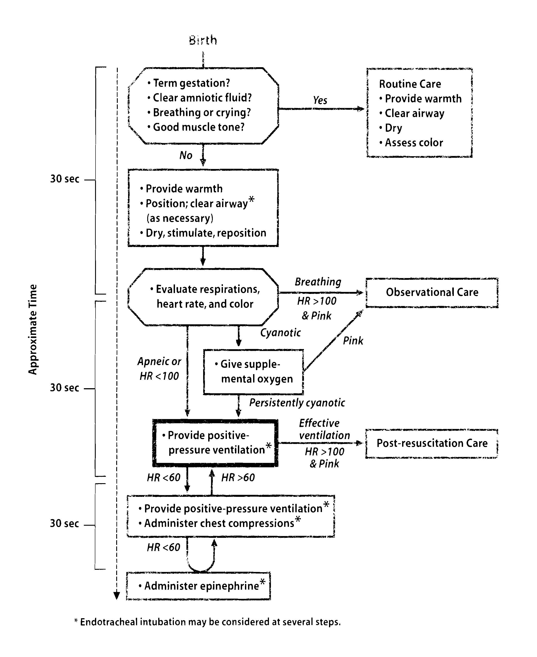
  - Warm the Infant immediately after delivery to prevent heat loss.
    - Dry infant with warm towels.
    - Place the infant under a pre-heated, radiant warmer.
  - Position the infant and open the airway. Avoid hyperextension or underextension of the neck. You may place a rolled blanket or towel under the shoulders elevating them ¾ to 1 inch off the mattress.
  - Suction the mouth and nose with a bulb syringe. The mouth should be suctioned first then the nose.
  - Provide tactile stimulation.
    - If the baby is not breathing, additional stimulation should be used.
      - Rub the infants back (spine).
      - Slapping or flicking the soles of the feet.
  - Evaluate respiratory rate.
    - If respirations are absent or slow, begin bag mask ventilation with 100% oxygen.
    - If the respiratory rate is adequate, or after bag mask ventilations have been started, evaluate Heart Rate.
  - Evaluate the heart rate.
    - The heart rate should be between 100 - 160/min.
    - If the heart rate is less than 100/min, begin bag/mask ventilation with 100% oxygen.
    - If the heart rate is less than 60/min and not responding to bag/mask ventilation, begin chest compressions.
  - Evaluate Color.
    - If the heart rate and respiratory rate is adequate, evaluate color.
    - If the infant is cyanotic, administer oxygen.
  - Medications
    - If heart rate is less than 60 and chest compressions are started, the next step is to deliver appropriate medication.
    - The first drug is epinephrine
      - Use a 1:10,000 solution.
      - 0.1-0.3 mL/kg.
    - Other drugs include:
      - Volume Expanders: Used if patient is losing blood or hypovolemic use whole blood, plasma, normal saline, or a solution of Ringer’s Lactate.
      - Naloxone: Used if patient is depressed from narcotic drugs given to the mother.
      - Sodium Bicarbonate: Used if metabolic acidosis is present.
  - Administration of Oxygen
    - Some debate about whether to use 100% oxygen, room air, or some intermediate level. NO CONSENSUS. If central cyanosis (lips & mucous membranes), definitely use
  - Meconium Stained Infants
    - If there is meconium in the amniotic fluid, once the baby is born, the infant will be intubated and suctioned with a meconium aspirator until no more meconium is aspirated from the lungs. Then tactile stimulation and/or bag mask ventilation may be started. The endotracheal tube is used as a suction catheter because the suction catheters are too small to suction the large particles seen in meconium aspirations. Only 10% of meconium stained babies actually aspirate.
  - Infant Resuscitation Bags
    - Capacity: Infant: 240 – 250 mL; Child: 500 mL
    - Pop-off: 35-40 cm H₂O
    - Proper Assembly: Occlude connection and pop-off and check for resistance.
    - FIO₂ is influenced by
      - Liter flow
      - Oxygen reservoir
      - Stroke volume
      - Respiratory rate
      - Recovery time (refill time) response time
    - Use pressure manometer to check pressures

Bag-Mask Ventilation

Observe chest rise and fall. Absence of chest rise and fall and no breath sounds indicate you are not ventilating the infant.

Inability to adequately ventilate the neonate can be caused by:

Improper bag-mask assembly (bags should be checked prior to using).

Inadequate seal of the mask.

Improper head position.

Airway obstruction (secretions or foreign body obstruction).

Gastric distention (place gastric tube).
    - If diaphragmatic hernia is suspected, an endotracheal tube should be placed to prevent any further gastric distention.
    - If choanal atresia is suspected, an ET tube should be placed.

ET tubes
    - Uncuffed ET tubes can be used in children under 8 years of age.
    - ET Tube Size (Use ID in mm)
      - Premature Infant: 2.5 mm to 3.0 mm.
      - Term Infant: 3.0 to 3.5 mm.
      - 6 months: 3.5 to 4.0 mm.
      - 1-2 years: 4.0 to 4.5 mm.
      - Children: Use formula for children greater than 1 year of age.
$$\text{ID of uncuffed ET tube }=\frac{\text{16 }+\text{ age in years}}{4}$$
  - Intubation
    - Vocal Cord Guide is the black ring around the ET tube. The vocal cord guide should be positioned at the level of the vocal cords.
    - Straight laryngoscopes blades are preferred.
      - Size 0 blade for premature babies.
      - Size 1 blade for term
    - 123, 789 Rule
      - 1 kg - 7 cm at lip line
      - 2 kg - 8 cm at lip line
      - 3 kg - 9 cm at lip line
    - Intubation should be limited to 20 - 30 seconds.
    - Equipment
      - ET tubes
      - Laryngoscope blade and handle with light
      - Stylet
      - Suction equipment
      - Tape
      - Resuscitation bag and mask with 100% source oxygen.
    - To confirm ET tube placement:
      - Observe rise and fall of chest.
      - Auscultate chest.
      - Chest x-ray (depth).
      - Capnography (exhaled CO₂)
      - ET tube should be seen at T₂ - T₅ on chest x-ray
  - Broselow Tape
    - Used in ER/critical care units.
    - Child or infant is measured from head to foot (height)
    - Weight section gives dosages of medications
    - Side of tape is color coded and indicates equipment sizes to use
    - Infants/children should always be measured to determine equipment sizes

  - Suctioning
    - Preoxygenate the patient 1-3 minutes prior to suction.
    - Maintain sterile technique.
    - Bag/mask ventilate prior to suctioning with increased O₂ concentration.
    - Infants under 6 months, increase oxygen by 10 - 20%.
    - Suction should never take longer than 10 - 15 seconds.
    - Never apply suction longer than 5 seconds.
    - Observe heart rate and pattern prior to suction.
    - Suction Pressures
      - Neonate: ⁻60 to ⁻80 mm Hg (no scientific data to support suction pressures)
      - Child: ⁻80 to ⁻100 mm Hg
    - Hazards of suctioning the airway:
      - Hypoxemia/hypoxia
      - Mucosal damage
      - Atelectasis
      - Infection
      - Accidental extubation
      - Vagal stimulation resulting in bradycardia, hypotension & bronchospasm.
      - Coughing/gagging
      - Cardiac arrhythmias
      - Increased intracranial pressures
    - Suction Catheter Size
      - 2.5 mm tube - use a 5 French (premature infant)
      - 3 mm tube - use a 6 French
      - 3.5 mm – 4.5 mm ET tube - use a 8 French
      - 5.0 – 7.0 mm ET tube - use a 10 French
      - 7.5 - 8.0 mm ET tube use a 12 French
** The outer diameter of the suction catheter should be no more than ½ the inner diameter of the ET tube.

ANATOMIC AND PHYSIOLOGIC DIFFERENCES BETWEEN THE INFANT AND ADULT

Infant tongue is larger.

Infants have more lymphoid tissue in the upper airway (pharynx).

These two factors increase the incidence of upper airway obstruction if swelling occurs.

Epiglottis is larger, less flexible and omega shaped and lies more horizontal.

Larynx lies higher in neck.

Narrowest portion of infant’s upper airway is the cricoid cartilage.

Tracheal diameter is 4 mm at birth compared to 16 mm in an adult.

Tracheal length is 57 mm in newborn (5.7 cm) compared to 120 mm in an adult (12.0 cm).

Ribs and sternum is cartilaginous (very flexible). Diaphragm is used to determine the tidal volume. There is little stability of thorax, which makes it difficult to increase tidal volume by chest expansion. Large abdominal contents pushes up on diaphragm.

To change their minute ventilation, infants will increase their RR rather than their tidal volumes.

Decreased pulmonary reserve

Heart is large in proportion to thorax (decreased expansion of the chest).

Infants are nose breathers.

Metabolic rate is higher in newborns. 100 cal/kg compared to adults which is 40-50 cal/kg.

Neonates have a greater surface area to mass ratio compared to adults.

- VITAL SIGNS
  - Respiratory Rate and Pattern of Breathing: Normal is 30 - 60/min.
    - Assess with stethoscope.
    - Infants may have tachypnea but no air exchange.
      - Apnea
        - Three types of apnea: Central, Obstructive and Mixed.
        - Apnea of prematurity is usually central from immature respiratory control center.
        - Short central apneic pauses of 15 seconds or less are normal.
        - Apnea is considered abnormal if is lasts longer than 15-20 seconds and/or is associated with hypotension, bradycardia, hypotonia or cyanosis.
        - Apnea may also be caused from sepsis, hypothermia, seizures, ICH, anemia or hypoxia
        - Many apneic spells can be terminated by tactile stimulation
        - Apnea of prematurity can be treated with methylxanthines, (caffeine or theophylline), CPAP, or mechanical ventilation.
  - Heart Rate: Normal is 100 - 160/min.
    - Tachycardia is greater than 160/min.
    - Bradycardia is less than 100/min.
    - When heart rate drops below 100/min, begin bag/mask ventilation with 100% oxygen.
    - Whenever the heart rate drops below 60/min and not responding to bag/mask ventilation, begin cardiac compressions.
    - Apical pulses should be taken, or assess at brachial or femoral sites.
    - Discrepancies between the pulse strength in the upper and lower extremities may indicate Coarctation of the Aorta. (Pulses in the lower extremities are weaker).
    - The point of maximal impulse of the heart (PMI) is where the apex of the heart beats the strongest against the chest wall. The PMI may be visible on the chest wall and can be used to assess mediastinal shift and hyperdynamic precordium (this indicates increased volume load on the heart and is secondary to cardiac shunting or congenital heart disease).
  - Blood Pressure: Normal is 70/50 mm Hg for a term infant and lower for a premature infant.
    - Differences between the blood pressure in a lower and upper extremity also indicates possibility of Coarctation of the Aorta.
    - Blood pressures may be taken on the leg with the cuff around the thigh or taken in the arm.
  - Temperature: Normal is 37° C and can be measured axillary or rectally.
  - Tidal Volume: 5-8 mL/kg
- Physical Examination
  - Will include morphometric measurements which include weight, length and head and chest circumference.
  - Neonatal Reflexes
    - Rooting Reflex: Stroke the corner of the mouth and the baby will turn its head toward the side that was stroked.
    - Sucking Reflex: Place pacifier or clean finger into mouth and the baby will begin sucking.
    - Grasp Reflex: Place index finger into the infant palm and the neonate should grasp your fingers
    - Moro Reflex: Slowly lowering the neonate back to a lying position and just before the head touches the bed, quickly remove the fingers, allowing the patient to fall to the bed. The normal response is upward and outward extension of the arms and rapid flexion of the hips and knees. Can also be tested by striking the mattress or table next to the infant or any loud noise should invoke the same response.
  - Bilirubin/Neonatal Jaundice
    - Jaundice (hyperbilirubinemia) is the yellowish-orange skin color that accompanies increased levels of bilirubin in the blood.
    - Bilirubin is a waste product that is eliminated from the body through the intestinal tract or the kidneys.
    - Jaundice is common in 25-50% of term births and there is a higher incidence in premature infants.
    - Reasons for increased bilirubin include:
      - Increased number of Red Blood Cells in infants.
      - Shorter life span of RBC (70 - 90 days)
      - Deficiency of enzymes in the liver
      - Blood incompatibility
      - Hemorrhages in the fetus (brain, skin)
      - Impaired liver function (prematurity or infections)
      - Obstruction of bile ducts
      - Maternal diabetes
      - Decreased oxygen and glucose levels
    - Indirect bilirubin should be less than 5 mg/dL.
    - Treatment includes phototherapy and blood transfusions.
    - Kernicterus (bilirubin encephalopathy): Unconjugated bilirubin crosses the blood brain barrier and attached to brain cells. This results in neurological defects.
  - Respiratory Distress
    - Nasal Flaring (infants are nose breathers)
    - Expiratory Grunting
    - Tachypnea or periods of apnea
    - Chest retractions
      - Intercostal retractions (between the ribs) - Most commonly seen with cardiac disease.
      - Substernal retractions (below the sternum)
      - Subcostal retractions (below the lower rib margin)
      - Supraclavicular area (above the clavicles)
    - Cyanosis
      - Central Cyanosis: Bluish color to mucous membranes in the mouth, tongue and nail beds.
      - Acrocyanosis: Bluish color to extremities from hypothermia, or polycythemia.
    - Silverman-Anderson Score is use to assess the degree of respiratory distress. Evaluates nasal flaring, grunting, retractions, see-saw respirations.
  - Pneumothorax
    - The presence of a pneumothorax can be confirmed at the bedside by transillumination.
      - A bright fiberoptic light is placed against the chest wall in a dark room.
      - Normally this produces a lighted halo around the point of contact with the skin.
      - In the presence of a pneumothorax or pneumomediastinum, the entire hemithorax lights up.
  - Lab Values
    - Glucose
      - The most frequent blood work done on a newborn
      - Hypoglycemia (low glucose) is detrimental to the developing newborns brain.
      - Normal values are 35 - 110 mg/dL for a newborn.
      - A glucose level of less than 25 mg/dL in preterm neonates is abnormal.
      - The glucose concentration is approximately ¹/₃ that of the maternal blood.
      - To correct hypoglycemia, give 10% dextrose and water intravenously at a dose of 200 mg/kg.
      - After three days the glucose should be between 45 - 125 mg/dL.
      - Hyperglycemia is greater than 160 mg/dL and may be an early sign of septicemia.
    - Bilirubin levels - 1-6 mg/dL during the first 24 hours
    - ABG
      - pH: 7.25 - 7.35
      - PaCO₂: 26 – 40 mm Hg
      - PaO₂: 50 – 70 mm Hg
      - HCO₃⁻: 17 – 23 mEq/L
    - Complete Blood Count
      - RBC: 4.8 - 7.1 million/mm3
      - Hb: 14 - 24 gm% or gm/dL
      - Hct 44 - 64%
      - WBC: 9,000 - 30,000/mm3
- Differentiation of Pulmonary from Cardiac Disease
  - Infants with heart disease often have a greyish blue pallor due to poor peripheral perfusion, from the onset. It is a later finding with pulmonary disease.
  - Palpatation of the precordium may reveal hyperactivity of the heart in Congenital Heart Disease or Shunts.
  - Breath sounds are decreased in infants with hyaline membrane disease. Breath sounds are well transmitted in cardiac disease.
  - Peripheral pulses may be poorly felt in infants with cardiac disease.
  - In early stages, administration of oxygen to the infant with pulmonary disease improves color and raises PaO₂. Little or no improvement is seen in infants with heart disease.
  - An elevated PCO₂ indicates respiratory failure, whereas respiratory alkalosis with low PaCO₂ occurs frequently in heart disease.
  - A severe uncorrectable metabolic acidosis is often due to poor cardiac output secondary to severe congenital heart disease.
  - Infants with lung disease have marked chest wall retractions.
  - Infants with lung disease (atelectasis) experience expiratory grunting whereas infants with congenital heart disease have tachypnea.
  - Infants with congenital heart disease tend to be large full term babies. Pulmonary disease is more often found in the small premature infant. (except infants of a diabetic mother)
- Thermoregulation
  - Maintenance of Thermal Regulation is one of the most important aspects of neonatal care. Care must be given to prevent the development of "cold stress".
  - Human beings are homeothermic which means the organism can maintain its body temperature within narrow limits in spite of gross variations in environmental temperatures. Core temperatures do not vary more than 0.3%. Thermal balance is maintained by a delicate balance between heat loss and heat production to maintain a core temperature of 37° C.
  - Heat Loss
    - Sweat
    - Vasodilation of blood vessels
    - Increased respirations
    - Influenced by body surface area to mass ratio
    - Environmental factors
  - Heat Production
    - Metabolism
    - Shivering
    - Voluntary increase in skeletal muscle contraction
    - Involuntary rhythmic contractions of skeletal muscle
    - Non-shivering thermogenesis (baby) - Metabolism of brown fat
  - Heat Conservation
    - Vasoconstriction of blood vessels
    - Decreased blood flow to the skin (blood is shunted away from the skin)
    - Subcutaneous fat (fat is a heat retaining tissue)
    - Fat surrounding internal organsIn neonates, heat loss is a major threat to survival (hypothermia).
    - The reasons a baby cannot regulate or maintain heat like an adult include the following:
      - Large surface area to weight ratio
        - Adult:$\frac{\text{BSA 1}\text{.}\text{7 meters square}}{\text{Mass: 80 kg}}=\text{BSA}:\text{Mass}\text{Ratio}\text{of}0\text{.}\text{02}m^{2}\text{kg}$
        - Infant: $\frac{\text{BSA 0}\text{.}\text{25 meters square}}{\text{Mass: 3}\text{.}\text{5 kg}}=\text{BSA}:\text{Mass}\text{Ratio}\text{of}3\text{.}\text{5 }m^{2}\text{kg}$
      - The infant has three times more surface area in which to loss heat compared to an adult.
      - No or little subcutaneous fat.
        - Fat is a heat retaining tissue.
        - Its capacity to conduct heat is very low compared to other tissues.
      - There is no fat surrounding internal organs.
      - Babies do not shiver or sweat like an adult.
      - Decreased Mass.
      - Premature neonates have a relatively thin layer of skin .
      - Premature neonates often are unable to take in enough calories to maintain the level of nutrients for heat production.
      - Premature neonates have little or no brown fat and any brown fat present is depleted rapidly in response to cold stress.
      - Frequent handling of newborns exposes these patients to a cold environment.
  - Brown Fat
    - First seen between 26 to 30 weeks gestation and disappears approximately weeks after birth.
    - Due to its unique thermogenic activity, brown fat is a good source of heat energy for the newborn.
    - The fetus stores the brown fat around the great vessels, kidneys, scapula, axilla, and the nape of the neck. It is innervated by neurons from the sympathetic NS. The breakdown of brown fat with the subsequent production of heat is called non-shivering thermogenesis. A sufficient amount of brown fat is not evident until 34-35 weeks gestation. Levels of brown fat decrease rapidly if the infant is exposed to cold.
    - After delivery, an environmental temperature should be maintained that falls within the Neutral Thermal Environment (NTE) or Thermoneutral Zone. The NTE is the environment temperature in which the metabolic rate is at a minimal and oxygen consumption is at its lowest. The NTE is based on the age and weight of the infant and can be found on charts. Studies have shown that oxygen consumption is lowest when abdominal skin temperature is 36.0 to 36.5° C.
    - Heat loss is the result of:
      - Internal Thermal Gradient (heat loss between the warm body core and cooler skin).
      - External Thermal Gradient (heat loss between the skin and the environment). The External Thermal Gradient is influenced by four environmental factors:
        - Radiation - Dissipation of heat from the neonate to cooler objects that surround the patient but are not in direct contact.
          - Sun
          - Incubator walls
          - Air conditioning
        - Conduction - Transfer of heat from the body to a cooler surface on which the neonate is lying (cold mattress or table, cold scale).
        - Convection - Loss of heat from the skin to moving air and is dependent on velocity and temperature of the air (wind chill factors, blowing cold oxygen over the infants face).
        - Evaporation - Loss of heat that results when a liquid changes to a vapor or gas. This occurs from mucosa of the respiratory tract and from the skin. In the delivery room the infant is covered with amniotic fluid and he loses a considerable amount of heat as the fluid evaporates. Babies should be dried quickly with warm towel.
      - To prevent heat loss:
        - Dry and warm the infant immediately after birth.
        - Place under radiant warmer.
        - Place cap on the patient’s head.
        - Place on warming mattress.
        - Pre-warm incubator.
        - Maintain skin temperature at 36.5° C by servo-controlled incubator
        - Two-walled incubators prevent radiant heat loss.
        - Use of Aluminum foil or cellophane.
        - Keep incubator away from air conditioner ducts or windows that cool the external wall of the incubator.
        - Convective heat loss can occur in the incubator if the oxygen to the resuscitation bag is left on.
        - Heat and humidity oxygen
      - Consequences of cold stress include:
        - Increased oxygen consumption.
        - Hypoxemia
        - Metabolic acidosis (anaerobic metabolism)
        - Rapid depletion of glycogen stores and brown fat stores.
        - Decreased blood glucose levels (hypoglycemia).
        - Decreased weight gain
        - Apnea
- INVASIVE BLOOD GAS SAMPLING IN THE NEWBORN
  - Umbilical artery catheter (UAC)
    - A sterile syringe is used to remove the deadspace fluid and some blood from the UAC. This is saved and replaced at the end of the procedure.
    - A second sterile heparin coated syringe is then used to remove the blood sample.
      - Usually 0.5 to 1 mL is removed.
    - No air should ever enter the arterial line.
    - Flush the line to clear away all blood and be sure that all connections are tight.
    - Roll the sample to mix the heparin with the blood.
    - Label the syringe and place in ice or analyze immediately.
    - UAC are placed in the descending branch of the Aorta. The umbilical arterial line is placed in either the low position L3 – L4 or high position T8 and confirmed by x-ray.
    - Hazards include:
      - Infection
      - Embolism
      - Hemorrhage
      - Decreased circulation to the legs
      - Decreased circulation to the intestines (necrotizing enterocolitis)
    - Umbilical artery PaO₂ may be used to regulate FIO₂ unless Persistent Pulmonary Hypertension of the Newborn (PPHN) is present. In this case, radial or temporal arteries must be used.
    - Umbilical artery PaO₂ represents post-ductal blood.
    - UAC is limited to newborns and usually not left in place longer than 7-10 days.
    - UAC are used for blood gas sampling, glucose administration, blood transfusions, monitoring of arterial blood pressure.
  - Artery puncture or arterial line
    - The following arteries may be punctured:
      - Radial
      - Brachial
    - Use a heparinized syringe and 25 gauge needle.
    - Apply pressure for a minimum of 5 minutes after the puncture.
    - Allen’s test should be performed prior to a radial puncture to check for collateral circulation.
    - Arterial lines can also be inserted when an umbilical vessel in not available and repeated blood gas sampling or blood pressure monitoring is needed.

Capillary stick
    - The heel of the infant is arterialized by using a warm wet cloth (45° C) on the site for 5-7 minutes.
    - The heel is cleansed with alcohol and punctured with a lancet on the lateral surface
    - Remove the first drop of blood.
    - Blood should flow freely and is collected by a capillary tube.
    - Do not squeeze the heel. This will alter the results.
    - Once the sample is obtained, place a flea in the tube and use a magnet to mix the sample.
    - Apply pressure to the heel to stop the bleeding.
    - PCO₂ and pH will correlate fairly well with arterial blood but the PO₂ will not.
    - Complications include:
      - Infection
      - Sample contamination by air
      - Calcified heel nodules
- NEONTAL RESUSCITATION
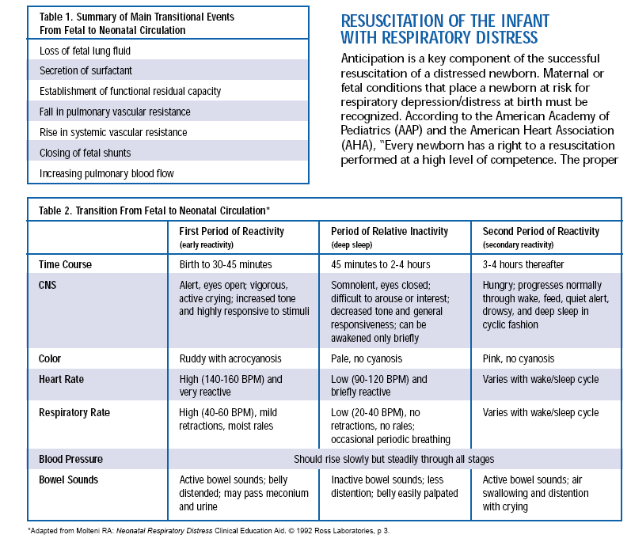
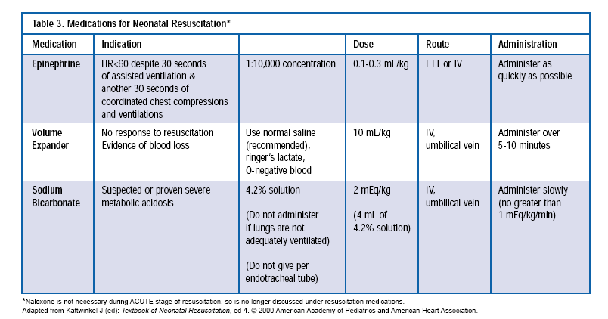
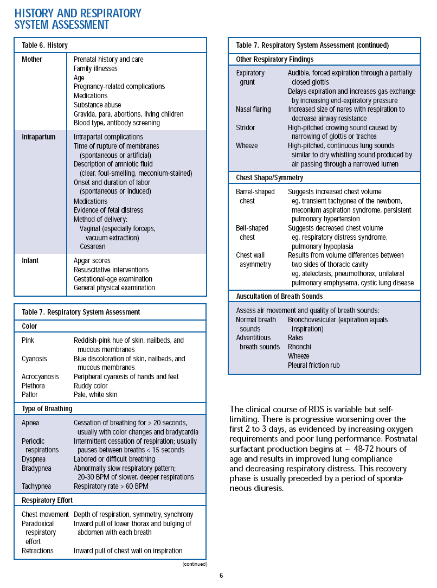

- RESPIRATORY CARE PROCEDURES
  - Mechanical Ventilation Formulas
    - Calculate total cycle time (TCT) for one breath
$\text{TCT}=\frac{\text{60}\text{sec}}{f}$
    - Calculating inspiratory time & expiratory time
      - Calculate TCT
      - Add I:E ratio together
      - Inspiratory Time $T_{I}=\frac{\text{TCT}}{\text{Sum}\text{of}I:E\text{ratio}}$
      - Expiratory Time (T_{E}) = TCT - T_{I}
    - Calculate the Respiratory Rate
$\frac{\text{60}\text{ seconds}}{T_{I}+T_{E}}$
    - Calculate the I:E Ratio
$I:E\text{ ratio}=\frac{\text{Larger \# }({\text{either T}}_{I}{\text{ or T}}_{E})}{\text{Smaller}\text{ \# }({\text{either T}}_{I}{\text{ or T}}_{E})}$
It will usually be expiratory time divided by the inspiratory time OR It may be inspiratory time divided by the expiratory time if inverse ratio ventilation is used.
    - Examples
      - Given an inspiratory time of 0.4 seconds & an expiratory time of 1.2 seconds, calculate the I:E ratio.
$\frac{1\text{.}2\text{ seconds}}{0\text{.}4\text{ seconds}}=3;\text{ so I:E ratio is 1:3}$
      - Given an inspiratory time of 0.8 seconds & an expiratory time of 1.6 seconds, calculate the I:E ratio.
$\frac{1\text{.}6\text{ seconds}}{0\text{.}8\text{ seconds}}=2;\text{ so I:E ratio is 1:2}$
      - INVERSE RATIO PROBLEM: Given an inspiratory time of 1.6 seconds and expiratory time of 0.8 seconds, calculate the I:E ratio.
$\frac{1\text{.}6\text{ seconds}}{0\text{.}8\text{ seconds}}=2;\text{ so I:E ratio is 2:1}$
      - MECHANICAL VENTILATION - EXAMPLE PROBLEMS
        - Given a f of 20 breaths/min, and an I:E ratio of 1:2, calculate the inspiratory time and expiratory time.
$\begin{aligned}\text{TCT}=\frac{\text{60}\text{ seconds}}{\text{20}/\text{min}}=3\text{ seconds} \\ 1+2=3 \\ T_{I}=\frac{\text{3 seconds}}{3}=1\text{ second} \\ T_{E}=\text{3 seconds - 1 second }=\text{ 2 seconds}\end{aligned}$
        - Given a f of 40/min and an I:E ratio of 1:3, calculate the inspiratory time and expiratory time.
$\begin{aligned}\text{TCT}=\frac{\text{60}\text{ seconds}}{\text{40}/\text{min}}=1\text{.}5\text{ seconds} \\ 1+3=4 \\ T_{I}=\frac{1\text{.}\text{5 seconds}}{4}=0\text{.}\text{375}\text{ seconds} \\ T_{E}=1\text{.}5\text{ seconds - 0}\text{.}\text{375 second }=\text{ 1}\text{.}\text{125 seconds}\end{aligned}$
        - Given a f of 60/min, I:E ratio of 1:1, calculate the inspiratory time and expiratory time.
$\begin{aligned}\text{TCT}=\frac{\text{60}\text{ seconds}}{\text{60}/\text{min}}=1\text{ seconds} \\ 1+1=2 \\ T_{I}=\frac{\text{1 seconds}}{2}=0\text{.}5\text{ seconds} \\ T_{E}=\text{1 second - 0}\text{.}\text{5 seconds }=\text{ 0}\text{.}\text{5 seconds}\end{aligned}$
        - Given an inspiratory time of 0.6 seconds and an expiratory time of 1.2 seconds, calculate the f and I:E ratio.
$\begin{aligned}f=\frac{\text{60}\text{ seconds}}{0\text{.}\text{6 }+\text{ 1}\text{.}2}=\text{33}\text{.}\text{33}\text{ per minute} \\ \text{I:E ratio }=\frac{1\text{.}\text{2 seconds}}{0\text{.}\text{6 seconds}}=2;\text{ I:E ratio is 1:2}\end{aligned}$
        - Given an inspiratory time of 1 second and an expiratory time of 1.5 seconds calculate the f and I:E ratio.
$\begin{aligned}f=\frac{\text{60}\text{ seconds}}{0\text{.}\text{6 }+\text{ 1}\text{.}2}=\text{33}\text{.}\text{33}\text{ per minute} \\ \text{I:E ratio }=\frac{1\text{.}\text{5 seconds}}{\text{1 second}}=1\text{.}5;\text{ I:E ratio is 1:1}\text{.}5\end{aligned}$
        - Given an inspiratory time of 1.2 seconds and an expiratory time of .8 seconds, calculate the f and I:E ratio.
$\begin{aligned}f=\frac{\text{60}\text{ seconds}}{1\text{.}2+0\text{.}8}=\text{30}\text{ per minute} \\ \text{I:E ratio }=\frac{1\text{.}\text{2 seconds}}{0\text{.}\text{8 seconds}}=1\text{.}5;\text{ I:E ratio is 1}\text{.}\text{5:1}\end{aligned}$
  - CPAP – Continuous Positive Airway Pressure
    - Definition/Description
      - CPAP is PEEP applied to a spontaneous breathing patient.
      - It is elevating the baseline pressure above atmospheric pressure during inspiration and expiration.
      - CPAP increases the FRC.
    - Methods Used To Deliver CPAP
      - CPAP can be applied with the following:
        - Baby intubated and on mechanical ventilator.
        - Nasal CPAP (delivered with nasal prongs to newborns).
        - Mask CPAP (InstaFlow).
    - Indications
      - Treatment of refractory hypoxemia caused from shunting. Infants/children will often show signs of respiratory distress:
        - Grunting
        - Cyanosis
        - Retractions
        - Tachypnea
        - Apneic periods
      - PaO₂ is less than normal on high FIO₂ (greater than 50 – 60%)
      - Atelectasis
      - To treat periods of apnea.
      - Infants/Children should be able to maintain adequate ventilation (normal or low PaCO₂).
    - Equipment needed
      - Air/oxygen blender with flowmeter
      - Humidifier/water traps
      - Nasal prongs
      - Pressure manometer
      - CPAP generator (spring loaded PEEP valve, Water bottle system)
      - Reservoir Bag
      - Low pressure alarm (optional)
    - Troubleshooting
      - Loss of pressure on the manometer.
        - A leak in the circuit.
        - Insufficient flowrate.
        - Misplaced nasal prongs or mask not tight.
        - Baby is crying (use pacifier).
      - Increase in pressure on the manometer.
        - Obstruction (secretions – needs suctioning).
        - Faulty exhalation PEEP valve.
        - Excessive flowrate.
  - Non-Invasive Monitoring
    - transcutaneous O₂ and CO₂ monitoring
      - Monitors PO₂ and PCO₂ by electrodes attached to the skin. These electrodes are heated to increase perfusion beneath the sensor site.
        - PO₂ electrode is the Clark electrode.
        - PCO₂ electrode is the Severinghaus electrode.
      - The site is heated to 43 - 44° C to cause vasodilation & increase perfusion to the area.
      - The electrode should be moved and changed every 2-4 hours.
      - After the site is changed it takes 10-20 minutes for the electrode to stabilize.
      - A drop of sterile water or special electrode gel in used between the electrode and skin to improve gas diffusion and displace air.
      - Although the PO₂ and PCO₂ values may not match the arterial blood gas values, they will correlate or follow each other.
      - Monitor should not be used if there is poor perfusion under the electrodes.
      - Troubleshooting:
        - If the TcO₂ is reading 80 torr and 10 min later you notice it is reading 159 torr without any changes in FiO₂, the electrode has detached from the skin and is exposed to room air, which has a partial pressure of approximately 159 - 160 torr.
        - Monitor will not read accurately if calibration is needed.
      - Hazards include skin or epidermal stripping, erythema, skin blistering, and burns. Burns can occur if temperature is too high or electrode is not changed every 2-4 hours.
      - Disadvantage is the monitor is labor intensive.
      - Transcutaneous monitors can be used to track pre and post ductal blood flow.
        - One electrode is placed in right upper chest and one is placed on lower chest or upper thigh.
      - The monitor tracks the power required to heat the sensor to the preset level.
        - As perfusion decreases, less power is needed to maintain the temperature.
        - As perfusion increases, more power is needed to maintain the temperature.
    - Pulse Oximeter
      - Pulse oximeters are used to measure the SpO₂ (“functional oxygen saturation) and the patient’s heart rate.
      - Utilizes Beer’s Law.
      - Conventional pulse oximeters measure saturation by comparing the absorption of two wavelengths of light. Cannot be used to detect COHb% or MetHb%.
      - Will not read accurately:
        - Elevated COHb%
        - Elevated MetHb%
        - Decreased perfusion
        - Nail polish
        - Dyes
        - Motion
        - Skin pigmentation
        - Severe anemia
        - Ambient light
      - Needs to have good perfusion under the sensor to read accurately.
      - Blood gases should be drawn periodically to correlate SpO₂ with SaO₂.
      - If the patients heart rate does not match heart rate on the monitor, the SpO₂ may not be accurate
      - Try another site.
      - SpO₂ levels should be kept between 95 and 97%. Levels above 97% may put the infant at risk of ROP.

Blood Gas Values
      - Newborns tend to tolerate moderate hypoxemia and acidosis better than older children and adults.
      - PaCO₂ should be 35 - 45 mm Hg.
      - pH should be 7.35 - 7.45 (ventilation is indicated when pH falls to less than 7.30).
      - PaO₂ should be:
        - 50-70 torr at birth;
        - 60-80 torr at 5-24 hours;
        - 60-90 torr at 1 day to 1month;
        - 80-100 torr from 1 month on.
      - A premature infant will have a higher PaCO₂ and lower pH.
      - The presence of fetal Hb after birth tends to shift the oxygen dissociation curve to the left. Fetal Hb can be found up to 1 year of age

  - Extracorporeal Membrane Oxygenation - (ECMO) & Extracorporeal Life Support (ECLS)

    - Description: ECMO is a means of oxygenating the blood outside the body. Used for respiratory or cardiovascular reversible diseases.
    - Venous blood is withdrawn, oxygenated and returned via the arterial or venous circulation.
    - Approximately 80% of cardiac output goes through the extracorporeal circuit (normal cardiac output is 120 ml/kg/min).
    - Indications
      - Pathology
        - Meconium Aspiration
        - Respiratory Distress Syndrome
        - Congenital Diaphragmatic Hernias
        - Persistent Pulmonary Hypertension of the Newborn
        - Pneumonia – Sepsis
        - Cardiac surgery - post-op

Age Groups
        - Newborns
        - Premature Infants
        - Children
        - Adults
      - Criteria for Use
        - Birth Weight: 2000 grams; U of M is now accepting babies at 1500 grams.
        - Gestational Age: 35 weeks gestation; U of M is now accepting babies at 33 weeks.
        - Reversible respiratory pathology
        - The infant’s respiratory disorder must be reversible within 1-2 weeks.
        - Cranial and Cardiac ultrasound or CT scan: Patients with intraventricular or intracerebral hemorrhage are not considered for ECMO.
        - No uncontrolled bleeding.
      - Selection Criteria
        - Oxygenation Index: Quantitates the degree of respiratory failure:
$\text{Oxygenation}=\frac{\text{MAP}×{\text{FiO}}_{2}×\text{100}}{{\text{PaO}}_{2}}$
        - >40 indicates = 80% mortality rate
        - A-a gradient (AaDO₂)
          - PAO₂ - PaO₂ = [(P_{B} - 47 mm Hg x FiO₂) - PaCO_{2 * 1.25}] - PaO₂
          - <600 mm Hg = 80% mortality rate
    - Contraindications to ECMO Support
      - Patient less than 1500 grams
      - Gestational age less than 33 weeks
      - Major chromosomal abnormalities
      - Uncontrolled bleeding
      - Pulmonary hypoplasia or severe BPD
    - Forms of ECMO
      - Veno-Arterial Bypass
        - Veno-Arterial (V-A) is the standard form of extracorporeal circulation.
        - CO₂ removed and the blood is returned back to the arterial circulation (aorta).
        - Catheters are inserted into the right internal jugular vein and right common carotid artery or femoral artery.
        - This mode of bypass provides complete support for the heart and lungs. Less blood flows through the patient’s heart and lungs thereby resting these organs.
        - Advantages:
          - Provides complete cardiopulmonary support.
          - Used for heart and lung failure.
          - Cardiac function is not essential
        - Disadvantages:
          - Any particle, bubble or embolism in the circuit can be infused directly into the arterial circulation.
          - Carotid artery ligation.
      - Veno-Venous (V-V) Bypass
        - Blood is drained from the venous circulation (right atrium) oxygen is added, CO₂ removed and blood is returned to the venous circulation.
        - Catheters are inserted into the internal jugular vein and femoral vein or a double lumen catheter is inserted into the internal jugular vein.
        - Advantages:
          - No carotid artery ligation is needed.
          - Particles, bubbles or emboli are perfused into the venous circulation
          - Oxygenating venous blood can help resolve PFC
          - The heart maintains normal cardiac output
        - Disadvantages:
          - Adequate cardiac function is essential.
          - Femoral vein ligation may cause leg edema.
          - Two potential operative sites
          - May require more ventilatory support from ventilator.
    - Extracorporeal Circuit
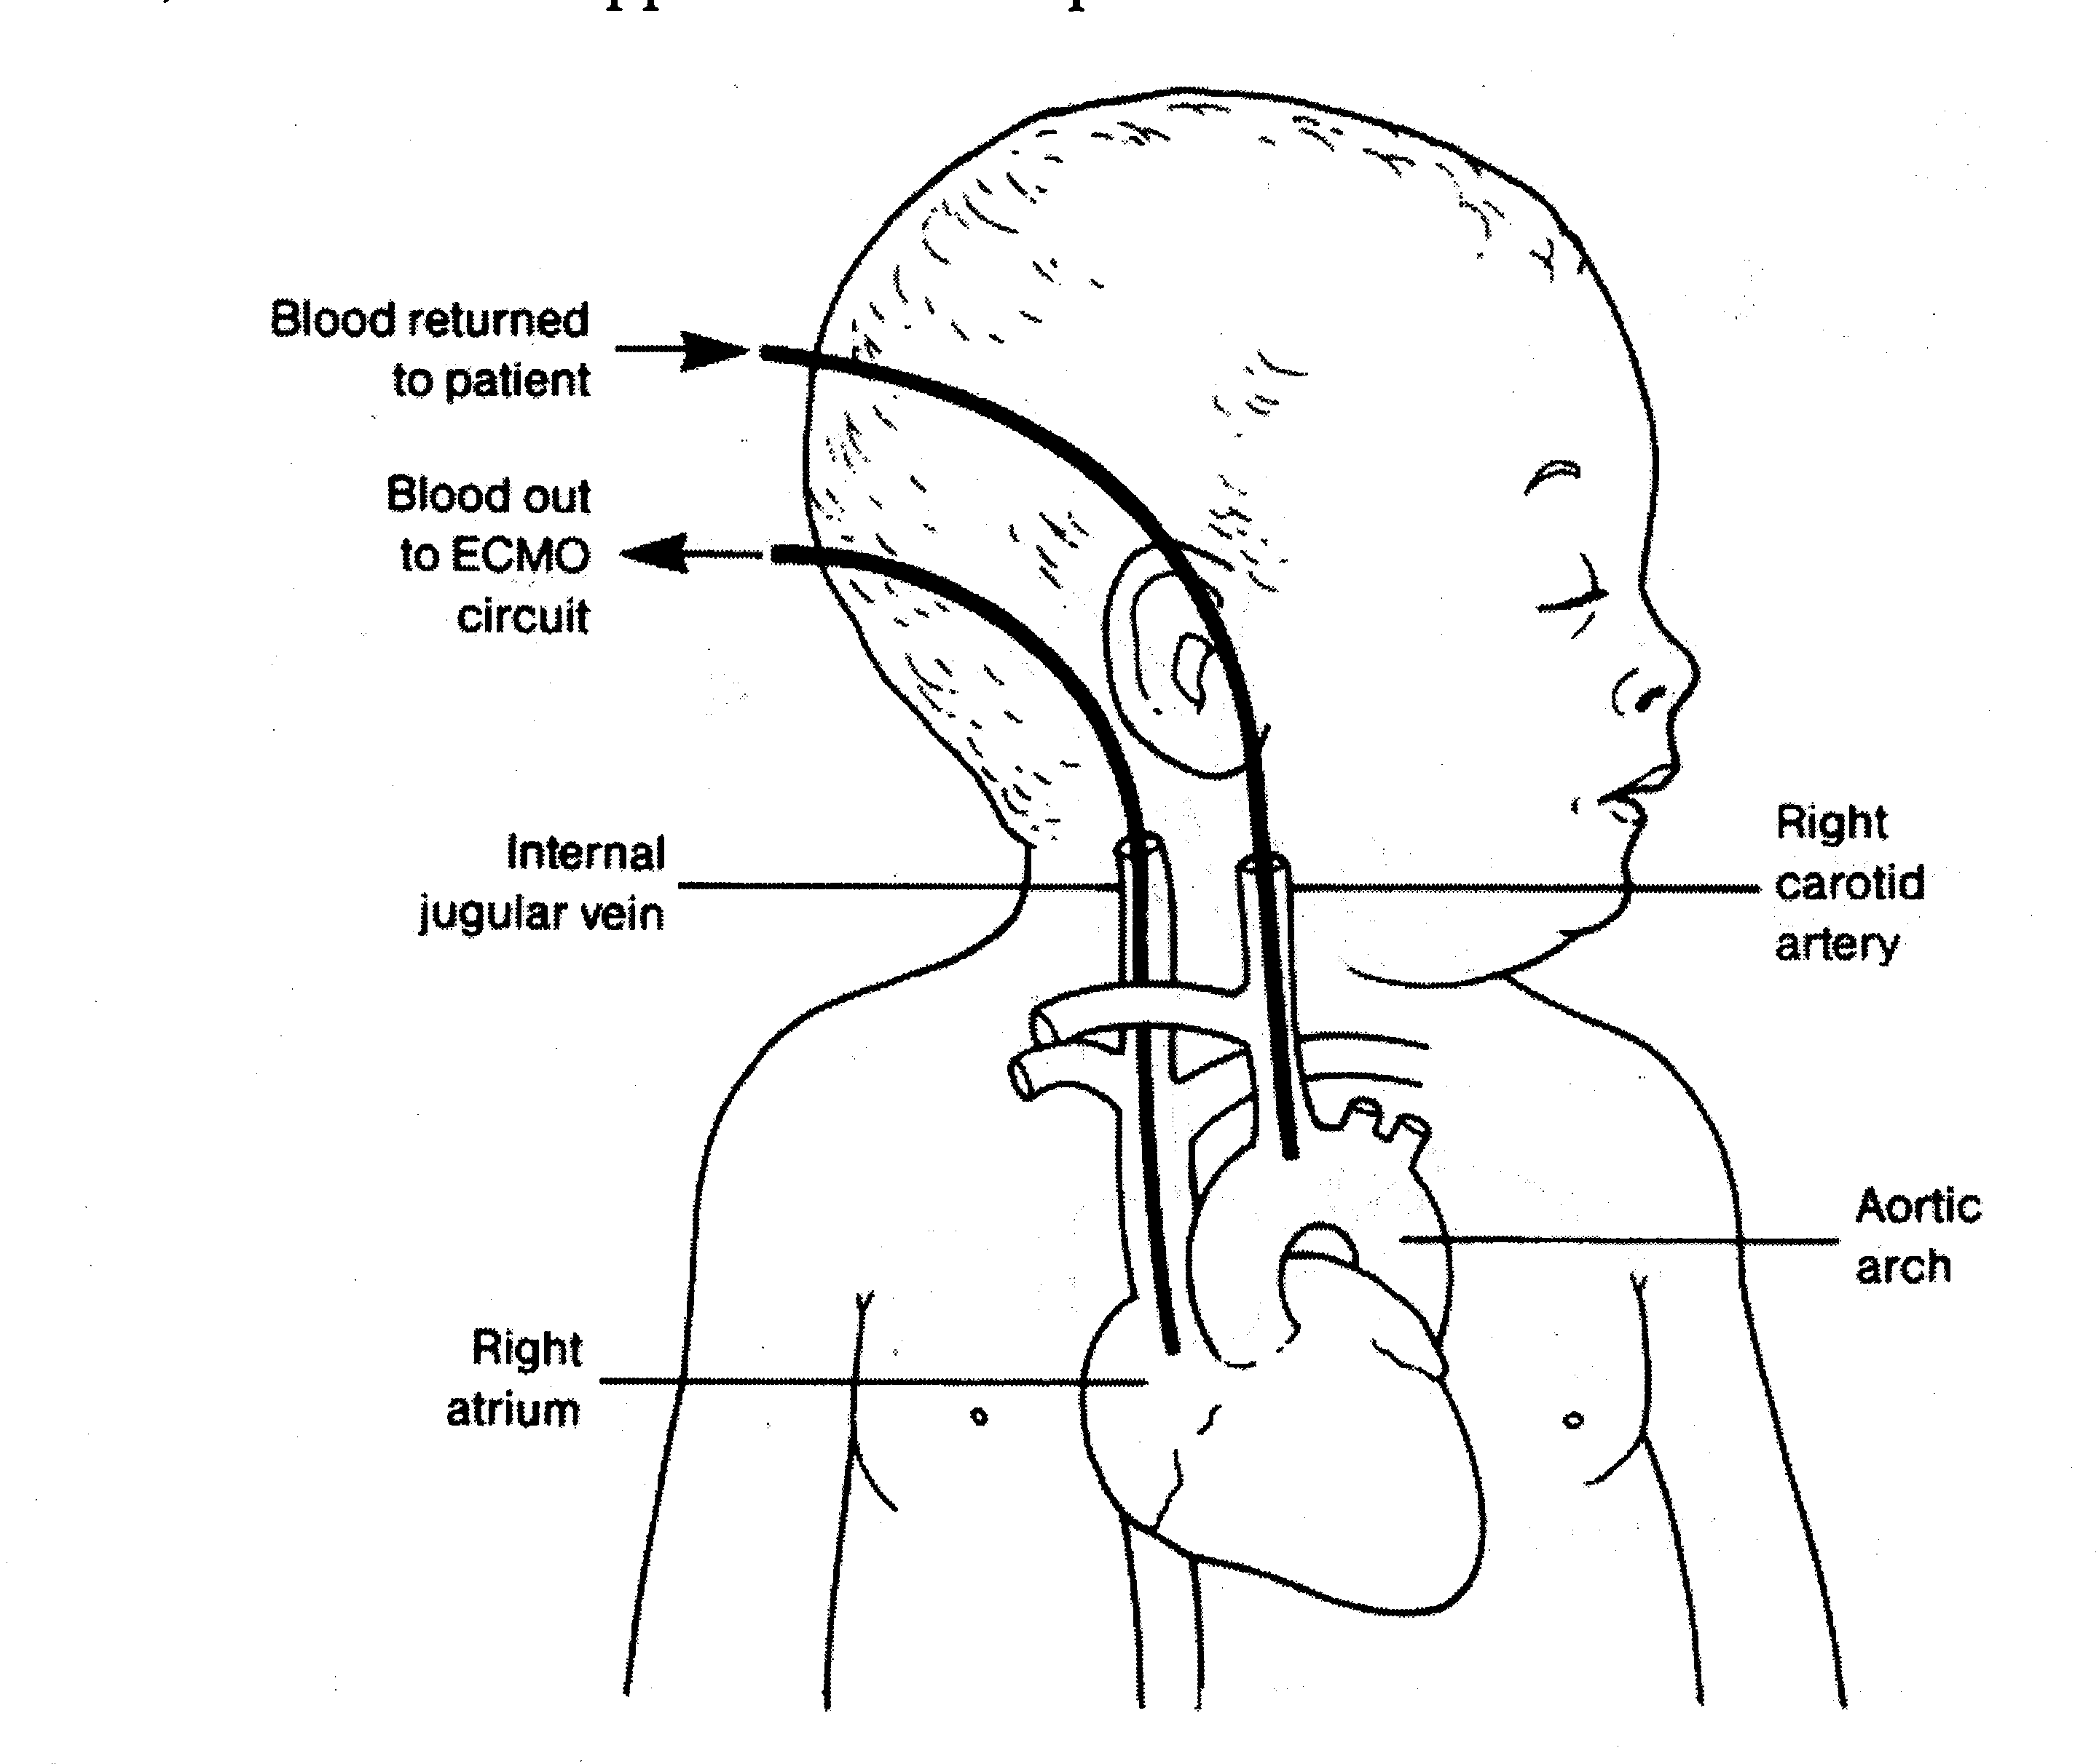
      - Venous Catheter
      - Bladder Box Assembly - servo regulated safety mechanism
      - Pump
      - Membrane Lung
      - Heat Exchanger - returns blood temperature to 37 ° C
      - Venous or Arterial Catheter
      - Continuous Infusion pump for heparin: The loading dose is 100 units/kg; maintenance dose is 50 units/kg/hour
      - Active Clotting Time machine: Activated Clotting Time is measured hourly and heparin dose is regulated by this measurement. The ACT should be maintained at 200 - 230 seconds
      - Venous Saturation Monitor: Venous saturation should be maintained between 65 and 80% by adjusting the ECMO flow rate.
      - Pulse oximeter can be used to monitor arterial oxygen saturation
    - Miscellaneous
      - Platelet monitoring: Platelet count must be closely monitored due to possible thrombocytopenia. Platelet transfusions are necessary when the level drops below 70,000.
      - Mechanical Ventilation: During ECMO The ECMO circuit, not the ventilator, is supporting the baby.
        - The ventilator is set at minimum levels to allow the lungs to "rest" and prevent the development of ventilator complications (barotrauma and oxygen toxicity).
        - ECMO only rests the lungs and does not treat the disease process.
        - Low settings are programmed on the ventilator.
        - Good pulmonary care must be given. Postural drainage and percussion, tracheal lavage should be done frequently.
        - In preparation for the first trial off ECMO, the patient’s FIO₂ is set at 100%, f at 30-40/min, PIP 30-35 cm H₂0 to initiate full reexpansion of the lung.
    - Discontinuation of ECMO
      - Weaning - a slow decrease in pump flow.
      - Trial Off - a temporary clamping of the cannulas and unclamping of the bridge.
      - Decannulation - removal of the cannulas.
  - High-Frequency Ventilation (HFV)
    - Used when the baby is unresponsive to conventional mechanical ventilation.
    - One Hertz (Hz) is one cycle per second (60 cycles per minute).
    - Delivers smaller Vt at decreased pressures.
    - Three types of HFV
      - HFPPV (High Frequency Positive Pressure Ventilation)
        - 1 – 2.5 Hz: 60 – 150 breaths/min
      - HFJV (High Frequency Jet Ventilation)
        - 2.5 – 10 Hz; 150 – 600 breaths/min
      - HFO (High Frequency Oscillation)
        - 7 – 50 Hz; 400 – 3,000 breath/min
  - Nitric Oxide (NO) Therapy
    - Nitric Oxide is a gas that can be delivered through the ventilator circuit.
    - 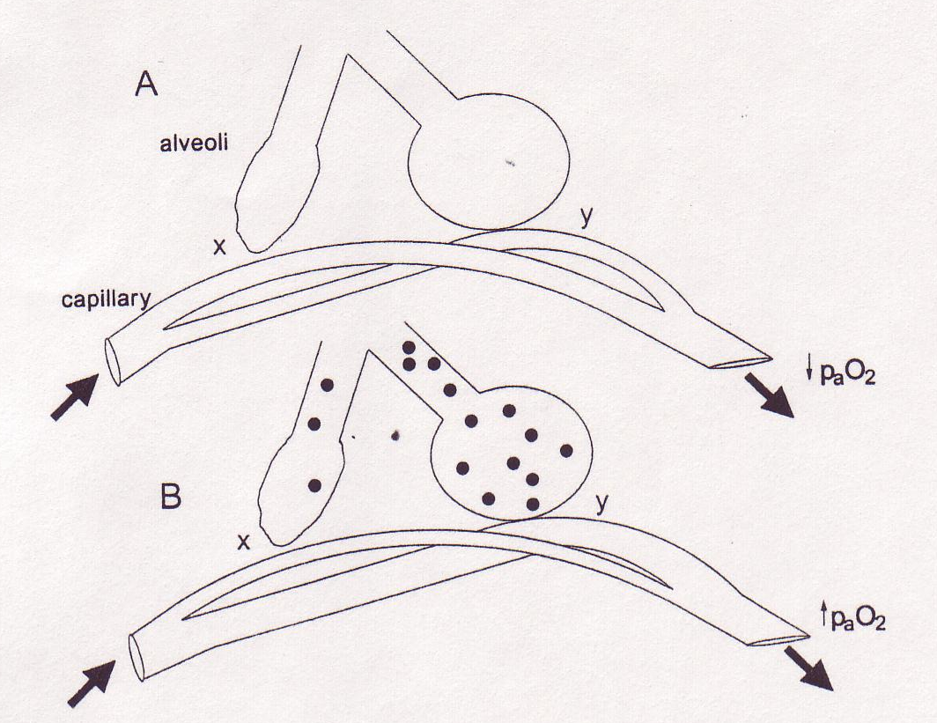Characteristics:
      - Colorless
      - Sweet-smelling
      - Nonflammable
      - Toxic
    - NO is a selective vasodilator in that it only dilates only the pulmonary blood vessels adjacent to functioning alveoli.
      - Atelectatic or fluid-filled lung units will not participate in NO uptake.
    - Initially used to reduce pulmonary hypertension.
    - Start at 5 – 20 parts/million (ppm) but may go as high as 80 ppm.
    - INOVent is a device that delivers and monitors NO.
    - Half-life of Nitric Oxide is about 5 seconds.
    - Once NO crosses the alveolar-capillary membrane it combines with hemoglobin to form methemoglobin (MetHb).
    - Monitor for Met Hb%.
    - May be difficult to wean babies from NO.

  - Surfactant Replacement Therapy

Exogenous surfactant is used to replace natural surfactant in the lung in RDS.

Two types of Surfactant:

Modified natural surfactants from other mammals

beractant (Survanta): Bovine lung mince extract

poractant alfa (Curosurf): Porcine lung mince

calfactant (Infasurf): Bovine lung mince

Artificial surfactants

Similar to natural in vitro, but less effective in vivo.

Colfosceril Palmitate (Exosurf) – No longer manufactured

lucinactant (Surfaxin) – To be released 200?

Method of Delivery

Two methods:

Injected down ET tube.

Aerosolized

Monitor airway pressure as compliance will improve dramatically.

NEONATAL DISEASES

Meconium Aspiration

Definition

Meconium is the first stool passed by the newborn. It is thick, dark greenish brown (pea soup) and composed of intestinal secretions, bile and cells.

Meconium found in the amniotic fluid is usually due to an episode of fetal distress (intrauterine asphyxia). The fetal response to hypoxia results in the release of meconium into amniotic fluid by intestinal peristalsis and reflex relaxation of the anal sphincter.

With the initiation of the first breath, the meconium in the pharynx may be inhaled into the lungs resulting in meconium aspiration.

Meconium Aspiration can cause an inflammatory reaction causing a chemical pneumonitis. The airways become blocked and air trapping occurs.

Bedside assessment

The first indication of meconium will be in the delivery room. (Differentiate meconium stained and meconium aspiration). Meconium aspiration is diagnosed whenever meconium is suctioned from below the vocal cords.

Meconium is more common when gestation exceeds 37 weeks (Term and post-term infants), in breech deliveries and with small gestational aged infants.

The infant’s head may be covered with meconium during the delivery. The respiratory distress caused by the aspiration of amniotic fluid may be delayed for a few hours after delivery.

Infants become progressively more tachypneic, with signs of grunting, flaring of alae nasi, chest wall retractions and cyanosis.

Some infants may be severely depressed at birth with low Apgar scores and in need of resuscitation.

The skin may be dry and scaly and their nails may be yellowish/green as a result of the meconium.

The peak of distress occurs within the first 24 hours.

PPHN may develop due to prolonged hypoxemia.

Maternal history is important in the initial assessment.

Laboratory Assessment

Chest x-ray:

The x-ray shows a combination of atelectasis and hyperinflation.

The hyperinflation is produced by the ball-valve mechanism.

The meconium allows air to enter on inspiration, but as the airway narrows on exhalation, the air is prevented from being exhaled.

This ball-valve mechanism may result in the development of a pneumothorax.

The diaphragm is flattened.

The Atelectasis is the result of total airway obstruction and inflammation.

ABG:

Respiratory acidosis and hypoxia may indicate the need for mechanical ventilation

ABG may worsen over the first 24 hours.

Check and monitor blood glucose (hypoglycemia may cause apnea in the newborn).

Fever and WBC elevation may indicate infection.

Treatment

If meconium is seen during delivery, the baby should be quickly intubated after delivery and suctioned prior to the first breath using a meconium aspirator.

This procedure should be repeated until no more meconium is suctioned.

Positive pressure must never be delivered to the airway until suctioning is complete.

100% oxygen should be blown by the patients face throughout the procedure.

Resuscitative measures may need to be instituted after the meconium has been aspirated.

Keep the infant warm and in a neutral thermal environment to decrease oxygen consumption and carbon dioxide production.

If mechanical ventilation is indicated, low peak pressures, short inspiratory times, long expiratory times and small amounts of PEEP may be indicated to decrease the amount of air trapping.

Small amounts of PEEP may help eliminate trapped gas and prevent the small airways from collapsing.

A pneumothorax may occur due to the ball-valve mechanism.

This may be confirmed by transillumination and chest x-ray.

With a tension pneumothorax a needle may be inserted into the intercostal space.

If it is not an emergency, a chest tube can be inserted into the 2 or 3rd intercostal space in the midclavicular line or between the 4th and 5th intercostal space at the anterior axillary time.

Therapy may also include HFV, ECMO, Aggressive CPT and suctioning and antibiotics.

Persistent Fetal Circulation – PFC Or (Persistent Pulmonary Hypertension Of The Newborn - PPHN)

Definition

Persistent Fetal Circulation is defined as pulmonary hypertension after birth that prevents the transition of fetal to newborn circulation.

PFC can be a primary disorder due to hypoxia during or after delivery or a secondary disorder that occurs because of an underlying disease such as:

Hyaline membrane disease

Transient tachypnea of the newborn

Pneumonia

Cold stress

Meconium aspiration

Diaphragmatic hernias

The hypoxia causes arteriolar vasoconstriction in the lung resulting in pulmonary hypertension.

The pulmonary vasoconstriction increases the pulmonary artery pressure.

The PAP is greater than the MAP.

As a result, the blood is shunted right to left across the ductus arteriosus and/or foramen ovale.

The shunting of blood results in pulmonary hypoperfusion and decreased PaO₂ and cyanosis.

This becomes a viscous cycle.

Bedside Assessment

The Apgar is usually 5 or less at 1 and 5 minutes.

History may reveal hypoxic episode during delivery or high risk delivery.

Signs and Symptoms include:

Tachypnea

Retractions

Cyanosis: The cyanosis is disproportionate to the degree of pulmonary isease indicated on the chest x-ray.

Breath sounds are clear if no pulmonary problem is present.

Refractory to oxygen therapy.

Post-ductal PaO₂ is 15% or 15 mm Hg less than preductal sample.

Infants will be monitored with a pulse oximeter or transcutaneous monitor.

Laboratory Assessment

ABG

PO₂ gradient between preductal and postductal blood.

PaO₂ will be refractory to oxygen therapy.

X-ray may be normal or reflective of other pathology

Monitor Glucose and electrolytes

Monitor Ca⁺² levels monitor closely.

CBC: Infant may be polycythemic.

Diagnostic Testing

Hyperoxia Test: If PaO₂ does not increase with 100% oxygen, suspect cardiac shunt. This is not specific for PFC because a low PaO₂ would be seen in PFC or some congenital heart defects.

Compare pre-ductal and post-ductal PaO₂

A gradient will exist.

A difference will exist with PFC and some congenital heart defects.

May not be specific.

Hyperoxia-Hyperventilation Test

This is most definitive.

If post-ductal PaO₂ is low, and you hyperventilate with 100% oxygen (until PaCO2 is 20 - 25 mm Hg), the PaO₂ should rise to greater than 100 mmHg. (The low PaCO₂ and high PaO₂ will close the ductus arteriosus).

Echocardiography - an ultrasound of the heart (ECHO) or Cardiac Catheterization

Treatment

Oxygen Therapy to maintain PaO₂ greater than 50-60 mm Hg

Mechanical Ventilation to hyperventilate to a PaCO₂ of 20-25 torr

Dopamine and/or Dobutamine to maintain Blood Pressure

Nitric Oxide Therapy

May be given through the ventilator circuit

Pulmonary vasodilator

Improves V/Q ratios

May be used with conventional or HFV.

Keep glucose and electrolytes normal.

Paralyzing agent (may be needed).

Babies must be weaned slowly from ventilator (decrease FiO₂ slowly)

ECMO or HFV.

Wilson-Mikity Syndrome

"Emphysema" of babies.

Premature infants or low birth weights (less than 1500 grams).

Similar to BPD but the baby has not been mechanically ventilated.

The x-ray is similar to stage III and IV BPD.

Initial symptoms appear near the end of the first week and progress over the next 2-6 weeks (this is the acute phase).

Treatment is oxygen and mechanical ventilation.

²/₃ survives the acute phase with clearing of the disease by age 2.

Treatment is supportive and the same as for BPD.

Transient Tachypnea Of The Newborn (TTN)

Amniotic Fluid stays in the lungs (retained lung fluid).

Occurs secondary to the delay in reabsorption of fetal lung fluid.
Increased lung fluid causes lung compliance and tidal volumes to be decreased.

Often seen with C-sections. The squeezing that occurs during vaginal deliveries helps eliminate fetal lung fluid.

Neonates have high Respiratory Rates (80 - 100/min or higher). This is an attempt to lose fluid through evaporation. Fluid usually clears in 24 - 72 hours.

X-ray findings are often similar for pneumonia, RDS and TTN so have to go by other findings.

Often the infant is started on broad-spectrum antibiotics in the event that pneumonia is present.

Pleural Effusions may be present on x-ray.

Lung maturity (normal L:S ratios, Presence of PC) is usually found.

Most ABG will reveal decreased PaO₂. Ventilation (PaCO₂) is usually normal.

Treatment is oxygen or CPAP.

If PaCO₂ levels elevate, the infant may require mechanical ventilation.

If MV is indicated it is usually short term and infants are weaned rapidly.

Frequent turning of the infant may help absorb fluids.

Diagnose through process of elimination.

Respiratory Distress Syndrome (RDS) Or Hyaline Membrane Disease (HMD)

Associated with lung immaturity

Baby is born less than 35 weeks gestation or low birth weight babies. (L:S ratios, PG and shake test can be used to determine lung maturity).

A deficiency of surfactant is not the only cause of RDS.

It is also associated with immaturity of other organ systems.

After birth or shortly afterwards, the infant develops respiratory distress.

Pathophysiology

Decreased surfactant

Atelectasis

Increases WOB

Lung compliance decreases

Hypoxemia and hypoxia

May be associated with PDA or PFC

Respiratory and metabolic acidosis

X-ray shows a reticulogranular pattern.

Diffuse whiteout over both lungs.

Lungs appear clouded or ground glass.

Treatment

Attempt to accelerate lung maturity by pharmacological means (steroids).

Delay labor with Beta Adrenergic Agents (Terbutaline)

Thermoregulation

CPAP or mechanical ventilation

Artificial Surfactant

If unresponsive: HFV or ECMO

Infants may have full recovery or develop side effects such as:

Bronchopulmonary dysplasia (chronic lung disease)

ROP

Intraventricular Hemorrhage (brain dysfunction)

Necrotizing enterocolitis

Intrapulmonary hemorrhage (lungs)

Intraventricular Hemorrhage (IVH) Or Intracranial Hemorrhage (ICH)

Premature infants and low birth weight infants are at greatest risk.

Intracranial bleeding can occur in term infants following birth trauma or asphyxia.

Areas include subarachnoid and subdural space.

Bleeding also occurs in premature infants around or within the ventricles in the brain.

Ultrasound or CT scan can diagnose hemorrhages.

Classification of IVH includes 4 grades. Grade IV is the most severe.

Bronchopulmonary Dysplasia (BPD) (Neonatal Chronic Lung Disease (NCLD))

Usually seen in preterm infants (less than 1500 grams).

Associated with:

Prolonged oxygen concentrations.

Positive pressure ventilation (these babies usually require positive pressure ventilation in the first week of life.

The amount of time exposed to each of these factors.

Defined as a progressive chronic lung disease that presents with persistent respiratory problems at 28 days or later, radiographic changes and oxygen dependency.

Clinical picture: Premature baby develops HMD (RDS), is placed on mechanical ventilation and later develops BPD.

Not all premature babies with HMD develop BPD. There is a pattern you can see in the first 3-4 days of life that indicate the infant may be at high risk for developing BPD.

Age

FiO₂

Mean airway pressure during mechanical ventilation

Presence of patent ductus arteriosus

Nutritional assessment

Birth weight

Infection

Lung Pathology

Mucosal hyperplasia of small airways

Destruction of type I cells

Inflammation and destruction of alveoli and capillary bed

Lungs are cystic in some areas and atelectatic in others fibrosis occurs.

X-ray shows typical honeycomb appearance with radiolucency.

Diaphragms are flattened

Cystic appearance.

Clinical Signs

Tachypnea (increased f)

Retractions

Mucous plugging

Hyperinflation of chest - barrel chest

Cyanotic spells

Poor ABG (respiratory acidosis) pH decreased or normal, PO₂ decreased, PCO₂ increased, HCO₃⁻ increased.

Wheezing

Inadequate growth (needs increased calories)

Decreased lung compliance

Increased FRC (air trapping)

Increased work of breathing and oxygen consumption

Clinical Goals:

Prevent hypoxemia that may lead to pulmonary hypertension and Cor Pulmonale.

Provide enough calories to support adequate growth and nutrition.

Do not attempt to wean off oxygen.

If growth is impaired and you are giving enough calories.

Limit peak inspiratory pressures by using CPAP or high frequency jet ventilation.

Prevent damaging effects of oxygen toxicity.

Baby may be on 80% oxygen. Because of shunting he/she could do just as well on 40%.

Limit fluid - BPD infants handle small increase in fluids very poorly. Interstitial and alveolar edema can develop rapidly.

Treatment

Prevent prematurity

Prevent oxygen toxicity

Steroids

Vitamin E

Diuretics

Surfactant

Limit fluid intake

High caloric formulas to supply nutritional needs

Bronchodilators

CPT

Echocardiography, cardiac catheterization, EKG to rule out other cardiac defects (VSD)

High frequency ventilation

Complications

Gastroesophageal reflux and feeding intolerance that leads to aspiration.

Decreased calcium and phosphorus resulting in long bone fractures, rib fractures, Tracheal malacia, tracheobronchial malacia.

Retinopathy of prematurity

Intracranial hemorrhage

Cerebral palsy

Hearing loss

Hematuria - kidney infections

Pneumothorax

Death is usually due to:

Cor Pulmonale (peripheral edema, hepatomegaly, jugular vein distention)

Infection

Sudden Death

Discharge from the hospital

Babies often go home with oxygen or on mechanical ventilator.

Medications include diuretics

There are frequent re-admissions back into the hospital.

Oxygen must be weaned slowly.

Special attention to nutrition is important.

Neonatal Infections

Pneumonia - infection in the lungs

Septicemia - infection in the bloodstream

Meningitis - infection or inflammation of the covering of the brain and spinal cord

Urinary Tract Infections

Conjunctivitis - infection or inflammation of the eye.

Omphalitis - infection/inflammation of the umbilical stump.

Pneumonia

Pneumonia may be:

Transplacental (maternal viral or bacterial infection)

Perinatal (contaminated amniotic fluid or PROM of greater than 12-24 hours. Most common is during labor and delivery

Postnatal (invasive lines, respiratory equipment, hospital personnel or as a result of meconium aspiration).

Pneumonia should be considered in any neonate with respiratory distress.

The infant may require resuscitation at birth.

Broad-spectrum antibiotics are often started until a positive culture and sensitivity report confirms organism present.

Premature infants are at greater risk than term infants in developing pneumonia.

Group B Beta Hemolytic Streptococci and Escherichia Coli are the most common organisms causing pneumonia at birth.

Pulmonary hypertension is a common consequence and may result in PPHN (PFC).

Diagnosis is confirmed with chest x-ray and culture and sensitivity reports and abnormal WBC counts.

Chest x-ray alone is often difficult to distinguish TTN, RDS, or pneumonia.

Postnatally acquired pneumonia are most commonly caused by:

Klebsiella

Pseudomonas

Penicillian-Resistant Staphylococcus (MRSA)

Candida Albicans (fungal)

Viruses that often affect newborns include:

Herpes virus

Respiratory Syncytial Virus

Cytomegalovirus

Chlamydia

Rubella

Adenovirus

Diaphragmatic Hernia

Diaphragmatic hernia is a congenital condition in which the abdominal organs herniate into the chest cavity through the diaphragm.

This condition is life threatening when abdominal organs in the chest compromise too much lung area.

The defect is most common in the posterolateral region of the diaphragm in an area called the foramen of Bochdalek.

Left side herniation is much more frequent (85-90%) than right-side herniation.

In left-sided herniation, the stomach, spleen and intestine can enter the chest cavity.

The mediastinum is shifted to the right.

The survival depends of the degree of lung maturity and the presence and reversibility of pulmonary hypertension.

The baby will be in respiratory distress at birth.

The heart sounds or (point of maximal impulse - PMI) may be shifted, breath sounds diminished and auscultated bowel sounds can be heard.

The chest x-ray is conclusive of the diagnosis.

The lungs are hypoplastic (underdeveloped).

Treatment:

Orogastric tube is inserted to remove air should not bag-mask these infants.

The infants should be intubated to prevent air in the stomach and intestines an ET tube is inserted and the patient is mechanically ventilated (high frequency ventilation is often used).

Improved survival rates have been noted when surgery is delayed this allows time for lung compliance to increase and tidal volumes to increase.

If ABG cannot be maintained on conventional or HFV, ECMO is indicated (ECMO has improved survival rates of PPHN from Congenital Diaphragmatic Hernias).

Prenatal ultrasound can accurately diagnose a CDH in utero (in utero repair has been accomplished successfully in several cases but is not yet a widespread technique).

High mortality rate.

Pneumothorax is common because lungs are stiff (decreased compliance).

Choanal Atresia

A congenital malformation of bone or a membrane causing partial or complete obstruction of one or both of the choana.

(Atresia is defined as a congenital absence or closure of a normal body opening or tubular structure.)

The complete obstruction occludes the infant’s airway and unless the obstruction is bypassed or treated, asphyxia will occur. (Infants are nose breathers early in life).

Choanal Atresia is usually found when a catheter or other probe fails to pass through the infant's nose.

Often the nose has a large accumulation of thick secretions.

If the obstruction is a membrane, it can be punctured to provide a patent airway.

Respiratory Distress occurs rapidly in the newborn with clinical signs of cyanosis and retractions.

Thick mucoid secretions fill the nose.

An oral airway should be placed to facilitate mouth breathing.

If the baby is still showing signs of respiratory distress with deteriorating blood gases, the baby should be intubated and ventilated.

Carbon dioxide levels may elevate resulting in respiratory acidosis with hypoxemia.

Surgical correction is always indicated.

Tracheoesophageal Fistula

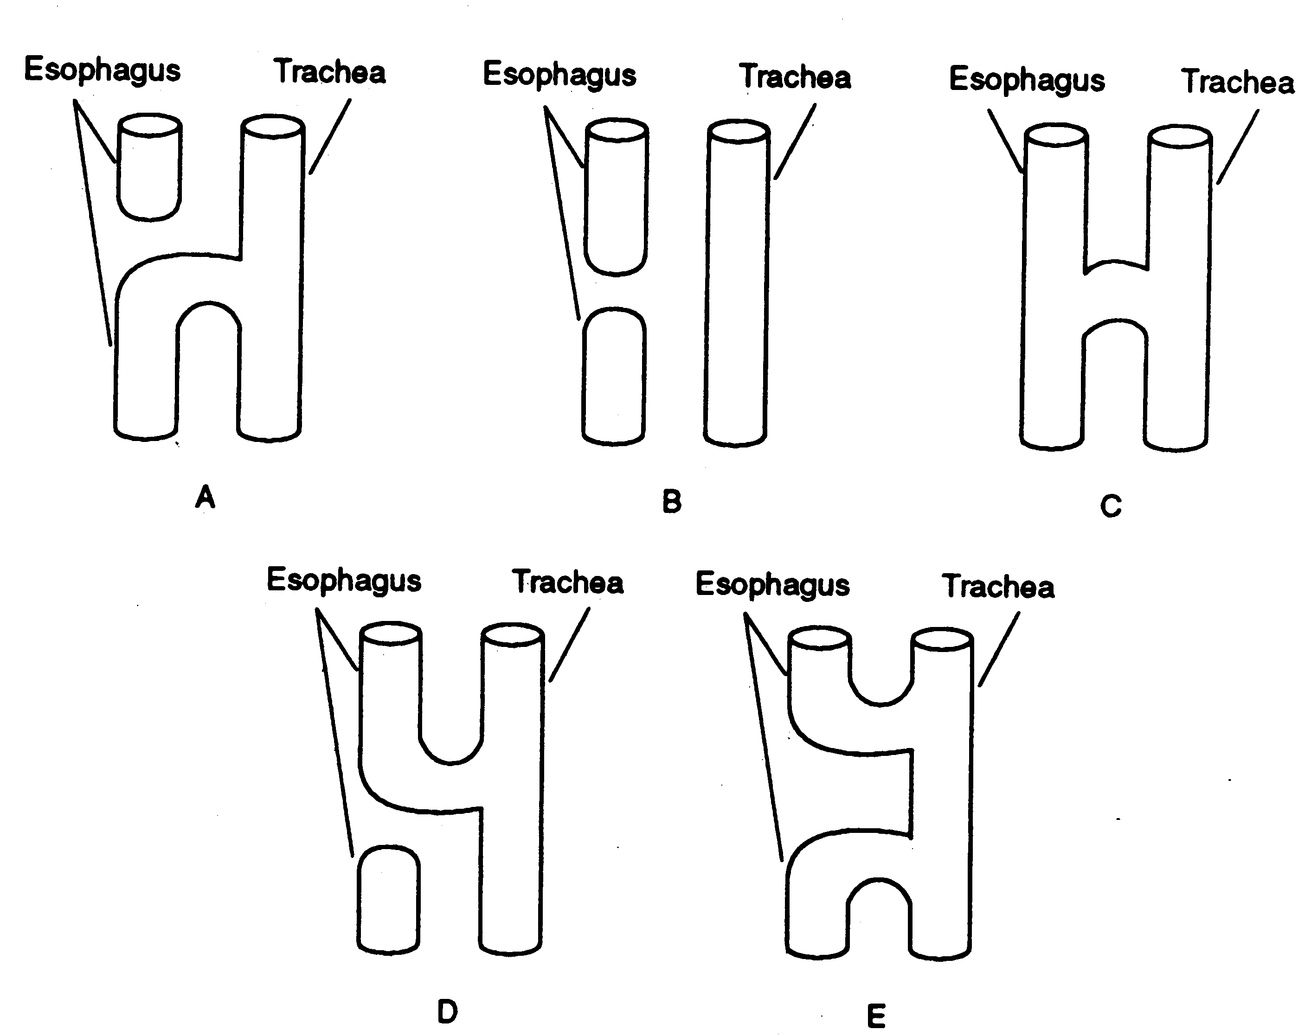
Fistula is defined as an abnormal communication between two passages or cavities

TEF is a congenital abnormality that commonly causes respiratory distress in newborns.

The most common form is where the upper esophagus is a pouch (atresia) and the lower esophagus is connected to the trachea (fistula).

Clinical Signs

Constant pooling of oral,nasal and pharyngeal secretions.

Continuous or sporadic respiratory distress.

Choking on feedings

Repeated vomiting with or after feedings.

The abdomen and GI tract becomes distended because of gas accumulating from the tracheal fistula.

Confirmed on chest x-ray: Persistent right upper lobe pneumonia or atelectasis because of the aspiration

Treatment

Surgical correction is needed.

Supportive care until surgical correction is accomplished (aspiration is a major complication).

A gastric feeding tube is usually placed in the esophageal pouch to remove secretions.

Mechanical ventilation should be avoided

Necrotizing Enterocolitis (NEC)

Mainly affects premature and SGA infants.

Initiated by injury to the intestinal mucosa due to hypoperfusion, hypoxia or hyperosmolar feeding.

The injured mucosa loses the ability to secrete the protective layer of mucus and thus becomes vulnerable to bacterial invasion.

Intestinal ischemia occurs and may result in necrosis and gangrene of the intestinal tract.

Often a complication of RDS.

Sepsis may develop.

Consists of:

Intestinal dilation (distended loops of intestine with gas)

Gastric ileus (obstruction)

Abdominal distention

Rectal bleeding

Confirmed with x-ray.

First sign is usually bloody stool and feedings are poorly tolerated.

Treatment

NG tube

Stop feeding (Hyperalimentation IV is indicated)

Antibiotics

20% require surgery

Oxygen or mechanical ventilation

Pneumothorax

Pneumothorax can occur as a complication of

Meconium aspiration

Diaphragmatic hernia

Respiratory Distress Syndrome

High ventilating pressures

Pneumonia

Clinical signs

Cyanosis

Tachypnea

Grunting

Nasal flaring

Point of maximal impulse (PMI) or apical pulse of the heart is shifted away from the affected side.

The normal PMI is at the midclavicular line at the 5th intercostal space.

With a bilateral pneumothorax, the PMI may be shifted downward.

Confirmation

Transillumination

A bright light is placed on the body region.

Normally a "halo" should be seen.

A pneumothorax will show up as an area of increased lucency (brightness) compared to unaffected areas.

Chest x-ray

Treatment

In the asymptomatic infant, observe the respiratory rate, heart rate, color along with chest x-ray films and pulse oximetry.

If the baby is symptomatic, evacuation of the air from the pleural space with a needle and syringe or chest tube is required.

Avoid positive pressure ventilation until a chest tube is in place.

The baby can be given 100% oxygen until the chest tube is in place.

CONGENITAL HEART DISEASES

Definitions

Anatomic Shunts:

Normal Anatomic Shunt (2-5%)

Cardiac Shunts

Right to left (results in refractory hypoxemia and cyanosis)

Left to right (acyanotic)

Atresia: obstruction or closure of a normal anatomical opening

Hypoplastic: incomplete or underdevelopment of an organ or tissue

Acyanotic: absence of cyanosis

Congenital Heart Diseases may be classified as:

Acyanotic - increased pulmonary blood flow caused from either a left-right shunt or left sided heart obstruction.

Atrial Septal Defect

Ventricular Septal Defect

Patent Ductus Arteriosus

Coarctation of the aorta (Postductal)

Cyanotic - Right to left shunt

Tetralogy of Fallot

Transposition of the Great Vessels

Coarctation of the Aorta (Preductal)

Cardiac Shunts may be right to left or left to right. The direction of blood flow is dependent on pressure gradients. Blood will always flow from a higher pressure to a lower pressure.

Infants with left to right shunts may present with either:

CHF and pulmonary edema (treated with digitalis and diuretics)

Pulmonary hypertensive (increased PVR)

Decreased cardiac output

Congenital heart defects may not be surgically corrected at the time they are diagnosed. Often palliative surgery is performed to help alleviate symptoms with corrective surgery performed once the child is older. Examples of palliative procedures include: Fontan, Blalock-Taussig, Potts, Waterston.

Some of the congenital heart defects are ductal dependent. Survival is dependent on the presence of a shunt in either the ductus arteriosus or Foramen Ovale. In these cases, oxygen delivery may be decreased or discontinued and drugs may be used to ensure the ductus arteriosus remains open. (PGE₁ - Alprostadil). A side effect of prostaglandins is central apnea that may occur 2-4 hours after administration.

Coarctation of the Aorta (Preductal coarctation)

Tetralogy of Fallot

Transposition of the Great Vessels

Hypoplastic Left Heart Syndrome

Oxygen may also be beneficial in some congenital heart defects and detrimental in others due to the change in pulmonary and systemic vascular resistance.

Giving oxygen and increasing the PaO₂ can close the ductus arteriosus. This can be detrimental when you want a left to right shunt as in ductal dependent congenital heart defects

 PaO₂ increase systemic vascular resistance; decrease pulmonary vascular resistance (closes the ductus arteriosus)

PaO₂ decrease systemic vascular resistance; increase pulmonary vascular resistance (keeps ductus arteriosus open)

Indomethacin (prostaglandin inhibitor) is a drug that can be given to close the ductus arteriosus. It causes constriction of the ductus and is used in congenital defects such as Patent Ductus Arteriosus.

Patent Ductus Arteriosis (PDA)

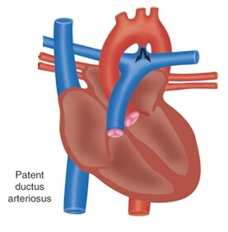
During Fetal Circulation, the ductus arteriosus remains patent by the presence of prostaglandins in the bloodstream. (PGE₁)

Occasionally, the ductus arteriosus remains open after birth and this is more commonly seen with premature infants. A patent ductus arteriosus is often associated with RDS.

After birth, the pressure in the aorta is higher than that in the pulmonary artery, causing the blood to flow from the aorta through the patent ductus and into the pulmonary artery. (left-to-right shunt) This results in increased blood flow to the lungs and a decreased blood flow to the systemic circulation.

The increased blood flow through the lungs increases PVR resulting in pulmonary hypertension and puts an added strain on the left ventricle that may lead to Congestive Heart Failure.

A PDA may close spontaneously at any time but it is unlikely that this will occur after the patient is one year of age. Surgical repair is usually required.

Clinical findings depend on the size of the PDA and the volume of blood shunted.

The infant may have a cardiac murmur, increased fatigue, slow growth and frequent respiratory infections.

Chest x-ray shows left ventricular and left atrial enlargement with a large aorta and pulmonary artery.

Diagnosis may be confirmed by cardiac catheterization or ECHO.

Treatment is indomethacin, which inhibits prostaglandins and can be used to promote closure of the ductus. This drug is most successful when administered to infants younger than 10 days old. Complete surgical repair is achieved by ligation of the ductus.

Atrial Septal Defect (ASD)

The defect is an opening between the atria that persists after birth. There is a left-to- right shunt through the ASD as a result of the left atrial pressure being higher than the right. This increases pulmonary blood flow and increases the work on the right side of the heart.

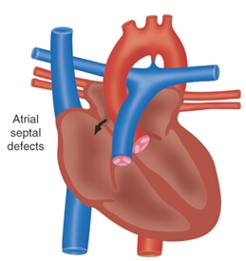Most patients will have few symptoms. A murmur is heard and the chest x-ray will reveal right atrial and right ventricular hypertrophy with normal left heart. The pulmonary artery will also be enlarged and there will be increased vascular markings.

Although symptoms have been reported in the neonatal period, most of these patients remain asymptomatic until school age. If CHF occurs, surgery is indicated. A simple suture closes the defect or if the defect is large enough, a tailored patch is sewn into the septum.

Cardiac catheterization and ECHO confirms the diagnosis

Ventricular Septal Defect (VSD)

A VSD is an opening between the ventricles that permits blood flow between them. It can occur alone or in combination with other defects.

It may be as small as a pinhole or large enough to make the ventricular septum almost completely absent.

The blood flow will shunt from left to right because the PVR is relatively low.

Clinical features depend on the size of the defect. Some children may be asymptomatic. The majority of VSD close spontaneously within the first and second years of life and no intervention is needed.

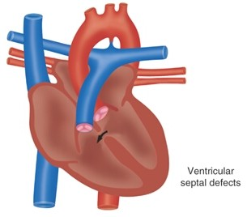
Infants with a large VSD may develop CHF

Medical management may include digoxin and diuretics.

Surgery will be required.

Pulmonary banding is sometimes performed to help direct the blood flow by narrowing the diameter of the pulmonary artery and thus increasing resistance to blood flow. This decreases the amount of left to right shunting. This is a palliative procedure. Later, if total repair is needed, open-heart surgery is performed and the banding is removed.

Diagnosis can be confirmed by cardiac catheterization or ECHO.

A murmur may be heard, along with fatigue, a higher incidence of respiratory infections, and slow growth.

Coarctation Of The Aorta

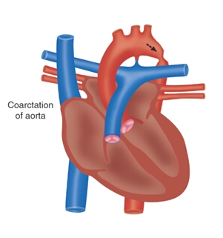Coarctation of the Aorta is a narrowing of the aortic lumen resulting in decreased blood flow through the aorta. This narrowing causes an increased left ventricular workload and puts a considerable strain on the left ventricle. The hypertension may be severe enough to cause congestive heart failure.

The coarctation may be preductal or postductal.

Postductal Coarctation: In the usual coarctation (postductal) the child's blood pressure is increased in the upper extremities and decreased in the lower extremities. Pulses in the upper extremities are full, while they are weak or absent in the lower extremities. CO is severely compromised to the lower extremities. Left to right shunt.

Preductal Coarctation: stenosis or narrowing of the aorta is proximal to the entrance of the ductus arteriosus. This results in a right-to left shunt resulting in cyanosis. A PDA is necessary to supply blood flow to the lower extremities.

If the child develops CHF, there will be signs of left ventricular hypertrophy and a dilated ascending aorta.

Medical management of the heart failure is recommended. Surgical correction (resecting that portion of the aorta) may be indicated.

Tetralogy Of Fallot

TOF is a group of four basic anatomic abnormalities:

Ventricular septal defect (VSD)

Right ventricular hypertrophyD

Dextroposition of the aorta (overriding aorta)

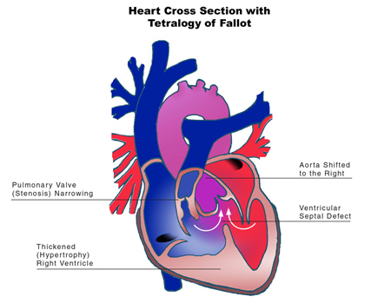
Pulmonary stenosis

The pulmonary stenosis causes right ventricular hypertrophy. The high pressure on the right side causes blood to shunt through the VSD from the right ventricle to the left ventricle. This causes deoxygenated blood to mix with oxygenated blood in the left ventricle. This results in a low oxygen concentration being pumped into the systemic circulation resulting in cyanosis.

Some infants are cyanotic at birth while others do not show cyanosis for months or even years. The infant may be mildly cyanotic at birth while the ductus is open, however, after the ductus constricts the cyanosis and hypoxemia become more severe. PGE1 is administered to maintain a PDA until surgery can be performed. Once cyanosis develops, it becomes progressively worse. Digital clubbing appears. Squatting is common in many children.

Cyanotic infants require palliative surgery to increase blood flow to the lungs, with complete corrective surgery done once the child is older. Palliative surgery to increase blood flow to the lung include:

Blalock-Taussig

Potts

Waterston

The ductus arteriosus is kept open by PGE₁ until palliative surgery can be performed. The congenital defect is referred to as a ductal dependent defect.

Many infants will develop “Tet spells” which include:

Hyperpnea or exaggerated, deep spontaneous breathing

Profound cyanosis (blue spells)

Irritability and crying

Fainting

Tet spells may be seen in any congenital heart defect in which there is obstruction to pulmonary blood flow. Tet spells are thought to occur when there is an increased oxygen requirement that cannot be met. The decreased PaO₂ causes acidosis that increases PVR and further decreases pulmonary blood flow. Feeding, crying or defecating often precipitates the spells.

Squatting - Flexing the legs is done for two reasons:

Decreases venous return from the lower extremities which is very desaturated and

Increases SVR which diverts more blood flow into the P.A.

Because of early surgical intervention before walking, squatting is rarely seen. In small infants, place in knee-chest position and give 100% O₂ and morphine.

Corrective surgery can be done with cardiopulmonary bypass and involves relieving the pulmonary stenosis and closing the ventricular septal defect.

Echocardiogram/and or x-ray will show a boot-shaped heart.

Transposition Of The Great Vessels

The aorta originates from the right ventricle and the pulmonary artery from the left ventricle. This causes the presence of two separate circulatory systems: one pulmonary and one systemic.

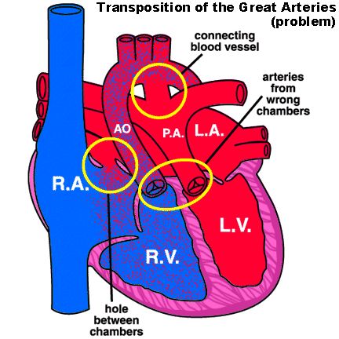
Deoxygenated blood entering the right atrium will flow into the right ventricle, but instead of entering the pulmonary artery for pulmonary circulation, it enters the aorta and circulates systemically.

Oxygenated blood entering the left atrium flows into the left ventricle but instead of entering the aorta and systemically circulating, it re-circulates through the pulmonary artery and pulmonary vascular bed.

A coexisting patent ductus arteriosus and foramen ovale allows survival for a few days by providing a shunt.

This defect is ductal dependent. PGE₁ is used immediately after the diagnosis to maintain ductal patency since continued survival is dependent on it.

Diagnosis is confirmed by cardiac catheterization.

Initial management is to create a means of adequate admixture. This is done by the surgical creation of an atrial septal defect by passing a catheter with a deflated balloon through the foramen ovale. The balloon is then inflated and with a sudden jerk, the catheter is pulled back into the right atrium rupturing the atrial septum (Rashkind balloon septostomy). This creates a shunt at the atrial level.

Eventually corrective surgery is performed.

Truncus Arteriosus

A defect in which a single great vessel arises from the ventricles of the heart supplying the coronary, pulmonary and systemic circulation. A large VSD allows total mixing of blood from the two ventricles making a heart function as a single ventricle.

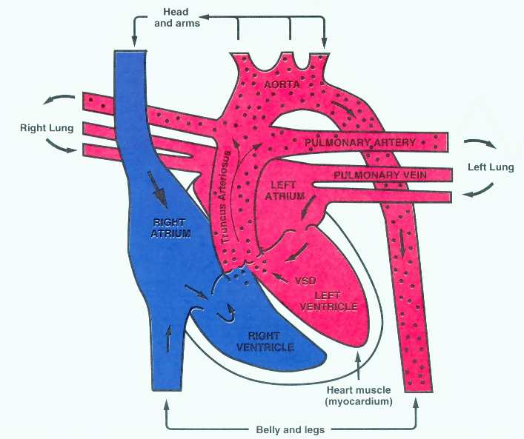
The PVR and SVR mediate the direction of flow.

If PVR is low, there is an increase in blood flow to the lungs, decreasing cardiac output.

If SVR decreases, blood will not flow to the lungs, and hypoxemia and acidosis will result.

Surgical treatment involves separating the pulmonary artery from the large vessel, closing the VSD and placing a valve between the right ventricle and pulmonary artery.

Hypoplastic Left Heart Syndrome

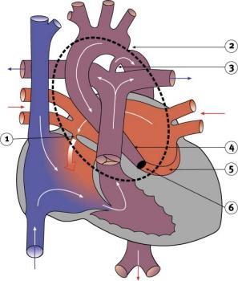
This syndrome describes a number of conditions including mitral or aortic atresia (6), or both, a small left ventricle (5), and marked hypoplasia of the ascending aorta (4). Since there is little or no output from the left ventricle, pulmonary venous blood returning to the LA must pass through the septum to the RA. The entire systemic output is supplied via right to left flow through the PDA (3).

This defect is ductal dependent.

PGE₁ is given immediately to maintain ductal patency.

The mortality is high with this syndrome and infants often die by one week of age. Extensive surgical repair is necessary. (Norwood-Glenn-Fontan)

Anomalous Venous Return (Total Anomalous Pulmonary Venous Return)

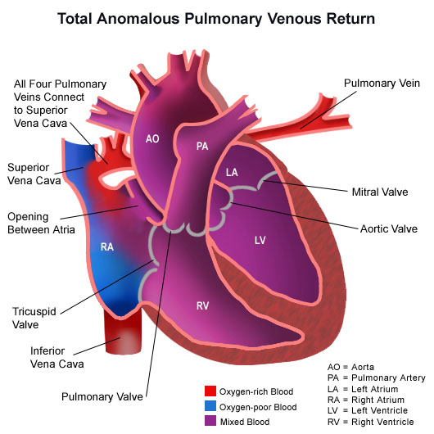
This defect involves the return of pulmonary venous blood to the right atrium instead of the left atrium. An ASD must be present in order for the neonate to survive.

This results in both arterial and venous blood returning to the right side of the heart as well as increased pressures and volume in the right side of the heart. There will be a right-left shunt across the ASD. Balloon Atrial Septostomy is often performed during the cardiac catheterization to enlarge the ASD.

Infants often develop pulmonary edema and CHF.

Surgical repair is indicated.

