- Internal Respiration
  - Definition
    - The transfer of oxygen from the blood to the tissue cells is internal respiration.
  - Normal Values for Oxygen Content
      - CaO₂; 20 vol%
      - CO₂: 15 vol%
      - CaO₂ – CO₂ [C(a-)O₂]: 5 vol%
  - Tissue Extraction
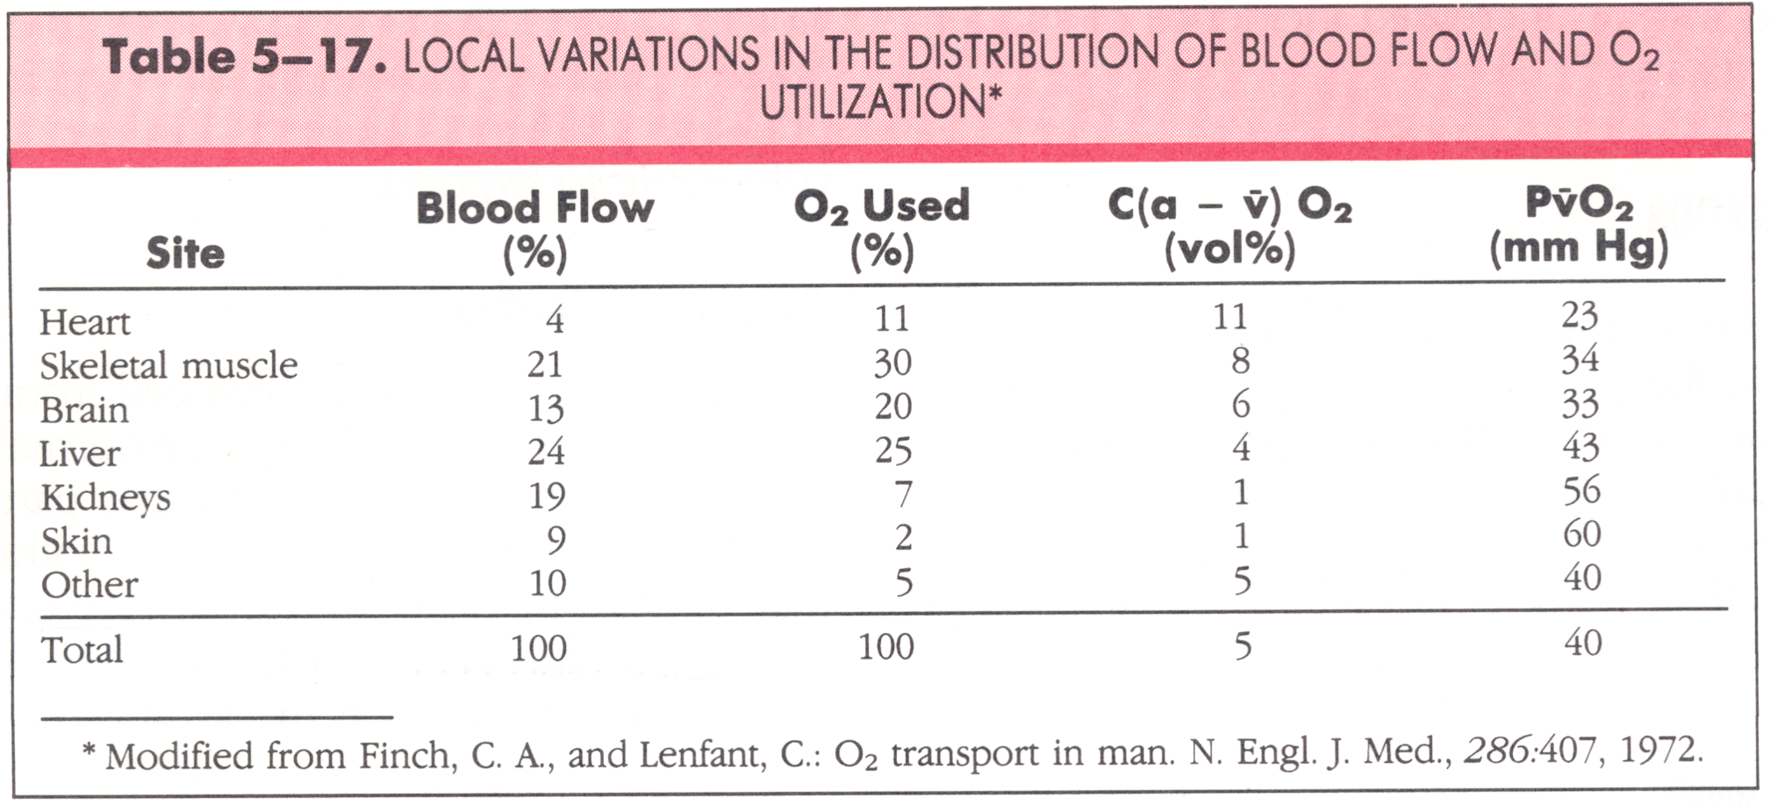
  - Oxygen Delivery
    - O₂ Delivery = CaO₂ x CO x 10
      - Normal: 20 vol% x 5.0 L/min x 10 = 1,000 mL/min
      - This is four times the O₂ required under basal conditions.
      - O₂ consumption = 250 mL/min
      - Reserve = 750 mL/min
  - Oxygen Extraction Ratio
    - $$O_{2}\text{ER}=\frac{C\left(a−\bar{v}\right)O_{2}}{{\text{CaO}}_{2}}$$
    - Normal: 5 vol%/20 vol% = .25 or 25%
    - Some tissues are capable of increasing oxygen extraction when additional O₂ is needed; Skeletal muscles can extract almost all the O₂ during maximal exercise.
    - Venous Oxygen Levels are the best index of tissue hypoxia.
    - Where the oxygen status of arterial blood is a primary reflection of the pulmonary system, mixed venous blood provides information regarding the balance of oxygen supply and demand.
    - Mixed venous oxygenation indices (PO₂, SO₂ and CO₂) are sometimes a good indicator of tissue hypoxia (exception is ARDS/septic shock & cyanide poisoning).
    - Low venous oxygen values are seen when:
      - Low arterial oxygen levels
      - increased oxygen consumption (exercise, shivering, seizures, fever, ↑ WOB)
      - decreased cardiac output
    - Fick Equation
$\text{CO}=\frac{\overset{˙}{V}O_{2}}{C\left(a−\bar{v}\right)O_{2}×\text{10}}$
      - If O₂ stays constant the cardiac output is inversely related to C(a-)O₂.
      - $\overset{˙}{V}O_{2}=\text{CO}×\left({\text{CaO}}_{2}−C\bar{v}O_{2}\right)×\text{10}$
- Respiration

  - Definition
    - Oxidative Phosphorylation -Oxidation of Pyruvic acid in the Kreb’s Cycle.
    - This takes place in the mitochondria and results in 36 ATP molecules, that contain the high energy bonds essential for all body processes.
    - C₆H₁₂0₆ + O₂ → H₂O + CO₂ + Energy (ATP).
    - Hypoxia, Cyanide Poisoning or lack of glucose blocks this reaction Anaerobic Metabolism.
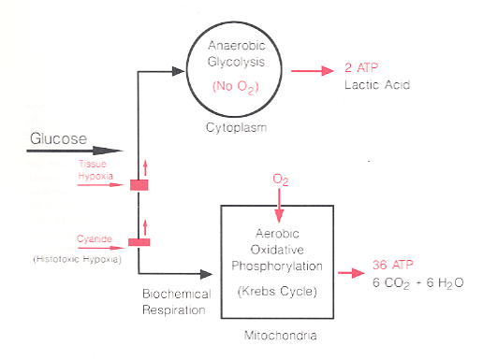
    - When hypoxia is present, anaerobic glycolysis occurs and only 2 ATP molecules are generated & lactic acid is produced resulting in metabolic acidosis.
    - Anaerobic metabolism results in dysoxia which if a form of hypoxia in which cellular uptake of oxygen is abnormally decreased (cyanide poisoning).
    - Causes of metabolic acidosis (pH 7.20, HCO₃⁻ 15 mEq/L, PaCO₂ 20 mm Hg, PaO₂ 88 mm Hg):
      - Tissue hypoxia (poisoning) is an example of anaerobic metabolism
      - Diabetic ketoacidosis
      - Renal disease
      - Electrolyte disturbances
    - Types of Hypoxia
      - Hypoxemic Hypoxia
      - Anemic Hypoxia
      - Histotoxic Hypoxia (cyanide or amobarbital)
      - Circulatory Hypoxia
    - High temperatures can also effect oxygen requirements.
      - O₂ consumption increases 10% for each 1° C increase in temperature.
      - If oxygen delivery does not meet the high oxygen consumption in this example, hypoxia can result.
  - Respiratory Quotient
    - $$\text{RQ}=\frac{{\text{CO}}_{2}\text{production}}{O_{2}\text{consumption}}=\frac{\overset{˙}{V}{\text{CO}}_{2}}{\overset{˙}{V}O_{2}}=\frac{\text{200}\text{mL}\text{min}}{\text{250}\text{mL}\text{min}}=0\text{.}8$$
    - The RQ is determined by metabolism of carbohydrates, fats and proteins.
      - Carbohydrate metabolism changes the RQ to 1.0
        - 6 CO₂ are produced for every 6 O₂ molecules consumed.
      - Fat metabolism changes the RQ to 0.7.
      - Protein metabolism results in a RQ of 0.8.
      - Combined RQ is 0.8
    - RQ is measured by a device called an indirect calorimeter or metabolic measurement cart; indirect calorimetry allows for an assessment of caloric requirements needed

