Renal Regulation of Acid Base Balance

Renal System

- Kidney
  - Composition
    - Nephron (1 million in each kidney)
    - Renal Corpuscle
    - Glomerulus (high pressure system)
    - Bowman’s Capsule
    - Renal Tubule
    - Proximal Tubule
    - Descending Loop of Henle
    - Loop of Henle
    - Ascending Loop of Henle
    - Distal Tubule
    - Collecting Ducts
    - Ureters
    - Bladder
    - Urethra
  - Layers
    - Cortex (outer layer) Renal Corpuscle if found
    - Medulla (inner layer) Loop of Henle and Collecting ducts
  - Renal Regeneration
    - Only 25% of the total renal mass is necessary for survival
    - The epithelium of the renal tubule can regenerate but the nephron itself will not.
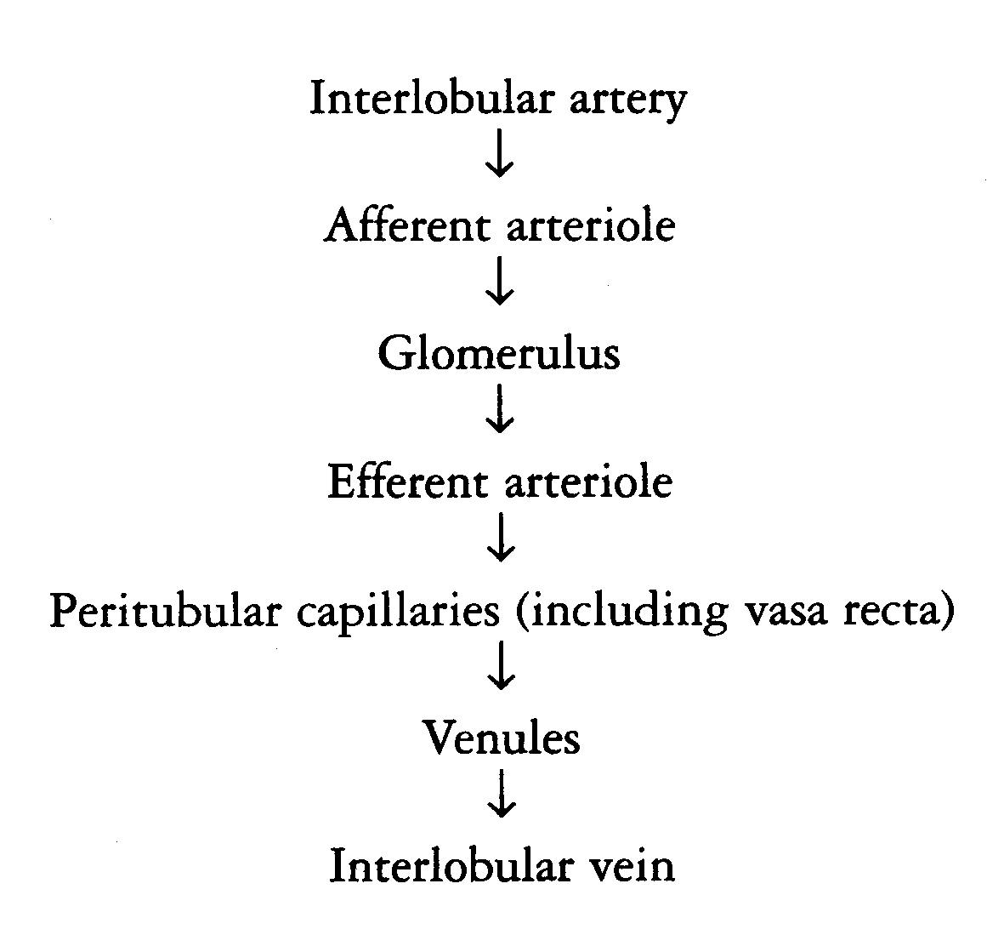
  - Blood Supply (see diagram attached)
    - Renal Fraction (amount of cardiac output perfusing the kidney) is 21%.
    - 1,000 – 1,250 mL blood pass through the glomeruli each minute.
    - 130 mL/min is filtered into the tubules.
      - This is called the glomerular filtrate
    - Pressure of the blood in the glomerulus causes fluid to filter into Bowman’s capsule and into the tubule.
  - Filtrate
    - Filtrate contains no blood cells, glucose or protein.
    - 99% of the filtrate is reabsorbed.
      - Glomerulus filtrate: 130 mL/min
      - Urine Production: 1 mL/min or 60 mL/hour
    - Na Reabsorption
      - 80% of Na is reabsorbed in the proximal tubules/loops.
      - 20% in distal tubules.
      - There is an exchange of Na⁺ for K⁺ or H⁺ in the distal tubules.
    - Composition of Urine
      - 95% water.
      - Nitrogenous waste from protein breakdown
        - Urea
        - Uric acid
        - Ammonia
        - Creatinine
      - Electrolytes
      - Toxins – bacterial or viral toxins
      - hormones
      - Pigments
      - Abnormal constituents
        - Signifies excessive levels in bloodstream
        - Glucose
          - **When blood glucose exceeds 180 mg%, glucose is seen in the urine
        - Albumin
        - Blood cells
    - pH of urine
      - 4.5 to 8.0 with a mean of 6.0
- Fluid Balance
  - INTAKE = OUTPUT
  - Renin-Angiotensin Mechanism
    - Low blood pressure is sensed by the juxta-glomerular cells in the kidney and also by baroreceptors in the aortic arch and carotid bodies.
    - Juxta-glomerular cells secrete the enzyme renin into the bloodstream.
    - Angiotensinogen is converted into Angiotensin I.
      - Angiotensin I circulates to the lung where it is converted to Angiotensin II.
    - Angiotensin II circulates to the adrenal cortex where it stimulates the secretion of aldosterone and causes vasoconstriction (both mechanisms will attempt to increase BP).
    - Aldosterone causes increased absorption of Na⁺ which increases water retention and ultimately an increase in blood pressure.

- Renal Failure
  - Three Causes of Renal Failure
    - Pre-renal Failure (hypoperfusion)
      - If mean BP falls to below 60 mm Hg for more than 30-40 minutes, renal ischemia can progress to renal necrosis.
      - Kidney size is normal
      - Causes
        - Dehydration
        - Cardiac failure
        - Hypovolemic shock
        - Trauma
    - Post-renal Failure (obstruction)
      - Kidney is swollen and larger than normal.
      - Causes
        - Hypertrophy of prostate gland
        - Calculi – kidney stones
        - Tumor
    - Intra-renal Failure
      - Nephritis (inflammation of the kidney)
      - Glomerularnephritis – inflammation of the capillary loops in the glomeruli of the kidney often secondary to hemolytic streptococcal infection.
      - Pyelonephritis – Renal medulla is affected. Usually caused by bacterial inflammation of the kidney by E coli and staphylococcus species.
      - Tubular Necrosis
        - Causes:
          - Nephrotoxin
          - Antibiotics
          - Bichloride of mercury
          - Carbon tetrachloride
      - Renal Ischemia
        - Causes
          - Severe hypotension
          - Infection
          - Trauma/injury
          - High blood pressure
          - Septic shock
          - Transfusion reactions
          - Blood clots - emboli
  - Acute vs. Chronic Renal Failure
    - Acute Renal Failure – Swollen large kidney
    - Chronic Renal Failure – small kidneys (atrophied)
  - Signs and Symptoms of Renal Failure
    - Hyperkalemia
      - Can lead to cardiac arrhythmias
    - Anemia
      - Secondary to the fact that the kidneys can no longer produce erythropoietin.
    - Decreased Ca⁺ concentration
    - Hypertension
    - Metabolic acidosis
    - Uremia (Azotemia)
    - Hyponatremia
    - Change in urine output
      - Oliguria – decreased urine output
      - Anuria – no urine output
      - Polyuria -excessive passage of urine

  - Tests used to Detect Renal Failure
    - Urinalysis
      - pH, bacterial count, specific gravity, presence of cells, protein
      - A bacterial count of over 100,000 per mL is abnormal.
    - BUN
      - Proteins are made up of amino acids. During catabolism, nitrogen is stripped from the amino acid and ammonia is formed.
      - 2 Ammonia + CO₂ form urea and urea is excreted from the body.
      - Urea is formed in the liver. Patients who have liver disease cannot manufacture urea and the ammonia levels rise in the blood leading to hepatic coma
    - Creatinine
      - Creatinine is a product of skeletal muscle metabolism and is unaffected by diet or fluid intake. It is a more reliable assessment tool for kidney function than BUN.
      - A twice normal creatinine level means a 50% nephron loss and the start of diminished kidney reserve
      - Edema starts to appear.
      - 8 times normal levels means 90% of nephron loss and end stage renal disease. The patient will need dialysis or kidney transplant

  - Treatment of Renal Failure
    - Diuretics
    - Peritoneal Dialysis
    - Hemodialysis
    - Decreased K intake
    - Kidney Transplant
- Diuretics
  - Indications:
    - Renal disease
    - Heart failure
    - Increased intracranial pressure
    - Increased intraocular pressure
    - Hypertension
    - Cerebral edema
    - Edema from hepatic cirrhosis
    - Edema from steroid administration
  - Types of Diuretics
    - Carbonic Anhydrase Inhibitor
      - Acetazolamide (Diamox)
      - Work in the proximal tubule to excrete HCO₃⁻ in the urine.
      - Used to treat metabolic alkalosis.
      - Excessive use may result in metabolic acidosis.
      - Also used to treat glaucoma.
    - Osmotic Diuretic
      - Keeps water from being reabsorbed in the proximal tubule and descending loop of Henle
      - Examples:
        - Mannitol (osmitrol)
        - Urea (ureaphil)
      - Used to treat high intracranial pressure, cerebral edema, acute renal failure, high intraocular pressure.
  - Loop Diuretics
    - Examples:
      - Furosemide (Lasix),
      - Ethacrynic Acid (Edecrin)
      - Bumeteanide (Bumex)
    - Very potent.
    - Work in the ascending limb
    - K⁺ loss can occur
  - Thiazide
    - Prevent Na⁺ & Cl⁻ reabsorption in the distal tubule with a depletion of K⁺
      - Chlorothiazide (Diuril)
  - Potassium Sparing Diuretics
    - Prevents sodium reabsorption in the distal tubule where Na usually exchanges with K⁺.
    - If Na⁺ reabsorption does not occur, K⁺ is not excreted into the tubule cells .
    - Used if patients are taking digitalis drugs
    - Examples:
      - Spironolactone (Aldactone)
      - Amiloride
  - Xanthines
    - Theophylline
    - Watch for dehydration & increased mucous viscosity in patients receiving theophylline for asthma/COPD

- Blood Urea Nitrogen (BUN) and Creatinine

 | Bun | Creatinine
Normal Values | 10 – 20 mg/dL | 0.6 to 1.2 mg/dL
Normal Ratio | 20 | 1
 | ↑ | Normal or slightly elevated | Volume Depletion or poor perfusion from:  low fluid intake  diuresis  vomiting  diarrhea  systemic infections  surgery  burns  hemorrhage  urinary infection  MI/CHF
 | ↑ | Normal or slightly  elevated | Protein Catabolism:  Excessive protein intake  starvation  trauma  corticosteroids  heavy exercise
 | ↑ | ↑ | Kidney Disease

Creatinine comes from skeletal muscle mass which stays relatively constant

