HOW TO SUBSCRIBE TO ITUNES FROM PANOPTO

If you access to an iPod or an iPhone and wish to download the presentations in Panopto via iTunes, here are some directions.

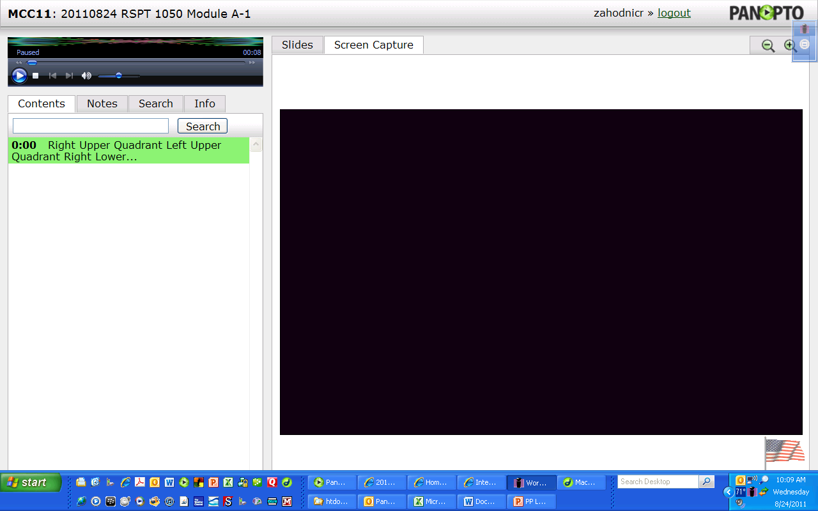
- Open a session from www.macomb-rspt.com from the appropriate course page.
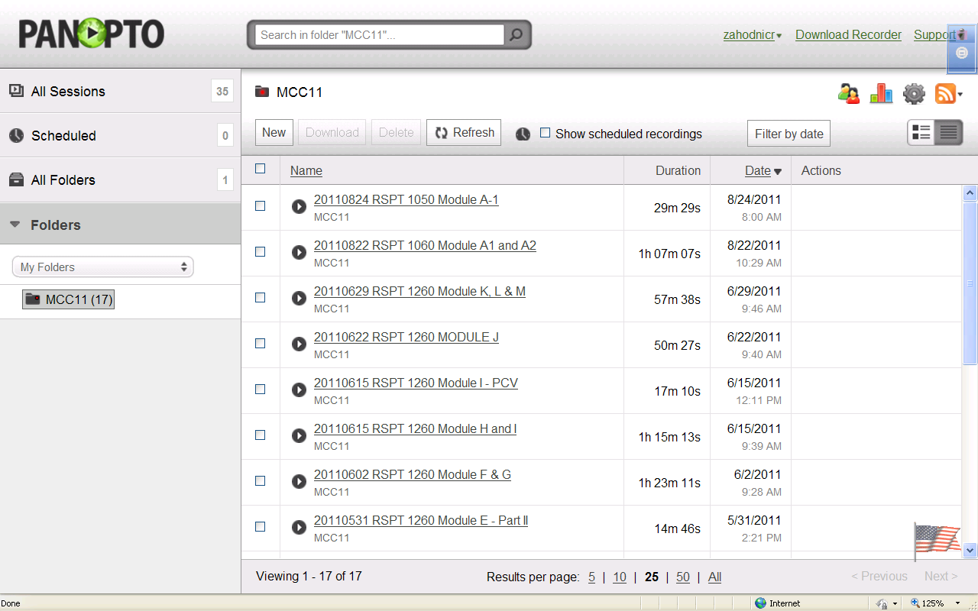
- Click on the Info Tab and click on the “sessions” link. The following screen should pop up.
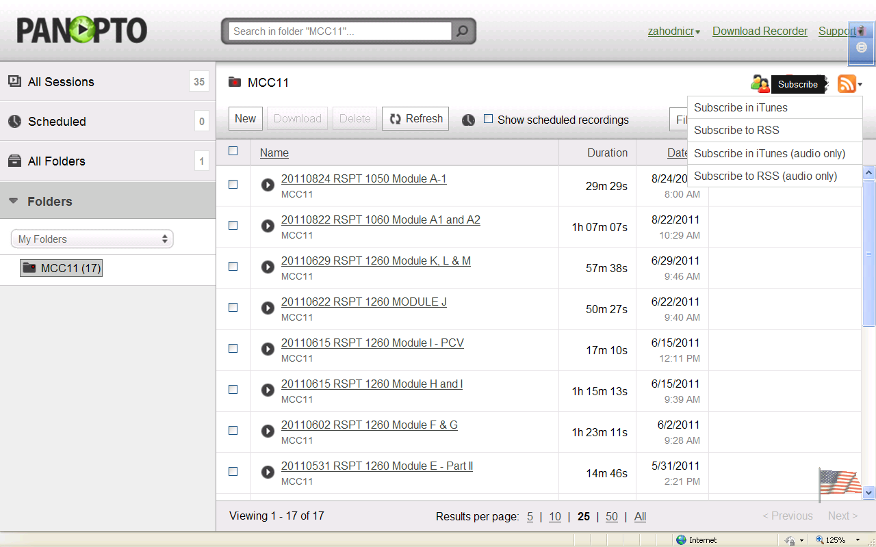
- In the upper right corner is an orange icon with a pull-down menu.
- Choose one of the two iTunes options.

